|  |  |
| --- | --- |
| ­­­­MINISTRY OF FINANCE  **NATIONAL STATISTICS OFFICE OF VIETNAM**  No: 158/BC-CTK | **SOCIALIST REPUBLIC OF VIET NAM**  **Independence-Freedom-Happiness**  *Ha Noi, 6th June 2025* |

**Report on socio-economic situation   
in May and the first 5 months of 2025**

**1. Agriculture, forestry, and fishery**

*Agricultural production in May focused on tending to the winter-spring rice in the northern localities; the tending to rice and harvesting winter-spring crop and summer-autumn rice in southern localities. Pig and poultry farming developed quite well. The afforestration and timber exploitation activities were as planned. Aquaculture witnessed a stability, marine capture fishery increased due to the southern fishing season.*

1. ***Agriculture***

*Winter-spring rice*

In the 2025 winter-spring rice crop, the whole country cultivated 2,970.9 thousand hectares, an increase of 17.0 thousand hectares, in comparision to that of the previous year due to the increase in the cultivated area in the southern localities. The northern localities cultivated 1,052.1 thousand hectares, a decrease of 7.7 thousand hectares due to land acquisition for construction of projects, industrial zones , and conversion of crop purposes from rice to other crops for higher economic efficiency, of which the Red River Delta reached 464.2 thousand hectares, a decrease of 7.1 thousand hectares. The southern localities cultivated 1,918.8 thousand hectares, an increase of 24.7 thousand hectares, in comparision to that of the previous year, of which the Mekong River Delta reached 1,508.3 thousand hectares, an increase of 20.6 thousand hectares due to favorable weather, less affected by saltwater intrusion, therefore farmers maximized the production area.

As of May 20, 2025, Southern localities harvested 1,881.0 thousand hectares of spring rice, accounting for 98.0% of the cultivated area, an equivalent to 101.1% compared to the same period last year, of which the Mekong River Delta harvested 1,508.3 thousand hectares, accounting for 100%.

*Summer-autumn rice*

Along with harvested winter-spring rice, as of May 20, 2025, the southern localities cultivated 1,258.3 thousand hectares of summer-autumn rice, equal to 111.3%, in comparison with that of the same period last year, of which the Mekong Delta region reached 1,162.3 thousand hectares, equal to 113.0%. This year's summer-autumn rice planting progress was faster than that of the same period last year because farmers took advantage of favorable weather and widespread rain to proactively cultivate early. Some localities were recorded with the expansion of production areas, in comparision to the same period last year, of which, Kien Giang by 50.8 thousand hectares; Bac Lieu by 35.6 thousand hectares; Tra Vinh by 23.1 thousand hectares; Soc Trang by 17.0 thousand hectares. Currently, summer-autumn rice was in the tillering and panicle formation stages, localities focussed on tending to ensure optimal yield.

*Annual crops*

Along with rice cultivation, localities across the country were planting other crops. Of which, the area of ​​some crops such as maize, peanuts, soybeans, and sweet potatoes continued to decrease compared to the same period last year, mainly due to low economic efficiency.

**Figure 1: Cultivation area of some other annual crops**

(As of 20/5/2025)

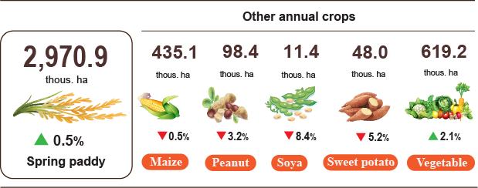

*Livestock*

Buffalo farming decreased due to low economic efficiency, narrowed grazing areas, long farming cycles causing the farmers uninterested in livestock repopulation.. Cattle farming witnessed a slight decrease compared to the same period last year. Pig and poultry farming witnessed a positive growth rate due to the epidemics and diseases was under control, product prices remained at a level that generated benefit for farmers. The domestic consumption market was stable, support policies on breeding animals, animal feed and preferential loans contributed to affiliating the farmer to restore the livestock repopulation and expand production scale.

**Figure 2. The growth rate of the population of cattle and poultry at the**

**end of May 2025 compared to the figure in the same time point last year**

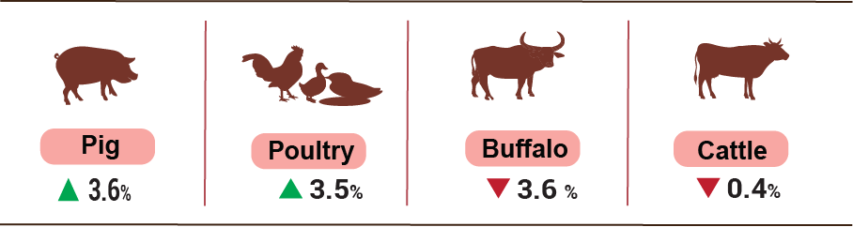

As of May 27th 2025, blue-ear disease, avian influenza in poultry and foot-and-mouth disease were not witnessed across the country; lumpy skin disease (LSD) still remained in Quang Ngai and African swine fever persisted in 18 localities[1] with outbreaks less than 21 days[2].

***b) Forestry***

The area of ​​newly concentrated planted forests in 5/2025 was estimated at 32.3 thousand hectares, an increase of 13.9%, in comparison to the same period last year[3]; the number of scattered forest trees reached 7.4 million trees, an increase of 2.9%; wood production reached 2.467,3 thousand m3, an expansion of 6.1% due to high wood prices, many localities harvested timber in the harvest time[4]. Total for the first five months of 2025, the area of ​​newly concentrated planted forest was estimated at 113.7 thousand ha, an increase of 13.6%, incomparision to the same period last year; the number of scattered forest trees reached 39.0 million trees, an increase of 3.7%; timber production was estimated at 8.395,2 thous. m3, an increase of 10.2%.

The damaged forest area in May 2025[5] was 122.3 hectares, a decline of 40.3% compared to the same period last year, of which the destroyed forest area was 67.0 hectares, rose by 9.8%; the burned forest area was 55.3 hectares, a drop of 57.6%. Total for the first five months of 2025, the damaged forest area was 603,8 hectares, rose by 7.4%, in comparision to the same period last year, of which the destroyed forest area was 466.2 ha, increased by 27.0%; the burned forest area was 137.6 hectares, a shrink of 51.7%.

***c) Fishery***

The production of fishery in 5/2025 was estimated at 828.2 thousand tons, an increase of 3.4%, in comparision to the same period last year, including: Fish reached 591.9 thousand tons, by 3.2%; shrimp reached 117.1 thousand tons, by 5.6%; other aquatic products reached 119.2 thousand tons, by 2.2%.

The production of aquaculture in the month reached 455.2 thousand tons, a growth of 4.7%, in comparision to the same period last year, of which: Fish reached 301.1 thousand tons, by 4.5%; shrimp reached 103.2 thousand tons, by 6.3%.

The production of Pangasius in the month saw an increasing tendency,in comparision to the same period last year due to stable raw pangasius prices[6], the production of harvested pangasius ensured raw material source for export processing. The production of Pangasius in the month was estimated to reach 163.4 thousand tons, an expansion of 5.4%, in comparision to the same period last year.

The production of shrimp in the month witnessed an increasing tendencey compared to the same period last year, whiteleg shrimp prices remained stable[7]. The production of whiteleg shrimp in May 2025 was estimated at 72.9 thousand tons, an expansion of 7.2%, in comparision to the same period last year; the production of black tiger shrimp reached 24.0 thousand tons, a growth of 4.3%.

The capture fihsery production in the month was estimated at 373.0 thousand tons, an increase of 1.8%, in comparision to the same period last year, of which: Fish reached 290.8 thousand tons, by 1.8%; shrimp reached 13.9 thousand tons, by 0.7%, other aquatic products reached 68.3 thousand tons, by 1.9% due to favorable weather, marine capturing entered the southern fishing season, along with the appearance of many fish species such as mackerel, anchovies, squid, therefore fishermen actively conducted marine capturing t. The production of marine capture fishery was estimated at 357.7 thousand tons, an increase of 1.8%, in comparision to the same period last year, of which: Fish reached 279.2 thousand tons, by 1.8%; shrimp reached 13.0 thousand tons, by 0.8%, other aquatic products reached 65.5 thousand tons, by 2.0%.

**Figure 3. Production of fishery in the first 5 months in 2025 compared to the same period in 2024**

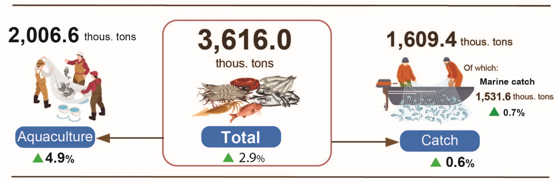

Total for the first five months in 2025, the production of fishery was estimated at 3.616,0 thousand tons, an increase of 2.9%, in comparision to the same period last year, including: Fish reached 2.641,9 thousand tons, by 2.9%; shrimp reached 429,8 thousand tons, by 5.1%; other fisheries reached 544.3 thousand tons, an increase of 1.8%.

**2. Industrial Production**

*The industrial sector continued to experience a robust growth rate in May.* The overall industrial production index was estimated at a growth rate of 4.3% month-on-month and surged by 9.4% year-on-year[8]. In the first five months in 2025, the overall index of industrial production rose by 8.8% compared to the same period last year.

The Index of Industrial Production (IIP) in May 2025 was estimated to increase by 4.3% compared to the previous month[9] and by 9.4% year-on-year. Specifically, the water supply, waste management, and wastewater treatment sector grew by 11.3% year-on-year; the manufacturing and processing sector rose by 11.0%; the electricity production and distribution sector increased by 3.3%; the mining sector increased by 1.2%.

For the first five months in 2025, the IIP was estimated at a growth rate of 8.8% compared to the same period last year (which saw an increase of 7.1% in 2024). Of which, the manufacturing grew by 10.8% (which saw an increase of 7.6% in 2024), contributing 8.8 percentage points to the overall growth; the electricity production and distribution increased by 4.2% (versus 12.9% in 2024), contributing 0.4 percentage points; the water supply, waste management, and wastewater treatment rose by 10.0% (versus 5.9% in 2024), contributing 0.2 percentage points; while the mining declined by 3.4% (5.0% decline in the same period of 2024), reducing the overall growth by 0.6 percentage points.

*In the first five months in 2025, the IIP of several key 2-digit activities increased compared to the same period last year*: Manufacture of motor vehicles rose by 34.3%; manufacture of leather and related products increased by 16.8%; manufacture of rubber and plastics products grew by 16.1%; manufacture of wearing apparel grew by 15.7%; manufacture of other transport equipment grew by 14.1%; manufacture of furniture by 12.8%; manufacture of wood and products of wood, bamboo, and schizostachyum aciculare increased by 12.6%; manufacture of coke and refined petroleum grew by 12.4%; manufacture of other non-metallic mineral products increased by11.3%; fabricated metal products (excluding machinery and equipment) increased by 11.2%; manufacture of computer, electronic and optical products rose by 9.6% and manufacture of food products grew by 8.8%. Conversely, the IIP for some activities witnessed decrease as follows: Extraction of crude petroleum and natural by 8.8%; manufacture of pharmaceuticals, medicinal chemical and botanical products by 6.1%; and manufacture of electrical equipment by 3.5%.

**Table 1. Year-on-year IIP growth rate for 5 months in the period of 2021 - 2025 for several key industrial activities**

%

|  | **2021** | **2022** | **2023** | **2024** | **2025** |
| --- | --- | --- | --- | --- | --- |
|  |  |  |  |  |  |
| Extraction of crude petroleum and natural | -10.2 | -1.1 | -2.1 | -11.0 | -8.8 |
| Manufacture of food products | 6.2 | 6.4 | 3.5 | 5.7 | 8.8 |
| Manufacture of wearing apparel | 9.1 | 23.2 | -8.1 | 5.4 | 15.7 |
| Manufacture of leather and related products | 11.5 | 13.3 | -2.3 | 7.8 | 16.8 |
| Manufacture of wood and products of wood, bamboo, and schizostachyum aciculare | 3.6 | 4.3 | -5.4 | 11.8 | 12.6 |
| Manufacture of coke and refined petroleum | 0.8 | -3.8 | 14.0 | 5.3 | 12.4 |
| Manufacture of pharmaceuticals, medicinal chemical and botanical products | -0.1 | 16.9 | 1.2 | 10.6 | -6.1 |
| Manufacture of rubber and plastics products | 10.8 | -12.3 | 6.8 | 27.9 | 16.1 |
| Manufacture of other non-metallic mineral products | 7.1 | 6.3 | -5.0 | -3.2 | 11.3 |
| Fabricated metal products (excluding machinery and equipment) | 9.9 | 10.7 | 2.6 | 12.0 | 11.2 |
| Manufacture of computer, electronic and optical products | 15.4 | 11.0 | -5.3 | 6.4 | 9.6 |
| Manufacture of electrical equipment | 13.5 | 22.3 | -1.7 | 24.2 | -3.5 |
| Manufacture of motor vehicles | 34.7 | 1.8 | -9.5 | 4.4 | 34.3 |
| Manufacture of other transport equipment | 13.6 | 2.6 | -5.6 | -5.4 | 14.1 |
| Manufacture of furniture | 17.1 | 4.7 | -3.7 | 19.9 | 12,8 |

*The industrial production index (IIP) for the first five months in 2025 increased in 62 provinces, in contrast, Ba Ria- Vung Tau and Cao Bang provinces saw decreases of 3.4% and 3.3%, respectively*. Some localities experienced significant IIP growth rate, driven by the manufacturing , as well as a high increase in the production and distribution of electricity [10]. Conversely, several localities saw lower or negative IIP growth due to the sluggish performance in the manufacturing , mining , and the low or negative growth in the production and distribution of electricity[11].

**Figure 4. Year-on-year IIP growth rate in the first 5 months 2025 for several localities (%).**

|  |  |
| --- | --- |
| **The 10 localities with the highest IIP growth rate** | **The 10 localities with the lowest IIP growth or a decline** |

*Some key industrial products in the first 4 months in 2025 witnessed year-on-year increases as follows*: Cars 70.3%; televisions by 25.6%; liquefied petroleum gas (LPG) by 21.7%; NPK mixed fertilizers by 18.8%; fabrics woven from natural fibers by 14.6%; rolled steel by 13.8%; fabrics woven from natural fibers by 13.4%; cement by 12.9%; rebar and angle steel by 11.7%; leather footgear by 11.5%; sugar 10.9%. Conversely, some products saw a decrease compared to the same period last year: natural gas (in the form of air) decreased by 12.4%; extracted crude oil by 5.1%; fabric made from synthetic fibers decreased by 4.3% and beers decreased by 0.3%.

*The number of employee in industrial enterprises as of May 1, 2025* saw a month-on-month growth of 1.1% and year-on-year increase of 4.5%. Among them, the number of employees in state-owned enterprises rose by 0.3% month-on-month and 1.1% year-over-year; in FDI enterprises increased by 1.3% and 5.3%, respectively; while in non-state enterprises rose by 0.8% and 3.0%, respectively. By sector, the number of employees in the mining sector grew by 0.4% month-on-month but slightly declined by 0.1% year-on-year. The manufacturing sector saw an increase of 1.2% and 4.8%, respectively. The production and distribution of electricity, gas, hot water, steam, and air conditioning remained unchanged from the previous month but rose by 0.8% year-over-year. Meanwhile water supply, sewerage, waste management, and remediation activities recorded a slight increase of 0.1% month-on-month and 1.5% year-on-year.

**3. Enterprise activities[12]**

In May, the whole country had more than 15.1 thousand newly established enterprises with registered capital of over 156.7 trillion VND and a total number of registered employees of 98.1 thousand, a decrease of 0.6% in the number of enterprises, an increase of 17.3% in registered capital and a decrease of 23.1% in the number of employees compared to that in April 2025. Compared to the same period of last year, the number of enterprises, the number of employees and the registered capital went up 6.1%, 16.6% and 29.3%, respectively. The average registered capital of a newly established enterprise in the month reached 10.4 billion VND, a month-on-month increase of 18.0% and a year-on-year increase of 9.9%. Besides, there were over 8.0 thousand resumed enterprises in the whole country, a month-on-month decrease of 11.1% and a year-on-year increase of 18.8%.

Generally, in the first five months of 2025, the whole country had nearly 66.8 thousand newly registered enterprises with a total registered capital of 647.1 trillion VND and the total number of registered employees of 453.9 thousand ones, up 0.6% in the number of enterprises, down 2.2% in the registered capital and up 6.2% in the number of employees against that in 2024. The average registered capital of a newly established enterprise in the first five months of 2025 achieved 9.7 billion VND, a year-on-year decrease of 2.7%. The total amount of additional registered capital into the economy in the first five months was nearly 2,279.5 trillion VND, an increase of 83.8% against that in 2024. Besides, there were more than 45.0 thousand resumed enterprises (up 32.2% over the same period of 2024), bringing the total number of newly-established enterprises and resumed enterprises in the first five months of 2025 to over 111.8 thousand ones, a year-on-year increase of 11.3%. On average there were nearly 22.4 thousand newly established and resumed enterprises per month.

By economic sector, in the first five months of 2025, there were 627 newly-established enterprises in the agriculture, forestry, and fishery sector, a year-on-year decrease of 1.7%; more than 15.2 thousand enterprises in the industry and construction sector, a decrease of 3.9%; nearly 50.9 thousand enterprises in the service sector, an increase of 2.0%.

Also in May, 5,924 enterprises registered for temporarily shut down for a specific period, down 17.5% compared to the previous month and up 11.7% against that in 2024; 6,535 enterprises temporarily suspended awaiting for dissolution procedures, a decrease of 27.3% and an increase of 43.6%; 1,909 enterprises completed dissolution procedures, up 9.1% and down 12.8%, respectively.

**Figure 5. Enterprise registration performance**

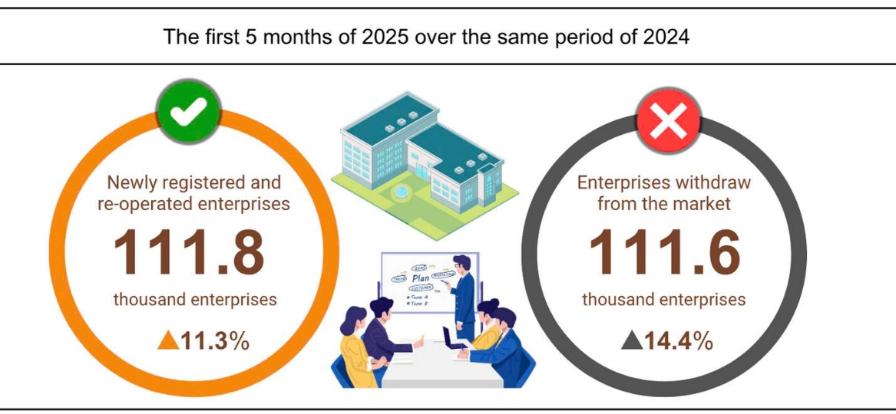

In the first five months of this year, there were nearly 74.6 thousand enterprises registered for temporarily shut down for a specific period, an increase of 12.8% against 2024; more than 27.5 thousand enterprises temporarily suspended awaiting for dissolution procedures, an increase of 18.3%; nearly 9.6 thousand completely dissolved enterprises, up 15.7%. On average, over 22.3 thousand enterprises withdrew from the market per month.

**Table 2: Newly registered and dissolved enterprises**

**in the first five months of 2025 by kinds of activity**

|  |  |  |  |  |
| --- | --- | --- | --- | --- |
|  | Number of enterprises (Enterprise) | | Year-on-Year  Growth rate (%) | |
| Newly registered | Dissolution | Newly registered | Dissolution |
| Wholesale and retail trade; repair of motor vehicles and motorcycles | 24,940 | 3,512 | -6.6 | 3.4 |
| Manufacturing | 8,537 | 1,015 | 5.5 | 19.6 |
| Construction | 5,943 | 681 | -15.4 | 13.3 |
| Real estate business | 2,064 | 524 | 12.7 | 6.3 |
| Transportation and storage | 3,586 | 366 | 3.2 | 20.4 |
| Accommodation and catering service | 2,199 | 505 | -11.2 | 39.1 |
| Production and distribution of electricity, water, gas | 515 | 123 | 10.0 | 35.2 |

**4. Investment**

*Investment capital from the State budget in May was accelerated by ministries, sectors and local authorities. In the first five months of 2025, investment capital from the State budget was estimated to reach 24.3% of the plan, up 17.5% over the same period last year. Foreign direct investment (FDI) implemented in Viet Nam in the first five months of 2025 was estimated at 8.9 billion USD, up 7.9% over the same period last year.*

Redisbursed capital from the State budget in May was estimated at 55.4 trillion VND, up 15.3% over the same period last year, including: Centrally managed capital reached 8.7 trillion VND, up 4.3%; locally managed capital reached 46.7 trillion VND, up 17.6%. In the first five months of 2025, the total disbursed capital from the State budget was estimated at 221.8 trillion VND, equal to 24.3% of the annual plan and up 17.5% over the same period last year (the same period in 2024 was equal to 24.2% and up 3.9%). Specifically:

- The centrally managed disbursed capital was estimated at 33.4 trillion VND, equal to 23.5% of the annual plan and up 5.6% over the same period last year. Of which, the Ministry of Construction reached 21 trillion VND, up 1.9%; the Ministry of Agriculture and Environment reached 5 trillion VND, up 49.3%; the Ministry of Health reached 884.5 billion VND, 3.1 times higher; the Ministry of Education and Training reached 478.7 billion VND, up 59.7%; the Ministry of Culture, Sports and Tourism reached 242.8 billion VND, up 30.2%; the Ministry of Science and Technology reached 146.5 billion VND, up 11.3%; the Ministry of Industry and Trade reached 78.8 billion VND, down 56.1%.

- The disbursed investment capital managed by local authorities was estimated at 188.4 trillion VND, equal to 24.4% of the annual plan and up 19.9% ​​over the same period last year, of which:

State budget capital at the provincial level reached 127.4 trillion VND, equal to 22.9% and up 22.4% over the same period in 2024;

State budget capital at the district level reached 52.8 trillion VND, equal to 27.8% and up 16.5%;

State budget capital at the commune level reached 8.2 trillion VND, equal to 32.8% and up 6.6%.

The investment capital disbursed from the State budget in the first five months of 2025 of a number of provinces and centrally run cities was as follows:

**Figure 6. Investment capital implemented from the State budget**

**First 5 months of the year in some localities**

*Total inward foreign investment in Vietnam[13]* as of May 31, 2025, including: Newly registered capital, adjusted registered capital and capital contribution and share purchase value of foreign investors reached 18.39 billion USD, an increase of 51.2% over the same period last year.

**Figure 7. Foreign investment capital registered in Viet Nam**

**May during 2021-2025 period (Billion USD)**

- In terms of newly registered capital: 1,549 projects were licensed with registered capital reaching 7.02 billion USD, an increase of 14.1% in the number of projects and a decrease of 13.2% in registered capital over the same period last year . Of which, the manufacturing was the one with the largest newly licensed foreign direct investment with registered capital reaching 4.17 billion USD, accounting for 59.4% of the total newly registered capital; real estate business activities reached 2.03 billion USD, accounting for 28.9%; the remaining activities reached 820.1 million USD, accounting for 11.7%.

Among the 65 countries and territories with newly licensed projects in Viet Nam in the first five months of 2025, Singapore was the largest investor with 2.12 billion USD, accounting for 30.2% of the total newly registered capital; followed by China with 1.81 billion USD, accounting for 25.8%; Japan with 753.4 million USD, accounting for 10.7%; Hong Kong Special Administrative Region (China) with 607.7 million USD, accounting for 8.7%; Taiwan (China) with 412.4 million USD, accounting for 5.9%; British Virgin Islands with 260.8 million USD, accounting for 3.7 %; South Korea with 196.4 million USD, accounting for 2.8%.

- Adjusted registered capital: 674 licensed projects from previous years registered to adjust investment capital to increase by 8.52 billion USD, 3.4 times higher than the same period last year.

If including newly registered capital and adjusted registered capital of licensed projects from the previous years, foreign direct investment registered in the manufacturing reached 9.33 billion USD, accounting for 60.1% of the total newly registered and increased capital; real estate business activities reached 4.76 billion USD, accounting for 30.7%; the remaining activities reached 1.44 billion USD, accounting for 9.2%.

- There were 1,358 projects registered for capital contributions and share purchases by foreign investors with a total capital contribution value of 2.86 billion USD, an increase of 82.9% over the same period last year. Of which, 558 turns of capital contributions and share purchases increased the charter capital of enterprises with a capital contribution value of 1.12 billion USD and 800 foreign investors bought back domestic shares without increasing the charter capital with a value of 1.74 billion USD. Regarding the form of capital contributions and share purchases by foreign investors, the investment capital in the processing and manufacturing industry reached 1.07 billion USD, accounting for 37.6% of the capital contribution value; professional activities, science and technology reached 717.3 million USD, accounting for 25.1%; the remaining activities reached 1.07 billion USD, accounting for 37.6 %.

*Disbursed foreign direct investment in Vietnam* in the first five months of 2025 was estimated at 8.90 billion USD, up 7.9% over the same period last year. This was the highest amount of foreign direct investment disbursed in five months in the past 5 years. Of which: the manufacturing reached 7.26 billion USD, accounting for 81.6 % of total disbursed foreign direct investment; real estate business activities reached 703.8 million USD, accounting for 7.9%; production and distribution of electricity, gas, hot water, steam and air conditioning reached 352.0 million USD, accounting for 4.0%.

**Figure 8. Disbursed foreign direct investment**

**first 5 months during 2021-2025 (Billion USD)**

*Viet nam's outward investment* in the first five months of 2025 had 46 projects newly licensed investment certificates with a total capital of of 275.7 million USD from Viet Nam, 2.7 times higher than that in the same period last year; there were 13 projects with adjusted capital with an increase of 41.6 million USD, an increase of 27.8%.

In total, Viet Nam's outward foreign direct investment (newly licensed and adjusted capital) reached 317.3 million USD, 2.3 times higher than that in the same period last year. Of which: Production and distribution of electricity, gas, hot water, steam and air conditioning reached 111.2 million USD, accounting for 35.0 % of total investment capital; the manufacturing reached 71.9 million USD, accounting for 22.7%; transportation and warehousing reached 50.5 million USD, accounting for 15.9%.

In the first five months of 2025, 24 countries and territories received investment from Vietnam, of which: Lao PDR was the leading country with 145.9 million USD, accounting for 46.0% of total investment capital; Indonesia 59.1 million USD, accounting for 18.6%; Philippines 34.3 million USD, accounting for 10.8%; Japan reached 26.1 million USD, accounting for 8.2%; British Virgin Islands 21.0 million USD, accounting for 6.6%.

**5. State budget revenue and expenditure[14]**

*State budget revenue in the first five months of 2025 was estimated to increase by 24.5% over the same period last year. State budget expenditure was estimated to increase by 27.7 % over the same period in 2024, ensuring the needs of socio-economic development, national defense, security, state management, payment of due debts as well as timely payment to subjects according to regulations.*

**Figure 9. State budget revenue and expenditure in the first 5 months of 2025**

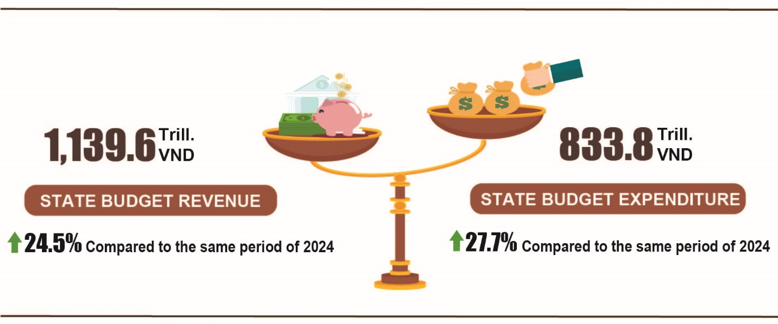

***State budget revenue***

Total state budget revenue in May 2025 was estimated at 172.4 trillion VND. The total state budget revenue accumulated in the first five months of 2025 was estimated at 1,139.6 trillion VND, reaching 57.9% of the annual estimate and going up by 24.5% over the same period last year. In particular, some main revenue items were as follows:

*- Domestic revenue* in May 2025 was estimated at 143.5 trillion VND. The accumulated revenue in the first five months of 2025 was estimated at 987.5 trillion VND, reaching 59.2% of the annual estimate and an increase of 27.6% over the same period last year[15].

*- Revenue from crude oil* in May 2025 was estimated at 4.6 trillion VND; the accumulated revenue in the first five months of 2025 reached 22.5 trillion VND, reaching 42.2% of the annual estimate and down 9.1% over the same period last year.

*- Budget revenue from import and export activities* in May 2025 was estimated at 24.2 trillion VND; accumulated revenue in the first five months of 2025 was estimated at 129.2 trillion VND, reaching 55.0% of the annual estimate and an increase of 10.6% over the same period last year.

***State budget expenditure***

Total state budget expenditure in May 2025 was estimated at 235.1 trillion VND; the accumulated expenditure in the first five months of 2025 was estimated at 833.8 trillion VND, equivalent to 32.7% of the annual estimate and increasing by 27.7% over the same period last year. Of which, recurrent expenditure in the first five months of 2025 was estimated at 585.5 trillion VND, equal to 37.3% of the annual estimate and an increase of 27.1% over the same period last year; development investment expenditure gained 199.3 trillion VND, reaching 25.2% and increse of 38.8%; interest payment was 47.7 trillion VND, reaching 43.1% and increasing 0.4%.

**6. Service activities**

***a) Retail sales of consumer goods and services***

*The people’s increasing demand in consumption and tourism during holidays and festivals, along with the high number of international visitors to Viet Nam, were positive factors contributing to the growth of the trade and service sector since the beginning of the year. Gross retail sales of goods and service revenue in May 2025 was estimated to increase by 10.2% compared to the same period last year. In the first five months of 2025, the gross retail sales of goods and consumer service revenue witnessed a year-on-year increase of 9.7% compared to the same period last year, of which: revenue from accommodation and catering services increased by 15.2% and tourism revenue increased by 24.7%.*

Gross retail sales of consumer goods and services at current prices in May 2025 was estimated at 574.9 trillion VND, going up by 0.4% over the previous month and rising by 10.2% over the same period last year. Of which, revenue from food and foodstuff increased by 11.3%; cultural and educational goods increased by 7.9%; household equipment and goods increased by 7.5%; garment increased by 3.7%; accommodation and catering services increased by 19.1% and tourism revenue increased by 35.0% thanks to the proactive implementation of tourism stimulus programs by many localities

**Table 3. Retail sales of consumer goods and services at current prices**

***Trillion VND***

|  |  |  |  |  |
| --- | --- | --- | --- | --- |
|  | Estimate  for May  2025 | Estimate for 5 months  of 2025 | Year-Over-Year  Growth rate (%) | |
|  |
|  | May 2025 | 5 months  of 2025 |
|  |
| **Total** | **574.9** | **2.851.4** | **10.2** | **9.7** |
| Retail sale of goods | 436.4 | 2.182.3 | 8.0 | 8.2 |
| Accommodation and catering service | 71.4 | 340.3 | 19.1 | 15.2 |
| Tourism revenue | 8.6 | 38.4 | 35.0 | 24.7 |
| Other services | 58.5 | 290.4 | 14.3 | 12.9 |

Overall, in the first five months of 2025, the gross retail sales of consumer goods and services at current prices was estimated at 2,851.4 trillion VND, going up by 9.7% compared to the same period last year (the figure of the same period in 2024 was 8.8%), if excluding the price factor rising by 7.4% (the figure of the same period in 2024 was 5.4%).

**Figure 10. Gross retail sales of consumer goods and services at current prices  
in the first five months of the 2021-2025 period**

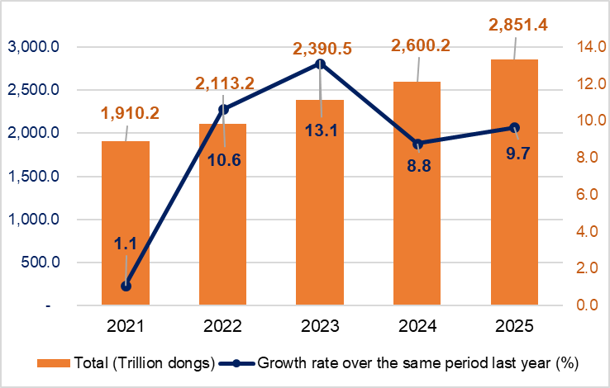

*Retail sales of goods* in the first five months of 2025 were estimated at 2,182.3 trillion VND, accounting for 76.5% of the total retail sales of consumer goods and services and going up by 8.2% over the same period last year. Of which, cultural and educational goods; food, foodstuff; garment; and household equipment and goods increased by 11.1%; 9.8%; 6.3%; and 5.8%, respectively. Retail sales of goods in the first five months of 2025 of some localities saw a year-on-year increase as follows: Ho Chi Minh City by 8.6%; Hai Phong by 8.4%; Can Tho by 7.7%; Ha Noi by 7.5%; Da Nang by 7.4%.

*Revenue from accommodation and catering services* in the first five months of 2025 was estimated at 340.3 trillion VND, accounting for 11.9% and going up by 15.2% over the same period last year. Revenue in the first five months of 2025 of some localities witnessed a year-on-year increase as follows: Ho Chi Minh City increased by 18.3%; Da Nang increased by 18.0%; Quang Ninh increased by 16.8%; Hai Phong increased by 14.0%; Ha Noi increased by 12.8%; Can Tho increased by 9.4%.

*Tourism revenue* in the first five months of 2025 was estimated at 38.4 trillion VND, accounting for 1.4% and going up by 24.7% over the same period last year. The revenue of some localities in the first five months of 2025 witnessed a high year-on-year growth as follows: Ho Chi Minh City increased by 30.4%; Dong Nai increased by 29.1%; Lao Cai increased by 24.4%; Ha Noi increased by 22.0%; Da Nang increased by 19.9%.

*Other services revenue* in the first five months of 2025 was estimated at 290.4 trillion VND, accounting for 10.2% and going up by 12.9% over the same period last year. Specifically, the revenue in the first five months of 2025 of some localities saw a high year-on-year increase as follows: Can Tho increased by 17.6%; Ho Chi Minh City increased by 15.1%; Ha Tinh increased by 13.3%; Khanh Hoa increased by 12.1%; Tay Ninh increased by 10.7%; Ha Noi increased by 9.2%; Hai Phong increased by 7.0%.

**b) Export and import of goods*[16]***

*In May, the total export and import turnover of goods[17] reached 78.64 billion USD, going up by 5.8% over the previous month and rising by 15.5% over the same period last year. Generally, the total export and import turnover of goods in the first five months of 2025 reached 355.79 billion USD, going up by 15.7% over the same period last year, of which export increased by 14.0%; import increased by 17.5%[18]. The trade balance of goods had a surplus of 4.67 billion USD.*

**Figure 11. Import and export of goods in the first 5 months of 2025**

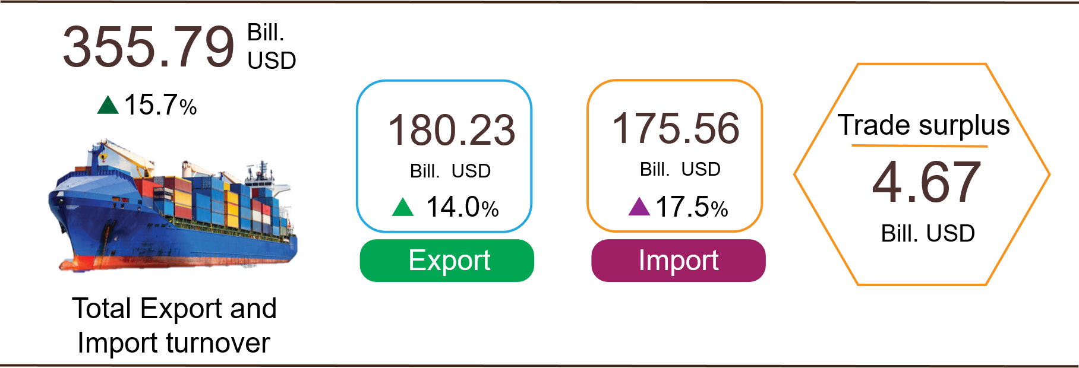

***Export of goods***

Export turnover of goods in April 2025 reached 37.45 billion USD [19].

Export turnover of goods in May 2025reached 39.6 billion USD, going up by 5.7% over the previous month. Of which, the domestic economic sector gained 8.61 billion USD, decreased by 26.1%; the FDI sector (including crude oil) reached 30.99 billion USD, increased by 20.1%. Compared to the same period last year, the export turnover of goods in May increased by 17.0%, of which the domestic economic sector decreased by 10.1%, the FDI sector (including crude oil) increased by 27.7%.

Generally, export turnover of goods in the first five months of 2025 reached 180.23 billion USD, increased by 14.0% over the same period last year. Of which, the domestic economic sector was 49.62 billion USD, went up by 12.5%, accounted for 27.5% of the total export turnover; the FDI sector (including crude oil) attained 130.61 billion USD, increased by 14.5%, shared 72.5%.

In the first five months of 2025, there were 25 products with export value of over 1 billion USD, contributing 90.0% to the total export turnover (7 products with export turnover of over 5 billion USD, accounting for 67.3%).

**Table 4. Value of some export products in the first 5 months of 2025**

|  |  |  |
| --- | --- | --- |
|  | Value  *(Mill. USD)* | Growth rate compare to  the same period last year *(%)* |
| **Products with a value of over 5 billion USD** |  |  |
| Electronic goods, computers and their parts | 38,415 | 39.7 |
| Phones all of kinds and their parts | 22,405 | -0.01 |
| Machinery, instrument, accessory | 22,085 | 16.4 |
| Textiles and sewing products | 15,059 | 12.0 |
| Footwear | 9,756 | 11.5 |
| Wood and wooden products | 6,807 | 8.6 |
| Transport and equipment | 6,705 | 8.6 |

*Regarding the structure of exported goods in the first five months of 2025,* the group of manufactured products reached 158.93 billion USD, accounting for 88.2%; the group of agricultural and forestry products reached 15.88 billion USD, accounting for 8.8%; the group of fishery products reached 4.21 billion USD, accounting for 2.3%; the group of fuels and minerals reached 1.21 billion USD, accounting for 0.7%.

**Figure 12. Structure of exported goods**

**in the first 5 months of 2025**



***Import of goods***

Import turnover of goods in April 2025 reached 36.87 billion USD[20].

Import turnover of goods in May 2025reached 39.04 billion USD, increased by 5.9% over the previous month. Of which the domestic economic sector gained 10.86 billion USD, decreased by 25.0%; the FDI sector reached 28.19 billion USD, increased by 25.9%. Compared to the same period last year, the import turnover of goods in May increased by 14.1%, of which the domestic economic sector decreased by 13.8%; the FDI sector increased by 30.4%.

Generally*,* the import turnover of goods in the first five months of 2025 reached 175.56 billion USD, increased by 17.5% over the same period last year. Of which the domestic economic sector reached 62.04 billion USD, went up by 12.9%; the FDI sector gained 113.52 billion USD, rose by 20.2%.

In the first five months of 2025, there were 29 imported products with a value of over 1 billion USD, accounting for 86.9% of the total import turnover (there were 4 products with import turnover of over 5 billion USD, accounting for 51.6%).

**Table 5. Value of some imported goods in the first 5 months of 2025**

|  |  |  |
| --- | --- | --- |
|  | Value  *(Mill. USD)* | Growth rate compare to  the same period last year *(%)* |

|  |  |  |  |
| --- | --- | --- | --- |
| **Products with a value of over 5 billion USD** | |  |  |
|  | Electronic goods, computers and their parts | 56,194 | 38.3 |
|  | Machinery, instrument, accessory | 22,896 | 22.7 |
|  | Textile fabrics | 6,322 | 4.6 |
|  | Plastic | 5,172 | 12.3 |

*Regarding the structure of imported goods in the first five months of 2025,* the group of capital goods reached 164.75 billion USD, accounted for 93.8%, of which the group of machinery, instrument, and accessory accounted for 51.2%; fuels, raw materials accounted for 42.6%. The group of consumer goods attained 10.81 billion USD, accounted for 6.2%.

**Figure 13. Structure of imported goods**

**in the first 5 months of 2025**



*Regarding the export and import market of goods in the first five months of 2025,* the United States was the Viet Nam's largest export market with a turnover of 57.2 billion USD. China remained the largest import market of Viet Nam with a turnover of 69.4 billion USD. In the first five months of 2025, the trade surplus to the United States reached 49.9 billion USD, going up by 28.5% over the same period last year; the trade surplus to the EU gained 16.3 billion USD, rising by 16.0%; the trade surplus to Japan was 0.9 billion USD, going up by 74.8%; the trade deficit from China was 45.9 billion USD, went up by 40.3%; the trade deficit from South Korea was 12.3 billion USD, went up by 5.7%; the trade deficit from ASEAN was 6.5 billion USD, increased by 66.3%.

**Figure 19. Major commodity export and import markets in the first 5 months of 2025**

|  |  |  |  |  |  |
| --- | --- | --- | --- | --- | --- |
|  | | |  | | |
|  |  | **Export of goods** | **Import of goods** |  |

According to preliminary data*,* the trade surplus in April was 0.58 billion USD[21]; the trade surplus in the first four months was 4.11 billion USD; the trade surplus in May was 0.56 billion USD. Generally, in the first five months of 2025, the trade balance of goods had a trade surplus of 4.67 billion USD (the trade surplus in the same period last year was 8.71 billion USD). Of which, the domestic economic sector had a trade deficit of 12.42 billion USD; the FDI sector (including crude oil) had a trade surplus of 17.09 billion USD.

***c) Consumer price index, gold price index and USD price index***

*A month-on-month increase of 0.16% in consumer price index (CPI) in May 2025 was mainly due to an increases in the prices of rental house, housing maintenance materials, electricity and eating out. The CPI in May increased by 1.53% and 3.24% compared to that in December 2024 and the same period last year, respectively.*

*On average, in the first five months of 2025, the CPI increased by 3.21% compared to that in the same period last year; core inflation rose by 3.10%.*

**Figure 15. Month-on-month CPI growth rate in May 2025**

In May 2025, among a month-on-month increase of the 0.16% in the CPI, ten groups of goods and services saw a rise in their price indices, while only the transport group experineced a decrease in its price index."

(1) Ten groups of goods and services with an increase in the price index were as follows:

*- The group of housing, electricity, water, fuel and construction materials* increased by 0.73% (impact on the increase of 0.14 percentage points in overall CPI), mainly due to a rise in the prices of the following items: Prices of housing maintenance materials; rental house; household electricity; tap water increased by 1.20%; 0.64%; 0.84%; household 1.0%[22], respectively. In contrast, the price of kerosene fell by 3.09% due to the impact of price adjustments during the month.

*- The group of other consumer goods and services* jumped up 0.43%, mainly concentrated in some items: the rise of 10.64% in Jewelry group in accordance with the increase in the prices of domestic and world gold; body care products; handbags, suitcases, wallets; watch and jewelry repair; wedding services climbed up 0.52%; 0.48%; 0.40%; 0.17%, respectively.

*- The group of culture, entertainment and tourism* rose by 0.28%. Of which, package tourism added up 1.09% (the expansion of 1.24%; 0.67% in domestic and international tourism, respectively) due to the sharp increase in tourism demand during holidays and preparation for the peak summer season. Hhotels; guest houses; sports venue rental tickets; sports equipment edged up 1.36%; 0.50%; 0.51%; 0.15%, respectively. On the contrary, the prices of ornamental plants and flowers; musical instruments reduced by 1.61%; 0.02%, respectively.

*- The group of post and telecommunications* increased by 0.21%. Of which, prices of regular mobile phones; accessories for smart phones and tablets; smart phones and tablets; phone repairs accelerated by 0.68%; 0.51%; 0.28%; 0.31%, respectively as the result of the increase again in the purchase demand for technology equipment with promotional programs; the soar in labor costs and price of replacement parts.

*- The group of household equipment and goods* increased by 0.19%. Of which, washing machine repair; air conditioner repair; refrigerator repair surged up 0.64%; 0.40%; 0.37%, respectively stem from the beginning of the hot season, while the cost of components and maintenance services also saw an increase. The price of thermos; soap bar, shower gel and shampoo; plastic utensils; electric fans went up 0.48%; 0.45%; 0.39%; 0.36%, respectively.

*- The group of beverage and cigarette* rose by 0.14% because of the increase in cost of production and consumer demand, of which carbonated soft drink; energy drinks in bottle, can, and box expanded by 0.49%; 0.17%, respectively. Prices of cigarettes and beer of all kinds added up 0.18% and 0.10% respectively compared to that in the previous month.

*- The group of garment, hat and footwear* increased by 0.05%. Of which, the price index of footwear services; hats, caps, and raincoats; garment services; fabrics of all kinds; other garments such as gloves and socks of all kinds surged up 0.40%; 0.52%; 0.33%; 0.12%; 0.04%, respectively.

*- The group of food and foodstuff services* rose by 0.03%, of which: groups of food and foodstuff dropped 0.18%[23]; 0.04%[24], respectively; meals and drinking out went up 0.28%[25].

*- The group of medicines and health care services* increased by 0.02%, focusing on the group of medical equipment such as fever-reducing bags, blood pressure monitors, medical cotton/bandages... With an upturn of 0.25% because of an increase in costs of production and people's needs for health care. The prices of pain relievers, fever reducers, non-steroidal anti-inflammatory drugs and drugs for gout and bone diseases; anti-allergy drugs and hypersensitivity drugs; and drugs affecting the respiratory tract climbed up 0.18%; 0.15%; 0.11%, respectively.

*The group of education* increased by 0.01%. Of which, the prices of stationery soared by 0.12%, specifically: an expansion of 0.24%; 0.17%; 0.11% in pens of all kinds; stationery and other school supplies; paper products, respectively.

(2) *The group of transport only experienced a* decrease of 0.42%, mainly due to a decline of 2.33% in the price index of diesel; a reduction of 1.20% in the price index of gasoline resulted from the impact of the adjustments of domestic gasoline price in line with the prices of world gasoline. On the contrary, some commodity groups recorded an increase in price: an upturn 0.36% in prices of vehicle maintenance group; the rise of 0.89%; 0.22%; 0.16% in the price of passenger transport by waterway; by bus; by road, respectively; the jump of 0.24%; 0.25% in the prices of car wash and tire pumping services; spare parts group respectively.

Core inflation[26] in May 2025 increased by 0.33% and 3.33% compared to that in the previous month and the same period of last year. On average, in the first five months of 2025, the year-on-year increase of 3.10% in core inflation was lower than the rise of 3.21% in average CPI, mainly due to the prices of food, foodstuffs, electricity, and health care services which were factors causing an increase in the CPI. However, the groups of commodities were excluded from the list of core inflation calculations.

Domestic gold price fluctuated in the same direction as world gold price. As of May 28, 2025, the average price of world gold was at 3,305.71 USD/ounce, a rise of 2.66% compared to that in April 2025. Global political instability and concerns about the trade war escalation between the US and China made investors seek gold as a safe haven asset. Domestically, the gold price index in May 2025 surged up 10.47%; 45.95%; 35.25% compared to that in the previous month; the same period last year; December 2024, respectively; on average in the first five months of 2025, the gold price index rocketed by 35.37%.

The domestic USD price fluctuates in the opposite direction to the world price. As of May 28, 2025, the USD price index in the international market reached 99.94 points, a decline of 0.82% compared to that in the previous month as investors expected the US Federal Reserve (FED) to cut interest rates after the US economy showed signs of weakness and reducing inflation. Domestically, the average price of USD in the free market was around 26,147 VND/USD, a month-on-month rise of 0.68% was due to increasing demand for foreign currency for import payments. The USD price index in May 2025 climbed by 2.69%; 2.59% compared to that in the same period of last year; December 2024, respectively; the average in the first five months of 2025 edged up 3.35%.

**d) Transport**

*Transport activities in May 2025 continued to be vibrant, meeting demands for travel and tourism of domestic people as well as international visitors to Viet Nam, serving production, import and export of goods. In May 2025, passengers carried and passenger traffic saw year-on-year increase of 17.9%; 17.4%, respectively; freight carried and freight traffic recorded year-on-year rise of 14.6%; 14.1%, respectively*

*Overall, in the first five months of 2025, passengers carried and passengers traffic jumped up 16.1% and 13.2%, respectively; freight carried and and freight traffic climbed up 14.6% and 12.1% compared to that in the same period last year.*

*Passenger carried* in May 2025 was estimated at 429.2 million turns of passengers, a month-on-month decrease of 1.1% and turns of passengers was 25.1 billion passengers-kilometers, an increase of 2.6%. Overall, in the first five months of 2025, passengers carried was estimated at 2,255.2 million turns of passengers, a year-on-year rise of 16.1% and passengers traffic reached 125.5 billion passengers-kilometers, a year-on-year growth of 13.2%.

Of which, domestic passenger carried reached 2,247.0 million turns of passengers, a year-on-year increase of 14.2%, and domestic passengers traffic was 99.2 billion passengers-kilometers, a year-on-year upturn of 14.2%; oversea passengers carriedreached 8.2 million turns of passengers, a year-on-year expansion of 9.5% and overseas passengers traffic reached 26.3 billion passengers-kilometers, a year-on-year rise of 9.4%.

**Table 6: Passenger transport in the first five months of 2025   
by types of transport**

|  |  |  |  |  |
| --- | --- | --- | --- | --- |
|  | Number of passengers | | Year-on-year growth rate (%) | |
|  | Carried (Mill. persons) | Traffic (Bill. persons-km) | Carried | Traffic |
| **Total** | **2,255.2** | **125.5** | **16.1** | **13.2** |
| Rail way[27] | 15.6 | 1.3 | 106.6 | 15.7 |
| Sea way[28] | 5.1 | 0.3 | -18.7 | -8.4 |
| Inland water way | 182.5 | 3.4 | 16.4 | 18.4 |
| Road | 2,028.6 | 80.8 | 15.9 | 15.2 |
| Airway | 23.4 | 39.7 | 9.0 | 9.1 |

*Freight carried* in May 2025 was estimated at 247.7 million tons of, a month-on-month increase of 2.9% and freight traffic reached 48.8 billion tons-kilometres, a month-on-month upturn of 0.6%. Overall, in the first five months of 2025, freight carried was estimated at 1,196.2 million tons, a year-on-year rise of 14.6% and freight traffic reached 237.6 billion tons.km of, a year-on-year increase of 12.1%. Of which, domestic freight carried reached 1,174.8 million tons of, an upturn of 14.7% and 136.1 billion tons-kilometres, a rise of 5.3%; overseas freight carried reached 21.4 million tons, an increase of 10.8% and freight traffic was 101.5 billion tons-kilometres , a rise of 22.8%.

**Table 7. Freight carriage in the first five months of 2025  
by types of transport**

|  |  |  |  |  |
| --- | --- | --- | --- | --- |
|  | Quantity of goods | | Year-on-year growth rate (%) | |
|  | Carried  (Mill. tons) | Traffic (Bill. tons-km) | Carried | Traffic |
| **Total** | **1,196.2** | **237.6** | **14.6** | **12.1** |
| Rail way | 2.2 | 1.6 | 5.7 | 6.5 |
| Sea way | 59.5 | 130.0 | 12.0 | 16.8 |
| Inland water way | 253.6 | 49.7 | 13.9 | 8.2 |
| Road | 880.7 | 52.2 | 15.0 | 6.5 |
| Airway | 0.2 | 4.1 | 8.2 | -2.9[29] |

***đ) International visitors to Viet Nam***

*Favorable visa policies, enhanced tourism promotion programs, and prestigious tourism awards, celebration activities of important national holidays attracted increasing numbers of international visitors to Viet Nam.*

The number of international visitors to Viet Nam in May 2025[30] reached 1.53 million, a month-on-month decrease of 7.6%, and a rise of 10.5% over the same period last year. In the first five months of 2025, international visitors to our country reached 9.2 million arrivals, a year-on-year rise of 21.3%. Of which, arrivals by air reached nearly 7.84 million arrivals, accounted for 85.2% of international arrivals to Viet Nam and increased by 23.6% over the same period last year; by road reached 1.18 million arrivals, comprised 12.9% and spread 10%; by sea reached 175.4 thousand arrivals, made up 1.9% and increased by 8.0%.

**Figure 16. International visitors to Viet Nam in the first 5 months  
of 2025 by territories**

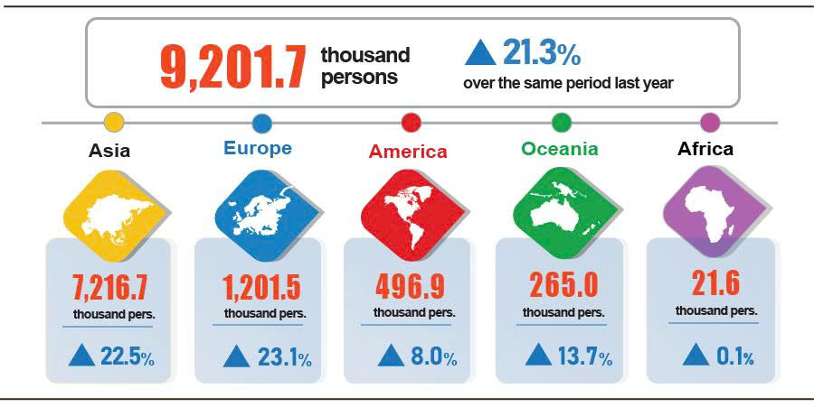

**7. Social situation**

***a) People's life***

In May, people's life continued to see improvement. According to preliminary results of the monthly Labor Force Survey, in May the proportion of surveyed households with unchanged and increased income was 97.1% compared to the figure in the same period last year (up 1 percentage point compared to that in the previous month's reporting period and up 2.3 percentage points compared to that in the same period last year); the proportion of households with decreased income was 2.9%.

In May, the households with a decrease in income compared to that in the same period of last year identified the main reasons[31] as follows: Some household members lost their jobs or temporarily quit their jobs (45.8%); the size of household production and business activities decreased (23.4%); input costs for household production and business activities increased (17.1%); and selling prices of products from household production and business activities declined (17.1%).

In the first five months of 2025, 29.6% of households reported experiencing at least one event that negatively affected their family life. Among the households negatively affected by events, 28.9% suffered from the impact of rising prices of goods and services; 2.4% of households was negatively affected by human epidemics; 1.7% of households was adversely affected by natural disasters and 1.6% of households suffered from epidemics in livestock and crops.

In the first five months of this year, 13.8% of interviewed households received assistance from various sources. Of which, 9.6%, 5.1%, 4.8%, 1.8%, 0.01% of households received assistance from relatives and friends; local programs and policies; national programs and policies; charitable activities of other organizations and individuals; and other sources, respectively.

Social security was always carried out promptly and practically by all levels and sectors. In May (up to May 28, 2025), the Government supported nearly 2 thousand tons of rice for people during the pre-harvest season the early 2025. Since the beginning of the year, the Government had provided people with 10.3 thousand tons of rice, including 6 thousand tons and 4.3 thousand tons of rice for hunger relief during Lunar New Year and the 2025 pre-harvest season for 402.6 thousand and 284.5 thousand people, respectively.

***b) Epidemic, food poisoning***

According to the report of the Ministry of Health, during the month (from April 18 to May 17, 2025), there were 19.3 thousand cases of rash fever suspected of measles (01 death); 4,650 cases of hand, foot and mouth disease; 1,052 cases of dengue fever (02 deaths); 09 deaths from rabies; 05 cases of meningococcal meningitis; 02 cases of viral encephalitis; 01 case of influenza A nationwide. In the first five months of 2025, there were 103.4 thousand cases of rash fever suspected of measles (11 deaths); nearly 26.0 thousand cases of dengue fever (05 deaths); 18.1 thousand cases of hand, foot and mouth disease; 111 cases of viral encephalitis (01 death); 33 deaths from rabies; 21 cases of meningococcal meningitis; 01 case of influenza A in the whole country.

As of May 17, 2025, the total number of people living with HIV nationwide was 249.4 thousand people; the number of deaths from HIV/AIDS was 116.4 thousand people.

The Covid-19 epidemic was breaking out again all over the world. In Viet Nam, in May 2025, there were 199 cases nationwide, since the beginning of the year there were 279 cases, no deaths.

Regarding food poisoning, in May 2025, there were 04 cases of food poisoning, affecting 54 people (01 death). In the first five months of 2025 (from December 18, 2024 to May 17, 2025), there were 26 of food poisoning nationwide, affecting 347 people (10 deaths).

***c) Culture and sports***

Culturally, the 2025 United Nations Day of Vesak - the largest cultural, spiritual and academic event of global Buddhism officially took place at the Viet Nam Buddhist Academy from May 6-8, 2025 in Ho Chi Minh City. On the occasion of the 135th anniversary of President Ho Chi Minh's birthday (May 19, 1890 - May 19, 2025), the Ministry of Culture, Sports and Tourism and a number of localities organized many meaningful cultural activities to commemorate the merits of President Ho Chi Minh[32].

Regarding the mass sports movement, in May, many exciting mass sports events took place across the country, attracting a large number of people and athletes.[33]

Regarding elite sports, Viet Nam organized or dispatched teams to participate in a number of sports activities taking place in May [34], including: The Vietnamese athletics team participated in the 2025 Hong Kong Open Athletics Championship taking place on May 10-11, 2025 and won 04 gold medals; The Vietnamese Canoeing team achieved outstanding performances including 01 gold medal, 04 silver medals and 01 bronze medal, ranked 3rd overall at the 2025 Asian Canoe Championship taking place in China from May 8-10, 2025.

***d) Traffic accident[35]***

In May (from April 26 to May 25, 2025), there were 1,468 traffic accidents nationwide, causing 850 deaths and 991 injuries. The number of traffic accidents, the number of deaths, the number of injuries decreased by 7.4%, 4.0%, and 8.2%, respectively compared to that in April 2025. The number of traffic accidents, the number of deaths, the number of injuries saw year-on-year decreases of 24.2%, 5.5% and 29.5%, respectively.

In the first five months of 2025, there were 7,589 traffic accidents nationwide, causing 4,212 deaths and 5,150 injuries. The number of traffic accidents, the number of deaths, the number of injuries decreased by 27.4%, 7.8%, 35.9%, compared to that in the same period last year. On average, 50 traffic accidents occurred a day in in the first five months of 2025 nationwide, causing 28 deaths and 34 injuries.

***d) Damage caused by natural disaster[36]***

In May, damage caused by natural disasters was mainly due to the impact of rain and floods, causing 25 deaths and 23 injuries; more than 8.9 thousand hectares of rice and crops were flooded and damaged; 20.1 thousand livestock and poultry killed; nearly 2.5 thousand houses collapsed, swept away and damaged; the total value of property loss caused by natural disasters in the month was 279.8 billion VND, a year-on-year decrease of 69.3%. In the first five months of this year, natural disasters caused 40 deaths and missing people, 38 injuries; 20.5 thousand hectares of rice and crops were damaged; 3.4 thousand houses collapsed, swept away and damaged; the total value of property damage was estimated at 433.3 billion VND, down 68.6% compared to that in the same period in 2024.

***e) Environmental protection, fire and explosion prevention***

In May (from April 18 to May 17, 2025)[37], 1,279 environmental violations in 48 out of 63 localities[38] were detected by the authorities, of which 1,152 cases were addressed with a total fine of 16.3 billion VND, up 31.4% compared to figure in the previous month and down 15.4% compared to that in the same period last year. In the first five months of this year, authorities detected 7,512 environmental violations, of which 6,769 cases were addressed with a total fine of 99.2 billion VND, a year-on-year reduction of 24.0%.

During the monthly period (from April 15 to May 14, 2025) [39], there were 267 fire and explosion incidents nationwide, causing 8 deaths and 15 injuries with an estimated losses of 23.6 billion VND, down 84.8% compared to the previous month and a year-on-year reduction of 11.2%. In the first five months of this year, there were 1,508 fire and explosion incidents nationwide, causing 44 deaths and 53 injuries, with an estimated losses of 229.1 billion VND, a year-on-year increase of 96.0%./.

**NATIONAL STATISTICS OFFICE OF VIETNAM**

1. Nam Dinh, Ninh Binh, Cao Bang, Bac Kan, Lang Son, Tuyen Quang, Yen Bai, Phu Tho, Quang Ninh, Lai Chau, Dien Bien, Son La, Hoa Binh, Quang Binh, Khanh Hoa, Gia Lai, Binh Phuoc and Bac Lieu.
2. Nam Dinh, Ninh Binh, Cao Bang, Bac Kan, Lang Son, Tuyen Quang, Yen Bai, Phu Tho, Quang Ninh, Lai Chau, Dien Bien, Son La, Hoa Binh, Quang Binh, Khanh Hoa, Gia Lai, Binh Phuoc, and Bac Lieu.
3. Some localities have increased concentrated newly planted forest areas: Quang Ninh increased 2.7 times compared to the same period last year; Lao Cai increased 62.5%; Ha Giang increased 48.7%; Quang Ngai increased 30.3%; Phu Tho increased 29.1%.
4. Some localities with high increases in exploited wood output include: Quang Tri increased by 35.5% over the same period last year; Quang Binh increased by 23.4%; Quang Ngai increased by 15.1%; Nghe An increased by 12.9%.
5. According to the Ministry of Agriculture and Environment, as of 15/5/2025.
6. Source: Compiled from reports of the Statistics Offices: The price of raw pangasius fish in the Mekong Delta, weighing 0.7-1.0 kg/fish, remained at VND 30,500/kg - VND 31,200/kg, an increase of about VND 3,000/kg compared to the same period in 2024.
7. Source: Compiled from reports of the Statistical Offices: The price of white-leg shrimp in the Mekong Delta remains at 150,000 - 160,000 VND/kg for 60-80 shrimp/kg.
8. The IIP in May 2024 decreased by 10.0% year- on –year.
9. The growth/decrease rate of the IIP index in April 2025 compared to the previous month for some provinces with large industrial scale: Bac Ninh increased by 14.1%; Ba Ria - Vung Tau increased by 11.1%; Quang Ninh increased by 5.5%; Dong Nai increased by 5.2%; Ho Chi Minh City increased by 5.1%; Binh Duong increased by 5.0%; Quang Ngai increased by 3.0%; Da Nang increased by 2.7%; Bac Giang increased by 2.1%; Hai Duong increased by 1.7%; Vinh Long increased by 1.3%; Hai Phong decreased by 4.3%.
10. The local index of industrial production for the manufacturing in the first months of 2025 increased significantly compared to the same period last year: Phu Tho increased by 46.7%; Nam Dinh increased by 29.6%; Bac Giang increased by 28.1%; Bac Kan increased by 23.6%; Ha Nam increased by 22.5%; Quang Ngai increased by 22.2%. The localities with high production indices for the electricity generation and distribution sector saw notable increases: Hoa Binh increased by 53.6%; Hue increased by 39.6%; Son La increased by 30.5%; Quang Ngai increased by 20.3%; Ha Nam increased by 14.1%.
11. Localities witnessed a slight increase or even decrease in the IIP in the manufacturing in the first five months of 2025 compared to the same period last year: Ha Tinh increased by 3.3%; Cao Bang decreased by 14.2%. Localities with a decrease in the electricity production and distribution index in the first five months of 2025 compared to the same period last year: Ba Ria - Vung Tau decreased by 55.3%; Khanh Hoa decreased by 9.3%; Bac Lieu decreased by 7.8%; Cao Bang decreased by 3.3%; Binh Thuan and Lang Son both decreased by 1.7%; Lao Cai decreased by 1.5%. The locality with a slight increase or decrease in the IIP in the mining in the first five months of 2025 compared to the same period last year: Binh Thuan increased by 1.3%; Hanoi decreased by 9.9%; Ba Ria - Vung Tau decreased by 9.6%.
12. Source: National Business Registration Information System, Department of Private Enterprise and Collective Economy Development, Ministry of Finance, received June 01st, 2025. Implementing Decree No. 62/2024/ND-CP dated June 07th, 2024 of the Government (effective from August 01st, 2024), the data period on business registration in the month is calculated from the 1st day to the last day of the reporting month. Particularly for time indicators (enterprises returning to operations, enterprises temporarily suspending business for a limited period of time, enterprises temporarily suspending operations awaiting dissolution procedures), the data period is the months before the time. August 01st, 2024 is calculated from the 21st day of the month preceding the reporting month to the 20th day of the reporting month.
13. According to the report of the Foreign Investment Department, Ministry of Finance, received on June 3, 2025.
14. According to Report No. 209 /BC-BTC dated May 28, 2025 of the Ministry of Finance.
15. The domestic revenue results were relatively good compared to the estimate and increased compared to the same period last year thanks to the timely issuance and focused implementation of policies to reduce and extend taxes, fees, and charges to support businesses and people to overcome difficulties in production and business activities, creating revenue for the State budget. At the same time, digital transformation and application of information technology in tax management and collection were promoted; collection management was strengthened, revenue loss was prevented, and tax arrears were handled.
16. The value of export turnover is calculated at F.O.B price and import turnover is calculated at C.I.F price (including transportation and insurance costs of imported goods).
17. The preliminary data of export and import of goods in May 2025 were provided by the Viet Nam Customs on June 3rd, 2025.
18. Total import and export turnover of goods in the first five months of 2024 reached 307.57 billion USD, going up by 17.4% over the same period last year, of which export reached 158.14 billion USD, rising by 16.2%; import reached 149.43 billion USD, growing by 18.7%.
19. The same as the data sent by the Viet Nam Customs to the National Statistics Office of Viet Nam on May 5th, 2025.
20. The same as the data sent by the Viet Nam Customs to the National Statistics Office of Viet Nam on May 5th, 2025.
21. The same as the data sent by the Viet Nam Customs to the National Statistics Office of Viet Nam on May 5th, 2025.
22. The electricity and tap water price index in May 2025 reflected fluctuations of one month latency compared to other commodities because of their calculation based on revenue and consumption output of April 2025.
23. The prices of rice decreased thank to abundant supply and stable demand for domestic consumption, while the decline in export the prices of rice affecting the prices of domestic rice. Accordingly, the price index of the rice group decreased by 0.28% (Regular rice; premium rice fell by 0.33%; 0.19%, respectively and sticky rice edged up 0.22%). The price index of some other food items reduced such as: the prices of potato; corn shrunk by 1.07%; 0.89%, respectively. On the contrary, the prices of cassava; glass noodle; corn flour; noodles, instant noodles, pho/porridge and bread; vermicelli, pho noodles, rice crackers jumped up 0.43%; 0.24%; 0.23%; 0.16%; 0.09%, respectively.
24. The price indices of pork, poultry, egg, fresh and processed fruit declined by 0.32%; 0.05%; 0.56%; 1.03%, respectively. On the contrary, some goods witnessed an increase in price index: the price indices of milk, butter and cheese; spices and beans and nuts; confectionery; tea, coffee and cocoa; fish sauce and dipping sauce; fresh seafood surged up 0.40%; 0.34%; 0.27%; 0.18%; 0.17%; 0.12%, respectively
25. The prices of drinking out; eating outside and fast food take-away went up 0.47%; 0.27%; and 0.22%, respectively due to increasing demand during the extended April 30 - May 1 holiday.
26. CPI excludes fresh food and foodstuff, energy and State-managed goods including health care services and education.
27. Supplementing passenger carried capacity with elevated rail way in Ha Noi and Metro in Ho Chi Minh City.
28. Ppassengers carried by sea way in the first five months of 2025 decreased compared to that in the same period, mainly due to unfavorable weather, causing the reduction in the number of sea way passengers, making many shipping routes suspend or reduce its operating frequency.
29. The main reason is the high transportation costs, which is why this type is not commonly chosen by businesses and customers, except for high-value items or those requiring quick delivery.
30. The reporting period was from April 26, 2025 to May 25, 2025.
31. A household could select various causes of reduction in income.
32. The Ministry of Culture, Sports and Tourism coordinated with the People's Committee of Nghe An province and other localities to organize a special exhibition with the theme "Ho Chi Minh, the most beautiful name" from May 16 to 20, 2025; a special art program "Gifts in May for Uncle Ho" ​​at the Hanoi Opera House on May 14, 2025; a special art program "He is Ho Chi Minh" at Ba Dinh Square on May 18, 2025; Ho Chi Minh Museum organized the opening of the exhibition "Simple but Noble Examples"; Ho Chi Minh City Museum organized the opening of the thematic exhibition "Journey following Uncle Ho through stamp and postcard collections"; the book launching ceremony "Ho Chi Minh in visual arts" took place at the Viet Nam Fine Arts Museum on May 17, 2025.
33. Binh Dinh Province Badminton Club Open Tournament from May 2-4, 2025 with 17 teams; Ninh Thuan Open Cycling Tournament 2025 with more than 100 racers; " Across The Summer Waves 2025" sea swimming tournament held on May 1, 2025; Vietnam Student Sports Festival in Saint Petersburg in 2025 held from April 26-May 4, 2025 with 9 delegations of athletes; Hanoi Open Swimming Tournament for the Disabled in 2025 on May 11 with nearly 30 athletes; National Jujitsu Youth Championship 2025 from May 10-20, 2025 in Bac Ninh.
34. Viet Nam participated in the 3.3 Asian Chess Championship in Mongolia from April 23 to May 1, 2025; the 2025 Asian Athletics Championship from May 27 to 31, 2025 in Korea; the National 3x3 U20 and U23 Basketball Championship with the participation of nearly 200 athletes took place from May 6 to 11, 2025 in Hue; the 2025 IRONMAN 70.3 Vietnam Championship took place from May 9 to 11, 2025 in Da Nang; the National Youth Fencing Championship took place from May 21 to 30, 2025 in Thanh Hoa; the 2025 National Table Tennis Championship took place from May 19 to 26, 2025 in Da Nang with more than 200 athletes.
35. According to a quick report from the Office of the Ministry of Public Security and the Viet Nam Maritime and Waterways Administration (Ministry of Construction) on May 28, 2025.
36. Summarizing Reports from 63 Departments of Agriculture and Environment, reporting period from April 19 to May 18, 2025.
37. According to reports from the Provincial Department of Agriculture and Environment, data from the Provincial and Municipal Police Departments was compiled by Provincial Statistics Offices.
38. 10 localities did not detect environmental violations in April 2025: Da Nang, Khanh Hoa, Ninh Thuan, Dak Nong, Lam Dong, Tay Ninh, Dong Thap, An Giang, Hau Giang, and Soc Trang.
39. According to a quick report from the Ministry of Public Security on May 23, 2025.