|  |  |
| --- | --- |
| ­­­­MINISTRY OF FINANCE  **NATIONAL STATISTICS OFFICE OF VIETNAM**  No: 106/BC-CTK | **SOCIALIST REPUBLIC OF VIET NAM**  **Independence-Freedom-Happiness**  *Ha Noi, 6th May 2025* |

**Report on socio-economic situation   
in April and the first 4 months of 2025**

**1. Agriculture, forestry, and fishery**

*Agricultural and forestry production in April focused mainly on winter-spring crop care in the northern localities; harvesting spring rice and crops and planting summer-autumn rice in the southern localities; afforestation was carried out as planned, and timber exploitation was promoted. Pig and poultry farming developed stably, and diseases were controlled. Aquaculture and exploitation increased significantly thanks to favorable weather, lower oil prices and higher seafood prices.*

1. ***Agriculture***

*Winter-spring rice*

As of April 20, 2025, the whole country planted 2,968.0 thousand hectares of spring rice, an increase of 15.7 thousand hectares compared to the previous winter-spring crop. Northern localities planted 1,051.2 thousand hectares, a decrease of 7.9 thousand hectares, mainly due to land acquisition for construction of projects, industrial parks, and conversion of crop purposes from rice to other crops with higher economic efficiency[1]. Southern localities planted 1,916.8 thousand hectares, an increase of 23.6 thousand hectares compared to the previous winter-spring crop. Thanks to favorable weather and less affected by saline intrusion, farmers planted actively the maximum area.

Due to good care right from the time of planting, most of the winter-spring rice areas have been grown and developed well. Up to now, Southern localities have harvested 1,644.0 thousand hectares of spring rice, accounting for 85.0% of the cultivated area and equal to 99.7% compared to the same period last year, of which the Mekong Delta has harvested 1,471.3 thousand hectares, accounting for 97.6% and equal to 101.1%.

*Summer-autumn rice*

After harvested spring rice, southern localities took advantage of favorable weather to clean the fields, plow, and dry the soil to plant the summer-autumn crop. As of April 20, 2025, southern localities planted 719.9 thousand hectares of summer-autumn rice, equal to 105.1% of that in the same period last year, of which the Mekong Delta region reached 715.9 thousand hectares, equal to 105.1%. The progress of summer-autumn rice planting was faster than the same period last year because many localities harvested the spring rice crop early and followed the early planting schedule to avoid drought and salinity. In comparison to the same period last year, some localities had faster progress in summer-autumn rice planting, such as: An Giang by 122.4%; Long An by 107.7%; Dong Thap by 107.5%... However, the summer-autumn crop in the Southern, Central and Central Highlands provinces is easily affected by saltwater intrusion, heat, drought and water shortage, so localities need to apply advanced farming techniques, ensure water sources for rice, review crop structure and adjust planting times to ensure the best time frame for the next crop.

*Annual crops*

Along with rice cultivation, localities across the country are planting crops. Of which, the area of ​​some crops such as corn, peanuts, soybeans, and sweet potatoes continues to decrease compared to the same period last year, mainly due to low economic efficiency.

**Figure 1: Cultivation area of some annual crops**

(As of 20/4/2025)

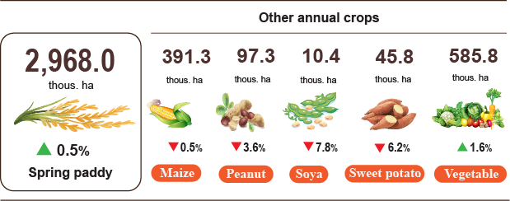

*Livestock*

Buffalo farming decreased due to low economic efficiency, long breeding cycles, making farmers uninterested in restocking their herds. Cattle farming has had tendency towards large-scale production, technology application and businesses linkages. Poultry farming has thrived with some broiler farms connecting with consumption businesses, forming a closed chain from farm to kitchen that has contributed to promotion of livestock development activities. Pig farming has developed thanks to effective control of African swine fever and a robust increase in consumption demand during holidays generating motivation farmers for restocking their herds, investment in barn upgrade, and application of biosecurity measures for improvement of productivity and product quality.

**Figure 2. The growth rate of the population of cattle and poultry at the**

**end of April 2025 compared to figure in the same time point of last year**

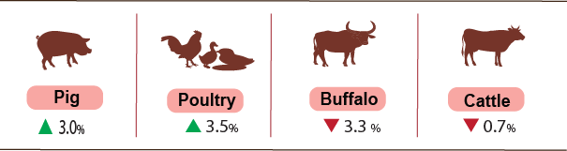

As of April 27th 2025, blue-ear disease and poulry flu were not witnessed across the country; lumpy skin disease (LSD) still remained in Quang Ngai and African swine fever persisted in Cao Bang, Lang Son, Dien Bien, Nghe An, Dak Nong, Binh Phuoc, Hau Giang and Ca Mau with outbreaks less than 21 days.

***b) Forestry***

The area of ​​newly concentrated planted forests in April 2025 was estimated at 32.2 thousand hectares, an increase of 1.1% compared to that in the same period of last year; the number of scattered forest trees reached 7.3 million trees, a decrease of 1.4%; timber production achieved 1,623,3 thousand m3, a rise of 6.6% because raw wood reached harvest time, many localities accelerated the pace of exploitation[2]. In the first four months of 2025, the area of ​​newly concentrated planted forest was estimated at 77.8 thousand ha, an expansion of 11.3% compared to that in the same period of last year; the number of scattered forest trees gained 31.5 million trees, an upturn of 3.7%; timber production was estimated at 5,951.3 thousand m3, a rise of 12.4%.

The damaged forest area in the month[3] was 251.5 hectares, an increase of 88.1% compared to that in the same period of last year, of which the area of deforested forest was 203.7 hectares, 2.7 times higher; the area of burned forest was 47.8 hectares, a decrease of 18.5%. Some localities with large areas of deforested forests included: Dak Lak 133.9 hectares ; Bac Kan 11.1 hectares ; Dien Bien, Lang Son, Ha Giang over 8.0 hectares . In the first four months of 2025, the of damaged forest area was 475.4 hectares, a jump of 22.4% over the same period of last year, of which the destroyed forest area was 393.2 hectares, a rise of 51.4%; the burned forest area was 82.2 hectares, a decline of 36.1%.

***c) Fishery***

Fishery output in April 2025 was estimated at 794.4 thousand tons, up 2.8% over the same period last year, including: Fish reached 569.7 thousand tons, up 2.6%; shrimp reached 110.3 thousand tons, up 5.4%; other aquatic products reached 114.4 thousand tons, up 1.9%.

Aquaculture output in the month was estimated at 437.8 thousand tons, up 4.7% over the same period last year, of which: Fish reached 291.8 thousand tons, up 4.4%; shrimp reached 98.3 thousand tons, up 6.0%.

Pangasius harvest output in the month increased compared to the same period last year due to the stable price of pangasius[4]. Pangasius output in the month was estimated to reach 150.8 thousand tons, up 4.2% over the same period last year.

Shrimp output in the month increased over the same period due to the increasing trend of whiteleg shrimp prices, the price of black tiger shrimp was high and stable[5]. Whiteleg shrimp output in April 2025 was estimated at 69.7 thousand tons, up 7.2% over the same period last year; black tiger shrimp output was reached at 24.5 thousand tons, up 3.4%.

The caught fishery output in the month was estimated at 356.6 thousand tons, up 0.7% over the same period last year, of which: Fish reached 277.9 thousand tons, up 0.7%; shrimp reached 12.0 thousand tons, up 0.8%, other aquatic products reached 66.7 thousand tons, up 0.8% due to favorable weather. Sea exploitation has begun in the Southern fishing season, along with the sharp decrease in oil prices compared to the same period last year, so fishermen actively went out to sea to exploit[6]. Marine fishery output was estimated at 341.9 thousand tons, up 0.7% over the same period last year, of which: Fish reached 268.8 thousand tons, up 0.7%; shrimp reached 11.2 thousand tons, up 0.9%, other aquatic products reached 61.9 thousand tons, up 0.8%.

**Figure 3. Year-on-year fishery production in the first 4 months of 2025**

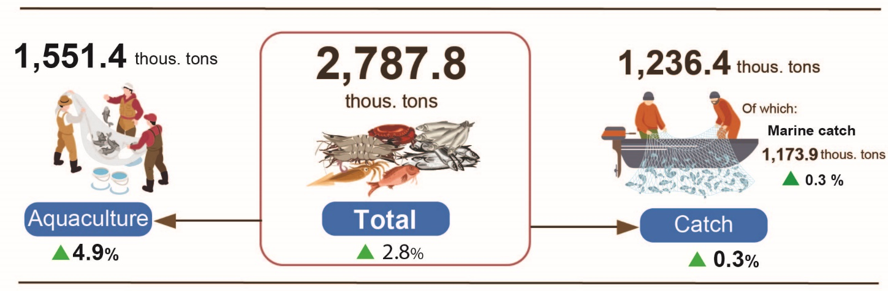

Totally for the first four months of 2025, fishery output was estimated at 2,787.8 thousand tons, up 2.8% over the same period last year, including: Fish reached 2,050.0 thousand tons, up 2.8%; shrimp reached 312.7 thousand tons, up 4.9%; other fishery products reached 425.1 thousand tons, up 1.6%.

**2. Industrial Production**

Industrial production in April sustained its upward trajectory. The overall index of industrial production was estimated to rise by 1.4% month-on-month and surged by 8.9% year-on-year[7]*.* In the first four months of 2025, the overall index of industrial production rose by 8.4% compared to the same period last year.

*In April 2025, the Index of Industrial Production (IIP)* was estimated to increase by 1.4% compared to the previous month[8] and by 8.9% year-on-year. Specifically, the manufacturing rose by 10.8% over the same period last year; the water supply, waste management, and wastewater treatment grew by 7.6%; the electricity production and distribution increased by 4.6%; whereas the mining declined by 4.2%.

For the first four months of 2025, the IIP wasestimated to grow by 8.4% compared to the same period last year (which saw a 6.3% increase in 2024). Of this, the manufacturing grew by 10.1% (compared to 6.5% in the same period of 2024), contributing 8.5 percentage points to the overall growth; the electricity production and distribution increased by 5.1% (compared to a 13.0% rise in 2024), contributing 0.5 percentage points; the water supply, waste management, and wastewater treatment rose by 10.2% (compared to as 6.0% increase in 2024), contributing 0.1 percentage points; while the mining declined by 4.5% (compared to a 4.1% drop in 2024), subtracted 0.7 percentage points from the overall growth.

*The IIP of several key 2-digit activities in the first four months of 2025 showed a year-on-year growth as follows*: Manufacture of motor vehicles rose by 35.1%; manufacture of leather and related products increased by 16.7%; Manufacture of rubber and plastics products grew by 16.4%; manufacture of wearing apparel grew by 15.7%; manufacture of wood and products of wood and cork increased by 15.2%; manufacture of coke and refined petroleum products grew by 14.1%; textiles increased by 10.5%; fabricated metal products (except machinery and equipment) went up by 10.0%; manufacture of electronic, computer and optical products expanded by 9.8%; manufacture of food products grew by 9.1%; manufacture of chemicals and chemical products increased by 6.0%; and electricity, gas, steam, and air conditioning supply jumped by 5.1%. Conversely, the IIP for some activities witnessed a year-on-year decrease as follows: Extraction of crude petroleum and natural gas declined by 10.9%; manufacture of electrical equipment dropped by 6.2% and manufacture of beverages went down by 0.1%.

**Figure 2. Year-on-year IIP growth rate for 4 months in the period of 2021 - 2025 for several key industrial activities**  %

|  | **2021** | **2022** | **2023** | **2024** | **2025** |
| --- | --- | --- | --- | --- | --- |
|  |  |  |  |  |  |
| Extraction of crude petroleum and natural | -9.9 | -1.0 | -3.8 | -9.4 | -10.9 |
| Manufacture of food products | 6.3 | 6.4 | 2.9 | 5.2 | 9.1 |
| Manufacture of beverages | 16.9 | 7.3 | 8.9 | -1.1 | -0.1 |
| Textiles | 7.6 | 5.0 | -5.6 | 14.0 | 10.5 |
| Manufacture of wearing apparel | 8.1 | 20.7 | -8.9 | 4.4 | 15.7 |
| Manufacture of leather and related products | 9.6 | 12.2 | -2.9 | 6.7 | 16.7 |
| Manufacture of wood and products of wood, bamboo, and schizostachyum aciculare | 3.6 | 3.3 | -2.3 | 8.5 | 15.2 |
| Manufacture of coke and refined petroleum | -2.5 | -5.2 | 15.6 | 4.3 | 14.1 |
| Manufacture of chemicals and Chemical products | 3.5 | 4.5 | 1.8 | 23.9 | 6.0 |
| Manufacture of rubber and plastics products | 12.5 | -14.6 | 6.2 | 28.3 | 16.4 |
| Fabricated metal products (excluding machinery and equipment) | 10.5 | 11.6 | 1.9 | 9.4 | 10.0 |
| Manufacture of computer, Electronic and optical products | 14.6 | 10.4 | -5.0 | 3.2 | 9.8 |
| manufacture of electrical equipment | 13.3 | 22.5 | -4.2 | 25.3 | -6.2 |
| Manufacture of motor vehicles | 31.8 | 2.3 | -9.6 | 2.9 | 35.1 |
| Electricity, gas, steam, and air conditioning supply | 7.4 | 7.0 | -0.2 | 13.0 | 5.1 |

The index of industrial production (IIP) for the first four months of 2025 increased in 62 provinces, excepting for Ba Ria-Vung Tau where IIP decreased by 3.2%. Some localities experienced significant IIP growth, driven by the manufacturing, as well as a high increase in the production and distribution of electricity[9]. Conversely, several localities saw lower or negative IIP growth due to the sluggish performance in the manufacturing, the mining, and the low or negative growth in the electricity production and distribution[10].

**Figure 4. Year-on-year IIP growth rate in the first 4 months 2025 for several localities (%).**

|  |  |
| --- | --- |
| **The 10 localities with the highest IIP growth rate.** | **The 10 localities with the lowest IIP growth or a decline.** |

*Some key industrial products in the first 4 months of 2025 witnessed a year-on-year increase as follows*: Cars 76.9%; televisions 27.7%; liquefied petroleum gas (LPG) 23.2%; NPK mixed fertilizers 18.5%; fabrics woven from natural fibers 16.6%; clothes 15.0%; leather footgear 9.8%; rolled steel 9.4%; rebar and angle steel 9.3%; cement 9.2%; and aquatic feed 8.4%. Conversely, some products saw a year-on-year decrease: natural gas (in the form of air) decreased by 14.0%; extracted crude oil 7.6%.

*The number of workers in the industrial enterprises as of April 1, 2025* saw a month-on-month growth of 0.7% and a year-on-year increase of 5.1%. Of which, the number of workers in the state-owned enterprises remained unchanged compared to the previous monthand increased by 0.5% compared to the same period last year; the figure in the non-state-owned enterprises grew by 0.8% and 3.9%, respectively and in the FDI enterprises rose by 0.8% and 5.9%, respectively. By activities, the number of workers in the mining remained unchanged compared to the previous month and decreased by 0,3% compared to the same period last year; the manufacturing increased by 0.8% and 5.5% respectively; the production and distribution of electricity, gas, hot water, steam, and air conditioning saw no month-on-month change and a year-on-yearincrease of 0.2%; the water supply, waste management, and wastewater treatment witnessed month-on-month decline of 0.1% and a year-on-year growth of 1.2%.

**3. Enterprise activities[11]**

In April, the whole country had more than 15.2 thousand newly established enterprises with registered capital of over 133.6 trillion VND and a total number of registered employees of 127.6 thousand employees, a decrease of 2.5% in the number of enterprises, an increase of 5.8% in registered capital and an increase of 45.8% in the number of employees compared to March 2025. Compared to the same period of last year, the number of enterprises and the number of employees went up 7.4% and 51.5%, respectively butin the registered capital went down 23.5% in. The average registered capital of a newly established enterprise in the month reached 8.8 billion VND, a month-on-month increase of 8.5% and a year-on-year reduction of 28.8%. Besides, there were 9.0 thousand resumed enterprises in the whole country, a month-on-month decrease of 1.2% and a year-on-year increase of 8.5%.

Generally, in the first four months of 2025, the whole country had more than 51.6 thousand newly registered enterprises with a total registered capital of 490.4 trillion VND and the total number of registered employees of 355.8 thousand ones, down 0.9% in the number of enterprises, down 6.9% in the registered capital and up 1.2% in the number of employees against 2024. The average registered capital of a newly established enterprise in the first four months of 2025 achieved 9.5 billion VND, a year-on-year decrease of 6.1%. The total amount of additional registered capital into the economy in the first four months was 1,794.4 trillion VND, an increase of 91.3% against 2024[12]. Besides, there were 38.3 thousand resumed enterprises (up 29.0% over the same period of 2024), bringing the total number of newly-established enterprises and resumed enterprises in the first four months of 2025 to over 89.9 thousand ones, a year-on-year increase of 9.9%. On average there were nearly 22.5 thousand newly established and resumed enterprises per month.

By economic sector in the first four months of 2025, there were 496 newly-established enterprises in the agricultural, forestry, and fishery sector, a year-on-year decrease of 0.8%; nearly 12.1 thousand enterprises in the industry and construction sector, a decrease of 4.4%; nearly 39.1 thousand enterprises in the service sector, an increase of 0.2%.

In April, 7,184 enterprises registered for temporary suspension of operation for a specific period, up 63.6% compared to the previous month and down 5.7% against 2024; 8,989 enterprises temporarily inactive and awaited dissolution procedures, an increase of 83.5% and up 93.1%; 1,750 enterprises completed dissolution procedures, down 18.1% and up 37.4%, respectively.

**Figure 5. Enterprise registration performance**

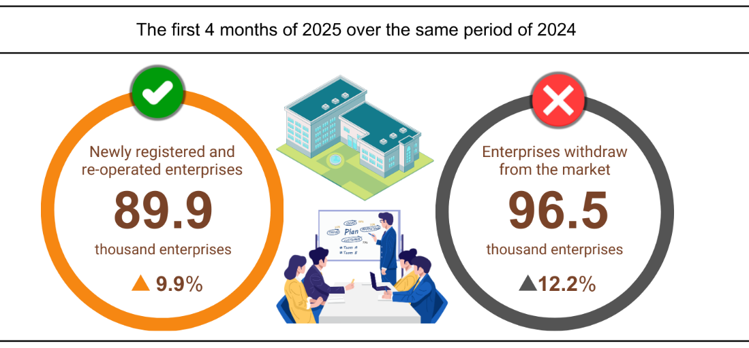

In the first four months of 2025, there were more than 68.7 thousand enterprises registered for temporarily shutdown for a specific period, an increase of 12.9% against 2024; nearly 20.2 thousand enterprises temporarily suspended awaiting for dissolution procedures, an increase of 5.7%; more than 7.6 thousand completely dissolved enterprises, up 26.1%. On average, over 24.1 thousand enterprises withdrew from the market per month.

**Table 3: Newly registered and dissolved enterprises in the first four months of 2025 by kinds of activity**

|  |  |  |  |  |
| --- | --- | --- | --- | --- |
|  | Number of enterprises (Enterprise) | | Year-on-Year  Growth rate (%) | |
| Newly registered | Dissolution | Newly registered | Dissolution |
| Wholesale and retail trade; repair of motor vehicles and motorcycles | 18,341 | 2,828 | -12.2 | 23.1 |
| Manufacturing | 6,648 | 818 | 4.3 | 25.7 |
| Construction | 4,843 | 550 | -14.8 | 19.8 |
| Real estate business | 1,582 | 440 | 15.1 | 14.0 |
| Transportation and storage | 2,764 | 309 | 3.1 | 35.5 |
| Accommodation and catering service | 1,589 | 390 | -18.2 | 42.3 |
| Production and distribution of electricity, water, gas | 396 | 103 | 6.7 | 33.8 |

**4. Investment**

*Investment capital from the State budget in April saw an acceleration in disbursement by ministries, line ministries and local authorities. In the first four months of 2025, investment capital from the State budget is estimated to reach 18.6% of the plan, a year-on-year increase of 17.7%. Foreign direct investment (FDI) implemented in Viet Nam in the first four months of 2025 was estimated at 6.74 billion USD, up 7.3% over the same period last year.*

Disbursed investment capital from the State budget in April was estimated at 48.7 trillion VND, up 12.9% over the same period last year, including centrally managed capital reached 8.0 trillion VND, up 6.1%; locally managed capital reached 40.7 trillion VND, up 14.4%. In the first four months of 2025, the total disbursed investment capital from the State budget was estimated at 165.6 trillion VND, equal to 18.6% of the annual plan and up 17.7% over the same period last year (the same period in 2024 was equal to 18.0% and up 4.4%). Specifically:

- The investment capital implemented under the central management was estimated at 24.9 trillion VND, equal to 17.5% of the annual plan and up 6.9% over the same period last year. Of which, the Ministry of Construction reached 15.7 trillion VND, up 2.6%; the Ministry of Agriculture and Environment reached 3.5 trillion VND, up 48.3%; the Ministry of Health reached 652.9 billion VND, 3.2 times higher; the Ministry of Education and Training reached 328.5 billion VND, up 53.4%; the Ministry of Culture, Sports and Tourism reached 176.8 billion VND, up 25.3%; the Ministry of Science and Technology reached 110.1 billion VND, up 10.8%; and the Ministry of Industry and Trade reached 60.2 billion VND, down 55.2%.

- Disbursed investment capital managed by local authorities was estimated at 140.7 trillion VND, equal to 18.7% of the annual plan and up 19.8% over the same period last year, of which:

Provincial-level State budget capital reached 95.0 trillion VND, equal to 17.5% and increased by 22.5% over the same period in 2024;

District-level State budget capital reached 39.6 trillion VND, equal to 21.6% and increased by 15.6%;

Commune-level State budget capital reached 6.1 trillion VND, equal to 24.4% and increased by 8.4%.

Investment capital disbursed from the State budget in the first four months of 2025 of a number of provinces and centrally run cities was as follows:

**Figure 6. Investment capital disbursed from the State budget**

**in the first 4 months in some localities**

*Total registered foreign investment capital in Viet Nam[13]* as of April 30, 2025, reached 13.82 billion USD, an increase of 39.9% over the same period last year.

**Figure 7. Registered foreign investment capital in Viet Nam   
as of the end of April during 2021-2025 period (Billion USD)**

**­­­**- Newly registered capital: 1,204 licensed projects with registered capital reaching 5.59 billion USD, an increase of 14.1% in the number of projects and a decrease of 23.8% in registered capital compared to the same period last year. Of which, the manufacturing witnessed largest newly licensed foreign direct investment with registered capital reaching 3.39 billion USD, accounting for 60.6% of the total newly registered capital; real estate business activities reached 1.51 billion USD, accounting for 26.9%; the remaining economic activities reached 697.2 million USD, accounting for 12.5%.

Among the 60 countries and territories with newly licensed investment projects in Viet Nam in the first four months of 2025, Singapore was the largest investor with 1.6 billion USD, accounting for 28.6% of the total newly registered capital; followed by China with 1.52 billion USD, accounting for 27.1%; Japan with 573.2 million USD, accounting for 10.3%; Hong Kong Special Administrative Region (China) with 499.9 million USD, accounting for 8.9%; Taiwan (China) with 389.6 million USD, accounting for 7.0%; British Virgin Islands with 232.8 million USD, accounting for 4.2%; Korea with 148 million USD, accounting for 2.6%.

- Adjusted registered capital: 540 licensed projects from previous years registered to increase investment capital by 6.40 billion USD, 3.9 times higher than the same period last year.

If including newly registered capital and adjusted registered capital of licensed projects from previous years, foreign direct investment capital registered in manufacturing activities reached 8.37 billion USD, accounting for 69.8% of the total newly registered and increased capital; real estate business activities reached 2.63 billion USD, accounting for 21.9%; the remaining economic activities reached 998.7 million USD, accounting for 8.3%.

- There were 1,106 registered capital contributions and share purchases by foreign investors with a total capital contribution value of 1.83 billion USD, 2 times higher than the same period last year. Of which, 477 capital contributions and share purchases increased the charter capital of enterprises with a capital contribution value of 854 million USD and 629 foreign investors bought back domestic shares without increasing the charter capital with a value of 973 million USD. Regarding the form of capital contributions and share purchases by foreign investors, manufacturing activities reached 554.8 million USD, accounting for 30.4% of the capital contribution value; professional activities, science and technology reached 385.9 million USD, accounting for 21.1%; the remaining economic activities reached 886.4 million USD, accounting for 48.5%.

*The disbursed foreign direct investment in Viet Nam* in the first four months of 2025 was estimated at 6.74 billion USD, an increase of 7.3% over the same period last year. This is the highest amount of disbursed foreign direct investment in the first three months of the year in the past 5 years. Of which: the manufacturing reached 5.5 billion USD, accounting for 81.6% of total disbursed foreign direct investment; real estate business activities reached 533.1 million USD, accounting for 7.9%; production and distribution of electricity, gas, hot water, steam and air conditioning reached 266.2 million USD, accounting for 3.9%.

**Figure 8. Disbursed foreign direct investment in   
4 months head year stage 2021-2025 period (Billion USD)**

Viet Nam's outward foreign direct investment in the first four months of 2025 had 43 projects newly licensed investment certificates with a total capital of Viet Nam's side of 269.2 million USD, 2.7 times higher than the same period last year; there were 12 projects with capital adjustment, the adjusted capital increasing by 40.1 million USD, 69.1 times higher.

In total, Viet Nam's outward foreign direct investment (newly licensed and adjusted capital) was nearly 309 million USD, 3.1 times higher than the same period last year. Of which: Production and distribution of electricity, gas, hot water, steam and air conditioning reached 111.2 million USD, accounting for 30.6% of total investment capital; the manufacturing reached 65.6 million USD, accounting for 21.2%; transportation and warehousing reached 50.5 million USD; accounting for 16.3%.

In the first four months of 2025, 24 countries and territories received investment from Viet Nam, of which: Lao PDR was the leading country with 140.6 million USD, accounting for 45.5% of total investment capital; Indonesia with 59.1 million USD, accounting for 19.1%; the Philippines with 34.3 million USD, accounting for 11.1%; Japan with 26.1 million USD, accounting for 8.4%; British Virgin Islands reached 21.0 million USD, accounting for 6.8%.

**5. State budget revenue and expenditure[14]**

*State budget revenue in the first four months of 2025 was estimated to increase by 26.3% over the same period last year. State budget expenditure was estimated to increase by 15.2% ensuring the needs of socio-economic development, national defense, security, state management, payment of due debts as well as timely payment to beneficiaries according to regulations.*

**Figure 9. State budget revenue and expenditure in the first 4 months of 2025**

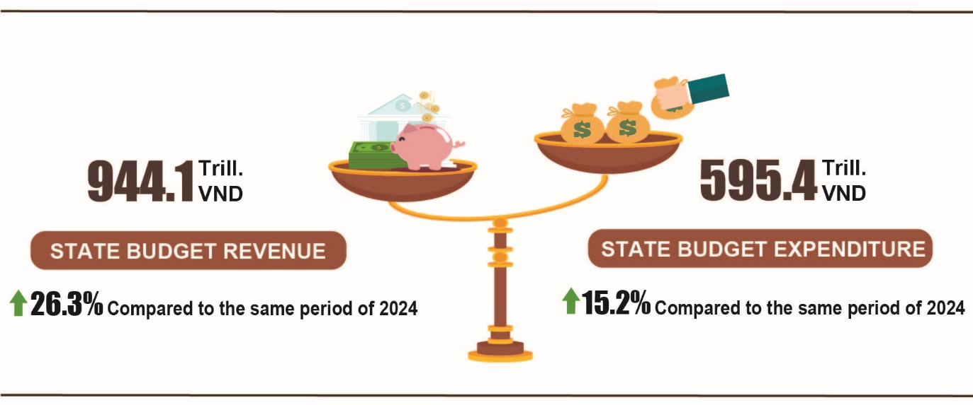

***State budget revenue***

Total state budget revenue in April 2025 was estimated at 199.9 trillion VND; the total state budget revenue accumulated in the first four months of 2025 was estimated at 944.1 trillion VND, reaching 48.0% of the annual estimate and going up by 26.3% over the same period last year. In particular, some main revenue items are as follows:

*- Domestic revenue* in April 2025 was estimated at 168.7 trillion VND; the accumulated revenue in the first four months of 2025 was estimated at 827.2 trillion VND, reaching 49.6% of the annual estimate and an increase of 29.5% over the same period last year[15].

*- Revenue from crude oil* month4/2025 was estimated at 4.0 trillion VND; the accumulated revenue in the first four months of 2025 reached 17.3 trillion VND, reaching 32.6% of the annual estimate and down 12.0% over the same period last year.

*- Budget revenue from import and export activities* in April 2025 was estimated at 27.2 trillion VND; accumulated revenue in the first four months of 2025 was estimated at 99.1 trillion VND, reaching 42.2% of the annual estimate and an increasing of 11.7% over the same period last year.

***State budget expenditure***

Total state budget expenditure in April 2025 was estimated at 164.9 trillion VND; the accumulated expenditure in the first four months of 2025 was estimated at 595.4 trillion VND, equivalent to 23.4% of the annual estimate and an increasing by 15.2% over the same period last year. Of which, recurrent expenditure in the first four months of 2025 reached 425.0 trillion VND, reaching 27.1% of the annual estimate and an increase of 16.1% over the same period last year; development investment expenditure gained 128.5 trillion VND, reaching 16.3% and an increase of 16.3%; interest payment was 40.7 trillion VND, reaching 36.8% and increasing by 2.3%.

**6. Service activities**

***a) Retail sales of consumer goods and services***

*The increased consumption and tourism demand of local people during holidays and festivals, along with the high number of international visitors to Viet Nam, were positive factors contributing to the growth of the trade and service sector since the beginning of the year. Total retail sales of goods and service revenue in April 2025 was estimated to increase by 11.1% compared to the same period last year. In the first four months of 2025, the total retail sales of goods and consumer service revenue witnessed a year-on-year increase of 9.9% compared to the same period last year, of which: Revenue from accommodation and catering services increased by 14.9% and tourism revenue increased by 24.5%.*

Total retail sales of consumer goods and services at current prices in April 2025 was estimated at 582.1 trillion VND, going up by 2.9% over the previous month and rising by 11.1% over the same period last year. Of which, revenue from cultural and educational goods increased by 10.9%; food and foodstuff increased by 10.0%; household equipment and goods increased by 6.9%; garment increased by 6.6%; accommodation and catering services increased by 18.8%; tourism revenue increased by 46.1%.

**Table 3. Retail sales of consumer goods and services at current prices**

***Trillion VND***

|  |  |  |  |  |
| --- | --- | --- | --- | --- |
|  | Estimate  for April  2025 | Estimate for 4 months of 2025 | Year-Over-Year  Growth rate (%) | |
|  |
|  | April 2025 | 4 months of 2025 |
|  |
| **Total** | **582.1** | **2,285.5** | **11.1** | **9.9** |
| Retail sale of goods | 442.8 | 1,752.5 | 8.8 | 8.7 |
| Accommodation and catering service | 71.1 | 270.6 | 18.8 | 14.9 |
| Tourism revenue | 9.1 | 30.4 | 46.1 | 24.5 |
| Other services | 59.1 | 232.0 | 17.0 | 12.6 |

Overall, in the first four months of 2025, the total retail sales of consumer goods and services at current prices was estimated at 2,285.5 trillion VND, going up by 9.9% compared to the same period last year (the figure of the same period in 2024 was 8.6%), if excluding the price factor, rising by 7.7% (the figure of the same period in 2024 was 5.4%).

**Figure 10. Total retail sales of consumer goods and services at current prices  
in the first four months of the 2021-2025 period**

*Retail sales of goods* in the first four months of 2025 were estimated at 1,752.5 trillion VND, accounting for 76.7% of the total retail sales of consumer goods and services and going up by 8.7% over the same period last year. Of which, cultural and educational goods; food, foodstuff; garment; and household equipment and goods increased by 12.6%; 9.8%; 7.4%; and 5.9%, respectively. Retail sales of goods in the first four months of 2025 of some localities saw a year-on-year increase as follows: Hai Phong 9.0%; Ho Chi Minh City 8.5%; Can Tho 8.1%; Da Nang 7.7%; Ha Noi 7.4%.

*Revenue from accommodation and catering services* in the first four months of 2025 was estimated at 270.6 trillion VND, accounting for 11.8% and going up by 14.9% over the same period last year. Revenue in the first four months of 2025 of some localities witnessed a year-on-year increase as follows: Quang Ninh 19.4%; Da Nang 18.7%; Ho Chi Minh City 15.9%; Ha Noi 15.8%; Hai Phong 15.2%; Can Tho 11.1%.

*Tourism revenue* in the first four months of 2025 was estimated at 30.4 trillion VND, accounting for 1.3% and going up by 24.5% over the same period last year due to the high demand for tourism of people during holidays and festivals, especially the great celebration of the 50th anniversary of the Liberation of the South and National Reunification Day. The revenue of some localities in the first four months of 2025 witnessed a high year-on-year growth as follows: Dong Nai 29.7%; Ha Noi 25.7%; Ho Chi Minh City 25.3%; Quang Ninh 23.5%; Da Nang 22.3%; Binh Duong 19.9%.

*Other services revenue* in the first four months of 2025 was estimated at 232.0 trillion VND, accounting for 10.2% and going up by 12.6% over the same period last year. Specifically, the revenue in the first four months of 2025 of some localities saw a year-on-year increase as follows: Can Tho 27.5%; Quang Ninh 13.6%; Ho Chi Minh City 13.0%; Khanh Hoa 11.1%; Ha Noi 6.9%; Hai Phong 5.6%.

**b) Export and import of goods*[16]***

*In April, the total export and import turnover of goods[17] reached 74.32 billion USD, going down by 1.4% over the previous month and rising by 21.3% over the same period last year. Generally, the total export and import turnover of goods in the first four months of 2025 reached 276.89 billion USD, going up by 15.7% over the same period last year, of which export increased by 13.0%; import increased by 18.6%[18]. The trade balance of goods had a surplus of 3.79 billion USD.*

**Figure 11. Import and export of goods in the first 4 months of 2025**

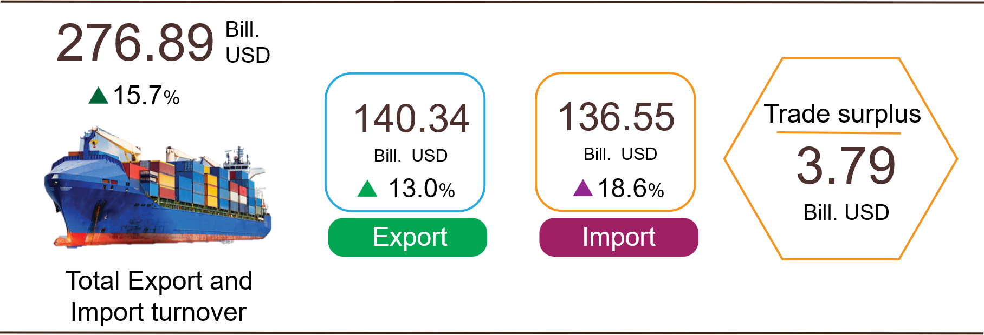

***Export of goods***

Export turnover of goods in March 2025 reached 38.51 billion USD [19].

Export turnover of goods in April 2025reached 37.45 billion USD, going down by 2.8% over the previous month. Of which, the domestic economic sector gained 11.66 billion USD, increased by 5.2%; the FDI sector (including crude oil) reached 25.79 billion USD, decreased by 6.0%. Compared to the same period last year, the export turnover of goods in April increased by 19.8%, of which the domestic economic sector increased by 25.7%, the FDI sector (including crude oil) increased by 17.2%.

Generally, export turnover of goods in the first four months of 2025 reached 140.34 billion USD, increased by 13.0% over the same period last year. Of which, the domestic economic sector was 40.74 billion USD, went up by 18.1%, accounted for 29.0% of the total export turnover; the FDI sector (including crude oil) attained 99.6 billion USD, increased by 11.0%, shared 71.0%.

In the first four months of 2025, there were 22 products with export value of over 1 billion USD, contributing 88.1% to the total export turnover (7 products with export turnover of over 5 billion USD, accounting for 67.1%).

**Table 4. Value of some export products in the first 4 months of 2025**

|  |  |  |
| --- | --- | --- |
|  | Value  *(Mill. USD)* | Growth rate compare to  the same period last year *(%)* |
| **Products with a value of over 5 billion USD** |  |  |
| Electronic goods, computers and their parts | 29,259 | 36.2 |
| Phones all of kinds and their parts | 17,799 | -1.9 |
| Machinery, instrument, accessory | 17,086 | 16.1 |
| Textiles and sewing products | 11,764 | 12.8 |
| Footwear | 7,601 | 14.5 |
| Wood and wooden products | 5,388 | 9.7 |
| Transport and equipments | 5,285 | 9.4 |

*Regarding the structure of exported goods in the first four months of 2025,* the group of fuels and minerals reached 1.03 billion USD, accounting for 0.7%; the group of manufactured products reached 123.71 billion USD, accounting for 88.2%; the group of agricultural and forestry products reached 12.39 billion USD, accounting for 8.8%; the group of fishery products reached 3.21 billion USD, accounting for 2.3%.

**Figure 12. Structure of exported goods by commodity group in the first 4 months of 2025**



***Import of goods***

Import turnover of goods in March 2025 reached 36.88 billion USD[20].

Import turnover of goods in April 2025reached 36.87 billion USD, approximately equal to last month's turnover. Of which the domestic economic sector gained 14.48 billion USD, increased by 3.6%; the FDI sector reached 22.39 billion USD, decreased by 2.2%. Compared to the same period last year, the import turnover of goods in April increased by 22.9%, of which the domestic economic sector increased by 26.0%; the FDI sector increased by 21.0%.

Generally*,* the import turnover of goods in the first four months of 2025 reached 136.55 billion USD, increased by 18.6% over the same period last year. Of which the domestic economic sector reached 51.26 billion USD, went up by 21.1%; the FDI sector gained 85.29 billion USD, rose by 17.1%.

In the first four months of 2025, there were 25 imported products with a value of over 1 billion USD, accounting for 84.2% of the total import turnover (there were 2 products with import turnover of over 5 billion USD, accounting for 44.3%).

**Table 5. Value of some imported goods in the first 4 months of 2025**

|  |  |  |  |
| --- | --- | --- | --- |
|  |  | Value | Year-on-year growth rate |
|  |  | *(Mill. USD)* | *(%)* |
| **Products with a value of over 5 billion USD** | |  |  |
|  | Electronic goods, computers and their parts | 42,879 | 35.4 |
|  | Machinery, instrument, accessory | 17,582 | 24.3 |

*Regarding the structure of imported goods in the first four months of 2025,* the group of capital goods reached 128.17 billion USD, accounted for 93.9%, of which the group of machinery, instrument, and accessory accounted for 50.6%; fuels, raw materials accounted for 43.3%. The group of consumer goods attained 8.38 billion USD, accounted for 6.1%.

**Figure 13. Structure of imported goods by commodity group in the first 4 months of 2025**



*Regarding the export and import market of goods in the first four months of 2025,* the United States was the Viet Nam's largest export market with a turnover of 43.4 billion USD. China remained the largest import market of Viet Nam with a turnover of 53.2 billion USD. In the first four months of 2025, the trade surplus to the United States reached 37.7 billion USD, going up by 24.9% over the same period last year; the trade surplus to the EU gained 13.4 billion USD, rising by 16.8%; the trade surplus to Japan was 0.7 billion USD, nearly 2 times higher than the figure of the same period in 2024; the trade deficit from China was 35.1 billion USD, went up by 44.2%; the trade deficit from South Korea was 9.6 billion USD, went up by 9.5%; the trade deficit from ASEAN was 5.4 billion USD, increased by 83.1%.

**Figure 14. Major commodity export and import markets in the first 4 months of 2025**

|  |  |  |  |  |  |
| --- | --- | --- | --- | --- | --- |
|  | | |  | | |
|  |  | **Export of goods** | **Import of goods** |  |

According to preliminary data*,* the trade surplus in March was 1.63 billion USD[21]; the trade surplus in the first quarter was 3.21 billion USD; the trade surplus in April was 0.58 billion USD. Generally, in the first four months of 2025, the trade balance of goods had a trade surplus of 3.79 billion USD (the trade surplus in the same period last year was 9.06 billion USD). Of which, the domestic economic sector had a trade deficit of 10.52 billion USD; the FDI sector (including crude oil) had a trade surplus of 14.31 billion USD.

**c) Consumer price index, gold price index and US dollar price index**

A month-on-month increase of 0.07% in consumer price index (CPI) in April 2025 was mainly attributed to the increase in rental housing prices, food and eating out prices. The CPI in April increased by 1.37% compared to December 2024; increased by 3.12% compared to the same period last year. On average, in the first four months of 2025, the CPI increased by 3.2% compared to the same period last year; core inflation increased by 3.05%.

**Figure 15. Month-on-month CPI growth rate in April 2025**

Contributing to the 0.07% month-on-month increase in CPI in April 2025, 08 groups of goods and services had price indexes increased, 02 groups of goods had price indexes decreased, and 01 group of goods had stable prices.

(1) Eight groups of goods and services with increasing price indexes included:

*- The group of housing, electricity, water, fuel and construction materials* reached the highest point at 0.62% (impact on the increase in overall CPI by 0.12 percentage points), mainly in the following items: House rental price increased by 0.57%; the price of housing maintenance materials increased by 0.62%; the price of housing repair services increased by 0.49%; the price of household electricity increased by 1.0% mainly due to the increase in demand for electricity in Southern localities because of scorching weather; the price of household water increased by 1.57%[22]. In addition, household electricity service increased by 0.27%, household water service increased by 0.21% due to increased costs of raw materials and labor. In contrast, the price of kerosene in April decreased by 3.57% due to the impact of price adjustments during the month.

*- The group of other consumer goods and services* increased by 0.15%, mainly in some items: Jewelry group increased by 7.32% according to domestic and world gold prices; watch and jewelry repair increased by 0.43%; watches and body care products both increased by 0.13%; environmental sanitation services increased by 0.23%. On the contrary, funeral and worship items decreased by 0.39%.

*- The group of food and foodstuff services* increased by 0.12%, of which: Food decreased by 0.65%[23]; foodstuff group increased by 0.17%[24]; meals and drinking out increased by 0.32%[25].

*- The group of beverage and cigarette* increased by 0.11% due to increased production costs and consumer demand, of which fruit juice increased by 0.18%; bottled and canned energy drinks increased by 0.1%; carbonated soft drinks increased by 0.03%. Prices of all kinds of beer and cigarettes increased by 0.16% and 0.13% respectively compared to the previous month.

*- The group of household equipment and goods* increased by 0.1%, of which, some items had increased prices: Electric iron increased by 0.94%; microwave, oven, induction cooker increased by 0.65%; electric fan increased by 0.59%; gas stove increased by 0.47%; food, kitchen utensils increased by 0.63%; hiring housekeepers, cleaning staff increased by 0.69%; renting household appliances increased by 0.24%; repairing household appliances increased by 0.15%.

*- The group of garment, hat and footwear* increased by 0.06%, of which the price index of fabrics increased by 0.13%; ready-made clothes increased by 0.04%; hats and raincoats increased by 0.16%; children's footwear increased by 1.0%; garment services increased by 0.12%; footwear services increased by 0.11% due to increased demand in the summer.

*- The group of medicines and health care services* increased by 0.02%, mainly due to the increase in the price of pharmaceutical raw materials and people's demand for health care. Specifically, the price of vitamins and minerals increased by 0.23% compared to the previous month; the group of medicines affecting the respiratory tract increased by 0.15%; the group of pain relievers, antipyretics, non-steroidal anti-inflammatory drugs and drugs for treating gout and bone diseases increased by 0.14%.

*- The group of culture, entertainment and tourism* increased by 0.01%, of which: package tour increased by 0.26% (foreign tourism increased by 0.48%; domestic tourism increased by 0.19%) due to increased travel demand during the holidays; hotels increased by 0.38%; sports and fitness equipment increased by 0.14%; movie and concert tickets increased by 0.65%. On the contrary, prices of ornamental plants and flowers decreased by 1.89%; cameras and video cameras decreased by 0.21%; color televisions decreased by 0.31%.

(2) Two groups of goods and services with decreasing price indexes include:

*- The group of post and telecommunications* decreased by 0.15%, of which: smart mobile phones and tablets decreased by 1.65%; accessories for smart mobile phones and tablets decreased by 1.56%; regular mobile phones decreased by 0.37%. In contrast, phone repair prices increased by 0.5% due to increased labor costs.

*- The transport group* decreased by 1.05% (causing the overall CPI to decrease by 0.1 percentage points). Of which: Gasoline price index decreased by 2.83%; diesel price index decreased by 3.31%; new car price decreased by 0.16%; motorbike price decreased by 0.06%. On the other hand, the price of passenger transport by waterway increased by 0.33%; passenger transport by road increased by 0.24%; car wash and pump service price increased by 0.31%; vehicle maintenance increased by 0.17%; auto spare parts increased by 0.19%; motorbike tires and tubes increased by 0.09%.

*Only the education group* remained stable, of which stationery prices increased by 0.07%, specifically: Pens of all kinds increased by 0.1%; paper products increased by 0.08%; stationery and other school supplies increased by 0.22%. On the contrary, educational services decreased by 0.01% because Lao Cai implemented the Resolution of the People's Council on special policies to support tuition fees for public and non-public junior high school students and continuing education students of junior high schools in the 2024-2025 school year.

Core inflation[26] in April 2025 increased by 0.21% compared to the previous month and by 3.14% compared to the same period last year. On average, in the first four months of 2025, core inflation increased by 3.05% compared to the same period last year, lower than the average CPI (up 3.2%) mainly due to the prices of food, foodstuffs, electricity, and medical services, which affected on the increase of CPI but were excluded from the list of core inflation calculations.

Domestic gold prices fluctuated in the same direction as world gold prices. As of April 28, 2025, the average world gold price was at 3,220.07 USD/ounce, rose 7.33% compared to March 2025. In April 2025, world gold prices continued to increase sharply and set a new peak due to prolonged geopolitical instability, including the armed conflict in Ukraine, tensions in the Middle East, and escalating trade conflicts between the US and China, which increased risk-aversion sentiment, boosted demand for storing gold as a haven. Massive gold purchases from central banks, especially in Asia and the Middle East, along with expectations that the US Federal Reserve (FED) will cut interest rates, contributed to pushing gold prices up. Domestically, the gold price index in April 2025 increased by 10.54% compared to the previous month; increased by 37.14% compared to the same period last year; increased by 22.43% compared to December 2024; on average in the first four months of 2025, the gold price index increased by 32.85%.

The domestic US dollar price fluctuated in the opposite direction to the world price, mainly due to increased demand for USD. As of April 28, 2025, the US dollar price index in the international market reached 100.77 points, down 3.05% compared to the previous month due to geopolitical tensions in the world, along with the economic policies of the Trump administration causing investors to sell USD and US Treasury bonds, reducing the value of the USD. Domestically, the average US dollar price in the free market is around 24,974 VND/USD. The US dollar price index in April 2025 increased by 0.97% compared to the previous month; increased by 3.17% compared to the same period last year; increased by 1.9% compared to December 2024; on average in the first four months of 2025, the US dollar price index increased by 3.52%.

***d) Transport***

Transportation activities in April 2025 continued to be vibrant, meeting the travel needs of domestic people as well as international visitors to Viet Nam, serving production and import and export of goods. Compared to the same period last year, passengers carried in April 2025 increased by 29.5% and passengers traffic spread 16.1%; freight carried rose 16.4% and freight traffic grew 14.4%.

Overall, in four months of 2025, passengers carried increased by 19.2% and passengers traffic went up 13.0% over the same period last year; freight carried increased by 14.7% and freight traffic expanded 11.5%.

Passenger transport in April 2025 was estimated at 486.4 million persons, an increase of 5.9% over the previous month and passenger traffic was 25.2 billion persons-kilometers, an increase of 5.2%. Overall, in four months of 2025, the number of passengers carried was estimated at 1,880.7 million passengers, a year-on-year rise of 19.2% (the corresponding figure in 2024 was at 6.8%) and the number of passengers traffic was 101.1 billion persons.km, a year-on-year growth of 13.0% (the corresponding figure in 2024 was at 12.4%). Of which, domestic transport reached 1,874.1 million persons, a year-on-year increase of 19.2%, and 79.9 billion persons-kilometers, a year-on-year spread of 14.3%; overseas transport reached 6.6 million persons, a year-on-year uptrend of 8.4% and 21.2 billion persons-kilometers, a year-on-year rise of 8.2%.

**Table 6: Passenger transport in the first four months of 2025   
by types of transport**

|  |  |  |  |  |
| --- | --- | --- | --- | --- |
|  | Number of passengers | | Year-on-year growth rate (%) | |
|  | Carried (Mill. persons) | Traffic (Bill. persons-km) | Carried | Traffic |
| **Total** | **1,880.7** | **101.1** | **19.2** | **13.0** |
| Rail way[27] | 15.4 | 1.1 | 154.0 | 14.3 |
| Sea way[28] | 4.6 | 0.3 | -19.0 | -7.7 |
| Inland water way | 156.5 | 2.6 | 21.0 | 15.7 |
| Road | 1,685.2 | 64.9 | 18.7 | 15.1 |
| Airway | 19.0 | 32.2 | 9.7 | 8.8 |

Freight transport in April 2025 was estimated at 241.2 million tons of freight carried, a month-on-month increase of 2.9% over the previous month and 48.1 billion tons.km of freight traffic, a month-on-month uptrend of 1.0%. Overall, in four months of 2025, freight transport was estimated at 949.1 million tons of freight carried, a rise of 14.7% over the same period last year (the corresponding figure in 2024 was 12.2%) and 188.9 billion tons.km of freight traffic, a year-on-year increase of 11.5% (the corresponding figure in 2024 was 9.3%). Of which, domestic transport reached 931.9 million tons of freight carried, an upturn of 14.8% and 110.8 billion tons.km of freight traffic, a rise of 6.8%; overseas transport reached 17.2 million tons of freight carried, an increase of 11.5% and 78.1 billion tons.km of freight traffic, a rise of 19.0%.

**Table 7. Freight carriage in four months of 2025  
by types of transport**

|  |  |  |  |  |
| --- | --- | --- | --- | --- |
|  | Quantity of goods | | Year-on-year growth rate (%) | |
|  | Carried  (Mill. tons) | Traffic (Bill. tons-km) | Carried | Traffic |
| **Total** | **949.1** | **188.9** | **14.7** | **11.5** |
| Rail way | 1.7 | 1.3 | 5.5 | 4.2 |
| Sea way | 47.8 | 103.3 | 11.0 | 16.6 |
| Inland water way | 196.0 | 39.2 | 12.1 | 7.0 |
| Road | 703.4 | 41.8 | 15.7 | 5.9 |
| Airway | 0.2 | 3.3 | 14.5 | -3.1 |

***đ) International visitors to Viet Nam***

*Favorable visa policies, enhanced tourism promotion programs, and prestigious tourism awards presented by international organizations have continued to attract increasing numbers of international visitors to Viet Nam.*

The number of international visitors to Viet Nam in April 2025[29] reached 1.65 million, a month-on-month decrease of 19.5%, and a rise of 6.3% over the same period last year. In four months of 2025, international visitors to our country reached 7.67 million arrivals, a year-on-year rise of 23.8%. Of which, arrivals by air reached nearly 6.59 million arrivals, accounted for 85.9% of international arrivals to Viet Nam and increased by 27.0% over the same period last year; by road reached 924.9 million arrivals, comprised 12.0% and spread 7.9%; by sea reached 158.3 thousand arrivals, made up 2.1% and increased by 4.5%.

**Figure 16. International visitors to Viet Nam in the first 4 months   
of 2025 by territories**

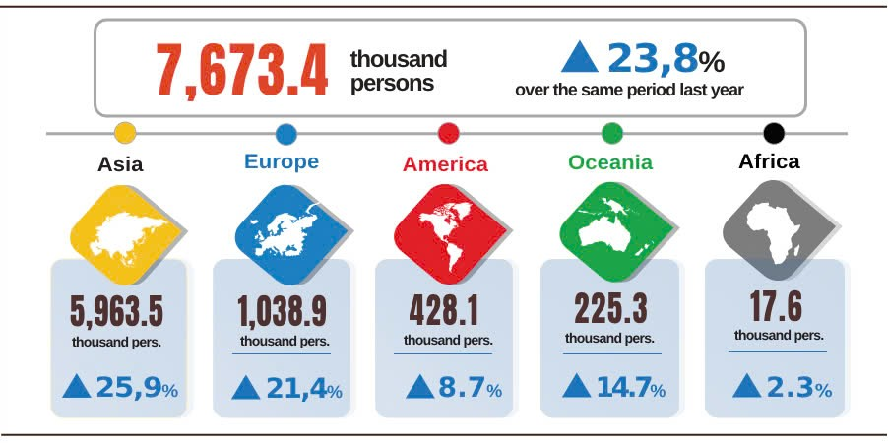

**7. Social situation**

***a) People's life***

According to preliminary results of the monthly Labor Force survey, in April the proportion of surveyed households with unchanged and increased income was 96.1% compared to the figure in the same period last year (a slight decrease of 0.2 percentage points compared to that in the previous month's reporting period and an increase of 1.3 percentage points compared to that in the same period of last year); the proportion of households with decreased income was 3.9%.

In April, the households with a decrease in income compared to that in the same period of last year identified the main reasons[30] as follows: Some household members lost their jobs or temporarily quit their jobs (37.0%); the size of household production and business activities decreased (25.4%); input costs for household production and business activities increased (22.6%); and selling prices of products from household production and business activities declined (20.9%).

In the first four months of 2025, 29.7% of households reported experiencing at least one event that adversely affected their family life. Of which the households negatively affected by events: 28.9% of households suffered from the impact of rising prices of goods and services; 2.4% of households was negatively affected by human epidemics; 1.7% of households was adversely affected by natural disasters and 1.6% of households suffered from epidemics in livestock and crops.

In April, 13.7% of interviewed households received assistance from various sources. Of which 9.7%; 5.0%; 4.7%; 1.8%; 0.01% of households received assistance from relatives and friends; local programs and policies; national programs and policies; charitable activities of other organizations and individuals; and other sources, respectively.

Social security work was always implemented promptly at all levels and sectors. In April (as of April 29, 2025), the Government supported nearly 1.5 thousand tons of rice for people during the pre-harvest season of the early 2025. Since the beginning of the year, the Government had provided people with approximately 8.3 thousand tons of rice, including: 6 thousand and 2.3 thousand tons of rice for hunger relief during Lunar New Year and the 2025 pre-harvest season for 402,600 and 152,700 people, respectively.

**b) Epidemic, food poisoning**

According to the report of the Ministry of Health, during the month (from March 18 - April 17, 2025), there were 31.8 thousand cases of rash fever suspected of measles (05 deaths); 5,713 cases of hand, foot and mouth disease; 4,645 cases of dengue fever (01 death); 27 cases of viral encephalitis (01 death); 06 cases of meningitis caused by meningococcal; 05 deaths from rabies nationwide. In the four months of 2025, there were 84.0 thousand cases of rash fever suspected of measles (10 deaths); 24.9 thousand cases of dengue fever (03 deaths); 13.4 thousand cases of hand, foot and mouth disease; 109 cases of viral encephalitis (01 death); 24 deaths from rabies; 16 cases of meningitis caused by meningococcal in the whole country.

As of April 17, 2025, the total number of people living with HIV nationwide was 248.7 thousand people, the number of deaths from HIV/AIDS in was 116.3 thousand people.

Regarding food poisoning, in April, there were 12 cases of food poisoning, affecting 231 people (01 deaths). In the first four months of 2025 (from December 18, 2024 to April 17, 2025), there were 22 cases of food poisoning nationwide, affecting 293 people (09 deaths).

**c) Culture and sports**

In April, numerous unique cultural activities that were rich in historical significance and imbued with community spirit, took place across the country, starting with a series of events celebrating the 50th anniversary of the Liberation of the South and National Reunification Day. The solemn commemorative activities were organized to evoke the heroic period of the nation during the 1975 Spring Campaign, to commemorate the contributions of heroic martyrs and simultaneously to review revolutionary traditions and educate the younger generation about patriotism and national solidarity. Followed by a series of activities celebrating the 50th anniversary of the Liberation of the South and the National Reunification taking place simultaneously across the country, with the highlight being the national-level military parade and march in Ho Chi Minh City on the morning of April 30 - reenacting the fervent spirit of the day the country was reunited, vividly portraying the historical spirit, national identity and aspirations for national development. The program was attended by many leaders, former high-ranking leaders of the Party, State, revolutionary elders, international guests and a large number of people. This was a historical event of particularly significance, affirming the glorious history of our nation's construction and defense, the great strength of the People and the role of the great national unity bloc for peace, independence and territorial integrity.

*Regarding public physical training and sports movement*, in April, many exciting mass sports events took place across the country, notably: The 50th Ha Noi Moi Newspaper Run - For Peace with nearly 400 athletes; the National Jujitsu Club Championship with more than 300 athletes held in Cao Bang; the Ciputra Ha Noi - Yonex Sunrise Viet Nam 2025 International Badminton Tournament recorded the glorious victory of Vietnamese athletes when they won the Gold Medal; the National Traditional Martial Arts Club Championship launched in Thai Nguyen, gathering 500 martial artists; the National Vovinam Strong Team Championship 2025 with participation of nearly 440 athletes in Nghe An; the 2025 National Club Pickleball Tournament attracting nearly 500 athletes, with the participation of international athletes for the first time; National mixed badminton team championship with more than 100 officials, coaches and athletes competing in Dien Bien; the 2025 Aqua Warriors Ha Long Bay Tournament held in Quang Ninh; the National Talent Wrestling Championship in Ninh Binh; the Tien Phong Newspaper Marathon National Championship with the participation of 7,000 athletes in Quang Tri.

*Regarding high-performance sports*, in April, Viet Nam's high-performance sports took place with many domestic and international tournaments, marking outstanding achievements of athletes such as: Vietnam Wushu excellently won second place overall with 04 gold medals, 02 silver medals at the 2025 World Sanshou Cup held in China; Viet Nam youth chess team won 03 gold medals, 06 silver medals, 06 bronze medals at the World Rapid and Blitz Chess Championship in Greece; Viet Nam delegation won a total of 06 medals (01 gold and 05 bronze) at the Southeast Asian Youth Table Tennis Championship held in Indonesia; athlete Mai Ngoc Anh won a silver medal in the women's high jump at the Asian U18 Athletics Championship in Saudi Arabia. In addition, many national and international competitions were also held in provinces and cities across the country, such as: the National Boxing Championship for Strong Teams held in Dak Lak with participation of 441 athletes; the Hanoi Open Golf Tournament - BIDV Cup opened at Long Bien Golf Course with completion of more than 600 domestic and foreign athletes; the National Chess Tournament held in Ho Chi Minh City with nearly 150 players nationwide; the Asian Women's Beach Volleyball Tournament held in Phu Yen with 22 teams from 10 countries.

***d) Traffic accident[31]***

In April (from March 26 to April 25, 2025), there were 1,585 traffic accidents nationwide, causing 885 deaths and 1,080 injuries. The number of traffic accidents; the number of deaths; the number of injuries increased by 18.9%; 21.4%; 21.6%, respectively compared to that in March 2025. The number of traffic accidents; the number of injuries decreased by 20.3%; 29.7%, respectively; the number of deaths increased by 3.8% compared to that in the same period in 2024.

In the first four months of 2025, there were 6,121 traffic accidents nationwide, causing 3,362 deaths and 4,159 injuries. The number of traffic accidents; the number of deaths; the number of injuries decreased by 28.2%; 8.3%; 37.2%, respectively compared to that in the same period of last year. On average, in the first four months of 2025 there were 51 traffic accidents per day nationwide, causing 28 deaths and 35 injuries..

***d) Damage caused by natural disaster[32]***

In April, damage caused by natural disasters was mainly due to the impact of tornadoes, and thunderstorms, causing 8 deaths and 9 injuries; nearly 1,500 hectares of rice and crops were flooded and damaged; 846 houses were collapsed, swept away, and damaged; the total value of property damage caused by natural disasters in the month was 35.3 billion VND, a decrease of 88.1% compared to that in the same period of last year. In the first four months of this year, natural disasters caused 15 deaths and missing persons, 15 injuries; 11,500 hectares of rice and crops were damaged; 1,020 houses were collapsed, swept away, and damaged; the total value of damaged property was estimated at 152.3 billion VND, an increase of 23.5% compared to that in the same period of 2024.

***e) Environmental protection, fire and explosion prevention***

In April (from March 18 to April 17, 2025) [33], 495 environmental violations in 48 out of 63 localities[34] were detected by the management agencies, of which 459 cases were handled with a total fine of 12.4 billion VND, a decline of 15.9% compared to figure in the previous month and a reduction of 55.2% compared to that in the same period of last year. In the first four months of this year, the number of detected environmental violations was 6,233 cases, of which 5,617 cases were handled with a total fine of 82.9 billion VND, a decrease of25.4% compared to that in the same period of last year.

During the month (from March 15 to April 14, 2025) [35], there were 301 fire and explosion incidents nationwide, causing 17 deaths and 15 injuries with an estimated losses of 154.5 billion VND, being 10.4 times and 8.3 times higher than that in the previous month and the same period of last year, respectively. In the first four months of this year, there were 1,241 fire and explosion incidents nationwide, causing 36 deaths and 38 injuries with an estimated losses of 205.6 billion VND, being 2.3 times higher than that in the same period of last year./.

**NATIONAL STATISTICS OFFICE OF VIETNAM**

1. Hanoi decreased by 1.3 thousand hectares; Ha Nam decreased by 1.2 thousand hectares; Hung Yen decreased by 0.9 thousand hectares; Hai Phong and Nam Dinh both decreased by 0.6 thousand hectares.
2. Some localities with a sharp increase in exploited wood output include: Thai Nguyen; Quang Ninh; Quang Binh; Nghe An increased by 89.2%; 37.6%; 18.1%; 16.3%, respectively over the same period of last year.
3. According to the Ministry of Agriculture and Environment, as of April 15th 2025.
4. Source: Compiled from reports of the Statistics Offices: The price of raw pangasius ranged from 30,000 - 31,000 VND/kg, an increase of about 3,000 VND/kg compared to the same period in 2024.
5. <https://vasep.com.vn/gia-thuy-san>: The price of white-leg shrimp in the Mekong Delta remained at 150,000 - 160,000 VND/kg for 60-80 shrimp/kg, while the price of black tiger shrimp, size 40 shrimp/kg, ranged from 260,000 - 280,000 VND/kg.
6. The price of DO 0.05S-II oil in April 2025 was 17,520 VND/liter (the same period in 2024 was 20,710 VND/liter).
7. The IIP in April 2024 decreased by 7.4% year-on–year.
8. The month-on-month IIP rate growth in April 2025 of some localities with large industrial share: Bac Giang increased by 10.5%; Da Nang increased by 7.4%; Ho Chi Minh City increased by 6.6%; Binh Duong increased by 5.8%; Vinh Long increased by 3.5%; Dong Nai increased by 3.1%; Ba Ria - Vung Tau increased by 2.0%; Hai Duong increased by 1.6%; Quang Nam increased by 1.0%; Hai Phong decreased by 0.8%; Quang Ninh decreased by 9.0%; Quang Ngai decreased by 9.5%.
9. Localities had a high year-on-year production index in the manufacturing in the first four months of 2025: Phu Tho increased by 47.4%; Bac Kan increased by 27.9%; Bac Giang increased by 27.3%; Nam Dinh increased by 24.7%. Localities with high production index of electricity production and distribution: Hoa Binh increased by 63.7%; Hue increased by 37.5%; Quang Ngai increased by 35.6%.
10. Localities witnessed a low or negative year-on-year production index in the manufacturing in the first four months of 2025: Lang Son increased by 2.9%; Lao Cai increased by 2.7%; Cao Bang fell 4.9%. Localities saw an year-on-year downward in the index of the electricity production and distribution in the first four months of 2025: Ba Ria - Vung Tau decreased by 35.6%; Bac Lieu decreased by 14.1%; Khanh Hoa decreased by 3.8%; Lao Cai decreased by 1.8%. Localities saw a low or downward year-on-year production index of the mining in the first four months of 2025: Binh Thuan increased by 1.2%; Ba Ria - Vung Tau decreased by 12.6%; Hanoi decreased by 9.2%.
11. Source: National Business Registration Information System, Department of Private Enterprise and Collective Economy Development, Ministry of Finance, received May 02nd, 2025. Implementing Decree No. 62/2024/ND-CP dated June 07th, 2024 of the Government (effective from August 01st, 2024), the data period on business registration in the month is calculated from the 1st day to the last day of the reporting month. Particularly for time indicators (enterprises returning to operations, enterprises temporarily suspending business for a limited period of time, enterprises temporarily suspending operations awaiting dissolution procedures), the data period is the months before the time. August 01st, 2024 is calculated from the 21st day of the month preceding the reporting month to the 20th day of the reporting month.
12. Of which, the additional registered capital of operating enterprises reached nearly 1,304.0 trillion VND, an increase of 217.1% over the same period of 2024.
13. Including: Newly registered capital, adjusted registered capital and value of capital contribution and share purchase of foreign investors.
14. According to the Report No. 151 /BC-BTC dated April 26th, 2025 of the Ministry of Finance.
15. Domestic revenue results are quite good compared to estimates and increased compared to the same period last year, mainly due to the economy in the last months of 2024 being quite good, and the first months of 2025 continuing to maintain growth momentum. The timely issuance and focused implementation from the beginning of the year of fiscal policies, reduction and extension of taxes, fees, charges and land rents have contributed to supporting businesses to quickly overcome difficulties, develop production and business activities, and generate revenue for the State budget. At the same time, the Tax authority has promoted digital transformation, applied information technology in tax management and collection; strengthened collection management, prevented revenue loss, and handled tax arrears.
16. The value of export turnover is calculated at F.O.B price and import turnover is calculated at C.I.F price (including transportation and insurance costs of imported goods).
17. The preliminary data of export and import of goods in April 2025 were provided by the Viet Nam Customs on May 5th, 2025.
18. Total import and export turnover of goods in the first four months of 2024 reached 239.38 billion USD, going up by 15.3% over the same period last year, of which export reached 124.22 billion USD, rising by 15.3%; import reached 115.16 billion USD, growing by 15.3%.
19. The same as the data sent by the Viet Nam Customs to the National Statistics Office of Viet Nam on April 3rd, 2025.
20. The same as the data sent by the Viet Nam Customs to the National Statistics Office of Viet Nam on April 3rd, 2025.
21. The same as the data sent by the Viet Nam Customs to the National Statistics Office of Viet Nam on April 3rd, 2025.
22. The electricity and water price index for April 2025 reflected fluctuations one month later than other commodities because it was calculated based on revenue and consumption output of March 2025.
23. Rice prices decreased due to abundant supply, stable consumer demand, and export rice prices decreased when import demand from other countries decreased, which also affected domestic rice prices. The price index of the rice group decreased by 0.96% (Regular rice decreased by 1.08%; premium rice decreased by 0.68% and sticky rice decreased by 0.27%). In addition, prices of other food items decreased as follows: Cassava price decreased by 0.16%; instant cereal decreased by 0.02%; other cereals such as kudzu powder and oatmeal decreased by 0.23%.
24. The pork price index increased by 0.8% due to the outbreak of the disease in some provinces and cities, the smuggled supply was tightened, many localities have reviewed and planned to relocate or stop the operation of unqualified livestock farms. In addition, the demand for pork consumption increased during the Hung Kings' death anniversary and the April 30th - May 1st, 2025 holiday. Accordingly, animal fat increased by 1.01%; roasted meat, ham increased by 0.48%; animal organs increased by 0.18%; other processed meat increased by 0.08%; canned meat increased by 0.01%. The price index of tea, coffee, cocoa increased by 0.42%; milk, butter, cheese increased by 0.21%; spices increased by 0.25%; molasses increased by 0.05%. On the contrary, some items had price indexes decreased: The price index of eggs of all kinds decreased by 0.16%; Fresh seafood price index decreased by 0.09%, processed seafood price index decreased by 0.02%; fresh and processed fruit price index decreased by 0.59%; fresh, dried and processed vegetable price index decreased by 0.08%.
25. During the Hung King Commemoration month and the whole country geared up for activities to celebrate the 50th anniversary of the liberation of the South and national reunification, which increased the demand for eating out. Of which, the price of eating out increased by 0.35%; drinking out increased by 0.32%; and fast food take-away increased by 0.2%.
26. CPI excludes fresh food and foodstuff, energy and State-managed goods including health care services and education.
27. Added passenger transport capacity by elevated rail way in Hanoi and Metro in Ho Chi Minh City.
28. Seaway passenger transport in the first four months of 2025 decreased compared to the same period, mainly due to unfavorable weather, which reduced the number of sea passengers, forced many shipping routes to suspend or reduce operating frequency.
29. The reporting period was from March 26, 2025 to April 25, 2025.
30. A household could select various causes of reduction in income.
31. According to a quick report from the Office of the Ministry of Public Security and the Viet Nam Maritime and Waterways Administration (Ministry of Construction) on April 28, 2025.
32. Summarizing Reports from 63 Departments of Agriculture and Environment, reporting period from March 19 to April 18, 2025.
33. According to reports from the Department of Agriculture and Environment, the Provincial and Municipal Police Departments were compiled by Provincial Statistics Offices.
34. 15 localities did not detect environmental violations in April 2025: Bac Kan, Tuyen Quang, Lao Cai, Lang Son, Son La, Nam Dinh, Da Nang, Khanh Hoa, Ninh Thuan, Kon Tum, Dak Nong, Lam Dong, Dong Thap, An Giang and Hau Giang.
35. According to a quick report from the Ministry of Public Security on April 23, 2025.