|  |  |
| --- | --- |
| ­­­­MINISTRY OF FINANCE  **STATISTICS OFFICE**  No: /BC-CTK | **SOCIALIST REPUBLIC OF VIET NAM**  **Independence-Freedom-Happiness**  *Ha Noi, 6th March 2025* |

**Socio-economic situation report in February 2025**

**1. Agriculture, forestry and fishery**

*Agricultural production in February focused on planting and tending spring rice and vegetables nationwide. Pig and poultry farming developed steadily. Forestry production mainly planted forests according to plan and implemented the "Tet tree planting festival to forever remember Uncle Ho" in the year of At Ty 2025. Timber output increased sharply compared to the same period last year. Marine aquatic product output was quite good, aquaculture was favorable when the price of aquaculture products increased.*

***a) Agriculture***

As of February 20, 2025, the whole country had cultivated 2,756.1 thousand hectares of spring rice, an increase of 4.2% over the same period last year. Of which, the northern localities cultivated 852.4 thousand hectares, an increase of 12.0%; the southern localities cultivated 1,903.7 thousand hectares, an increase of 1.1%. The progress of spring rice cultivation in the North increased quite well because after Tet, the weather was favorable, many localities took advantage of speeding up the cultivation progress. Some localities had a sharp increase in cultivated area compared to the same period last year: Nam Dinh reached 70.1 thousand hectares, an increase of 73.4%; Hanoi reached 55.6 thousand hectares, an increase of 160%; Bac Giang reached 21.6 thousand hectares, an increase of 18.5%; Bac Ninh reached 18.8 thousand hectares, an increase of 29.7%.

Southern localities have basically completed the spring rice cultivation and started harvesting some early rice crops. In the Mekong Delta, the spring rice cultivation area reached 1,505.0 thousand hectares, up 1.2% over the same period last year. Some localities proactively planted early to avoid drought and salinity, such as Ben Tre with 7.6 thousand hectares, up 6.8 thousand hectares; Bac Lieu with 58.2 thousand hectares, up 12.3 thousand hectares; Long An with 239.7 thousand hectares, up 3.9 thousand hectares. Due to the early planting schedule, the spring rice harvest in the Mekong Delta has also been faster; so far, the whole region has harvested 395.4 thousand hectares, equal to 139.2% over the same period in 2024.

Along with the spring rice planting, localities across the country were planting crops. The area of ​​some crops such as sweet potatoes and soybeans have decreased compared to the same period last year, mainly due to low economic efficiency and difficulties in product consumption.

**Figure 1: Cultivation of main spring crops**

(As of 20/02/2025)

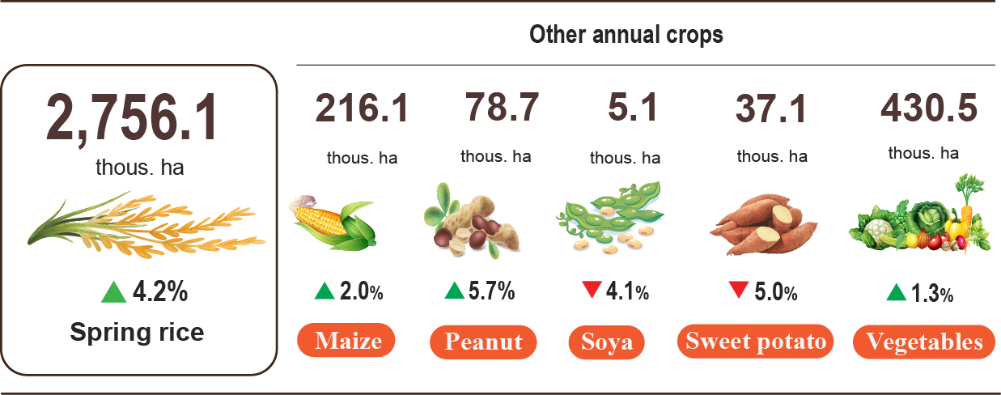

Buffalo and cow husbandry in the month tended to decrease[1]. Pig and poultry farming has developed well due to effective disease control, stable prices and consumption markets, help favorable conditions for farmers to expand production and improve product quality. However, in the first months of the year, the weather in the northern localities is prone to disease outbreaks for livestock and poultry, so farmers need to strengthen measures to control and prevent diseases and ensure the safety of livestock.

**Figure 2. The growth rate of the population of livestock**

**at the end of Febuary, 2025 compared to the same time last year**

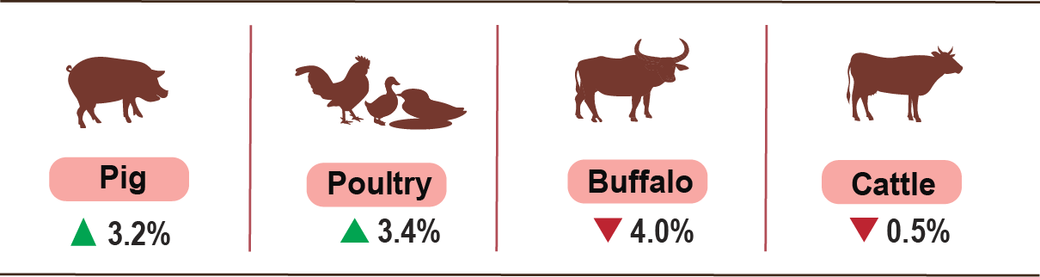

As of Febuary 26, 2025, the whole country has no blue ears disease; avian flu disease was reported in Tuyen Quang, Long An, Tien Giang; foot-and-mouth disease was reported in Lao Cai, Thanh Hoa; LSD was reported in Tien Giang; African swine fever was reported in 11 localities and animal rabies remained in 12 localites for less than 21 days.

*Forestry production mainly includes afforestation according to plan and implementation of the "Tet tree planting festival to forever remember Uncle Ho" in the year of At Ty 2025. Timber output increased sharply compared to the same period last year. Marine aquatic product output was quite good, aquaculture was favorable when the price of aquaculture products increased.*

***b) Forestry***

The area nationwide of newly concentrated planted forest in February 2025 was estimated at 11.4 thousand hectares, up 8.5% over the same period in 2024. Favorable weather conditions have accelerated the progress of afforestation in many localities, such as: Bac Kan increased by 44.4% over the same period last year; Quang Ninh, increased by 43.0%; Yen Bai increased by 29.7%; Phu Tho increased by 16.3%; Tuyen Quang increased by 14.1%. The number of scattered forestry trees was estimated at 9.6 million trees, an increase of 8.8% over the same period last year. The output of exploited timber was estimated at 1,338.8 thousand m³, up 18.2% Due to high raw wood prices, people are increasing the harvest of wood that is at the age of exploitation. Some localities have high timber exploitation output compared to the same period in 2024: Quang Ninh, 2.7 times higher; Quang Tri increased by 70.8%; Tuyen Quang increased by 64.0%; Yen Bai increased by 45.2%; Quang Binh increased by 33.9%.

Generally, in the 2 months of 2025, The area nationwide of newly planted forest was estimated at 20.1 thousand hectares, up 8.8% over the same period last year; the number of scattered forest trees planted was estimated at 13.4 million, up 6.8%; the output of exploited timber was estimated at 2,620.7 thousand m³, up 18.9%.

Forest area damaged in February 2025[2] was 73.1 hectares, up 34.7% over the same period last year[3], of which: The burnt forest area was 17.3 hectares, 39.7 times concentrated in Cao Bang 10.0 ha, Bac Kan 3.8 ha, Lai Chau 2.0 ha; the area of ​​forest cut down and destroyed is 56.0 ha, an increase of 4.0%. Total first two months of 2025, forest area damaged was 145.4 hectares, up 64.0% over the same period last year, of which the burnt forest area was 19.4 hectares, 27 times; the area of ​​forest cut down and destroyed was 126.0 hectares, up 43.3%.

***c) Fishery***

Fishery output in February 2025 was estimated at 650.5 thousand tons, up 4.0% over the same period last year, including: Fish reached 479.6 thousand tons up 4.1%; shrimp estimated at 69.3 thousand tons up 5.4%; other aquatic products estimated at 101.6 thousand tons, up 2.6%.

Aquaculture production in the month was estimated at 362.5 thousand tons, up 4.6% over the same period last year, of which: Fish output reached 258.7 thousand tons, up 5.0%; shrimp output reached 58.0 thousand tons, up 5.8%; other aquatic products estimated at 45.8 thousand tons, up 1.1%.

Pangasius production February 2025 was estimated at 121.7 thousand tons, up 4.6% over the same period last year, Due to the increase in raw pangasius prices and many export contracts being signed, people have increased their farming[4].

Shrimp output increased significantly due to white-leg shrimp prices[5] tend to increase again in the first week of February, after a slight decrease in the last week of January 2025. The output of white-leg shrimp February 2025 was estimated at 36.5 thousand tons, up 7.7% over the same period last year; the output of black tiger shrimp reached 16.7 thousand tons, up 3.1%.

The caught fishery production in February 2025 was estimated at 288.0 thousand tons, up 3.2% over the same period last year, including: Fish output estimated at was 220.9 thousand tons, up 3.1%; shrimp output estimated at was 11.3 thousand tons, up 3.2%; other aquatic products output estimated at was 55.8 thousand tons, up 3.9%. Estimated marine aquatic product output reached 270.5 thousand tons, up 3.3%[6], of which: Fish reached 208.3 thousand tons, up 3.1%; shrimp reached 10.1 thousand tons, up 4.0%; other aquatic products reached 52.1 thousand tons, up 4.3%.

**Figure 3. Fishery production of February in 2025**

**over the same previous in 2024**

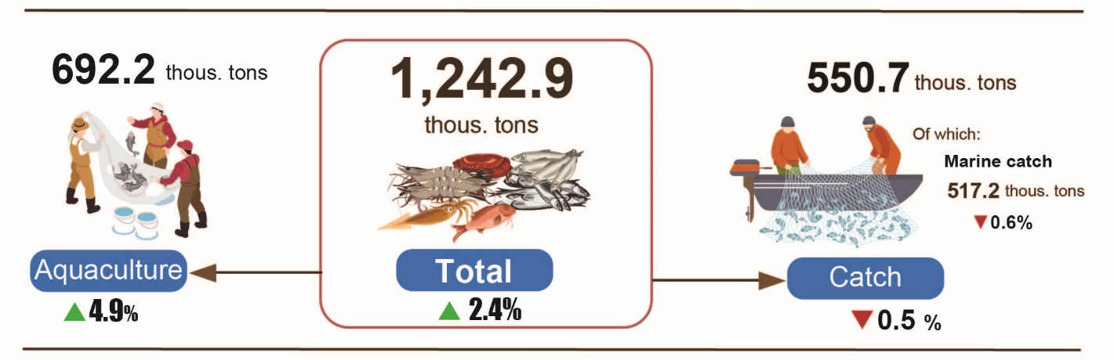

Generally, in the 2 months of 2025, fishery output was estimated at 1,242.9 thousand tons, up 2.4% over the same period last year, including: Fish reached 922.2 thousand tons, up 2.5%; shrimp reached 125.1 thousand tons, up 4,4%; other fishery products reached 195.6 thousand tons, up 0.9%.

**2. Industrial production**

**2. Industry Production**

*The industrial production in February 2025 is estimated to decrease 2.2%[7] compared to the previous month; increased by 17.2% compared to the same period last year [8]; overall, in the first two months of 2025, the Industrial Production Index (IIP) increased by 7.2% compared to the same period last year.*

In February 2025, the Industrial Production Index (IIP) of the manufacturing and processing sector increased by 20.0% compared to the same period last year; electricity production and distribution rose by 9.9%; water supply, waste management, and wastewater treatment activities grew by 13.9%; while the mining sector saw a modest increase of 0.4%.

Overall, in the first two months of 2025, the IIP is estimated to have increased by 7.2% compared to the same period in 2024 (which saw a 6.5% increase). Specifically, the manufacturing and processing industry grew by 9.3% (compared to 6.6% in 2024), contributing 7.9 percentage points to the overall growth. The electricity production and distribution sector increased by 2.3% (compared to a 13.7% rise in 2024), contributing 0.2 percentage points. The water supply, waste management, and wastewater treatment sector grew by 8.0% (compared to 1.4% in 2024), contributing 0.1 percentage points. However, the mining sector declined by 6.4% (compared to a 1.9% decrease in 2024), reducing the overall growth rate by 1.0 percentage point.

The IIP of some key level-II industries in the first two months of 2025 increased compared to the same period last year: motor vehicle manufacturing surged by 53.5%; leather and related products grew by 22.5%; furniture manufacturing increased by 19.8%; apparel production rose by 15.3%; wood processing and the production of wooden, bamboo, and rattan products grew by 12.5%; textiles increased by 12.2%; other transportation equipment manufacturing rose by 12.1%; rubber and plastic products manufacturing increased by 11.3%; electronic products, computers, and optical products production grew by 9.5 and food processing increased by 7.4%. Conversely, the IIP of some industries declined compared to the same period last year: crude oil and natural gas extraction dropped by 12.0%; pharmaceutical, chemical, and medicinal manufacturing fell by 10.4%; coke and refined petroleum products manufacturing decreased by 3.6%; tobacco product manufacturing declined by 2.8%; and electrical equipment manufacturing decreased by 1.7%.

**Table 1. Growth/Decline Rate of the IIP in the First Two Months of 2021-2025 Compared to the Same Period of the Previous Year for Key Industrial Sectors**

%

|  |  |  |  |  |  |
| --- | --- | --- | --- | --- | --- |
|  | **2021** | **2022** | **2023** | **2024** | **2025** |
| Crude oil and natural gas extraction | -9,9 | -3,4 | -3,1 | -6,6 | -12,0 |
| Food processing | 3,3 | 6,2 | 1,2 | 4,2 | 7,4 |
| Tobacco product manufacturing | 4,8 | 5,8 | 6,1 | 9,6 | -2,8 |
| Textiles | 5,0 | 5,3 | -9,9 | 18,0 | 12,2 |
| Apparel production | 2,1 | 25,7 | -14,0 | 4,1 | 15,3 |
| Leather and related products | 2,3 | 9,6 | -6,2 | 6,6 | 22,5 |
| Wood processing and the production of wooden, bamboo, and rattan products | 3,4 | -1,2 | 3,9 | 3,5 | 12,5 |
| Coke and refined petroleum products manufacturing | -3,7 | -12,7 | 21,6 | 28,4 | -3,6 |
| Pharmaceutical, chemical, and medicinal manufacturing | 4,9 | 5,0 | 6,5 | 16,3 | -10,4 |
| Rubber and plastic products manufacturing | 7,6 | -16,5 | 9,6 | 24,0 | 11,3 |
| electronic products, computers, and optical products production | 17,9 | 4,9 | -2,1 | -1,8 | 9,5 |
| Electrical equipment manufacturing | 14,3 | 14,4 | -10,7 | 24,6 | -1,7 |
| Motor vehicle manufacturing | 7,2 | 7,0 | -11,8 | 1,6 | 53,5 |
| Other transportation equipment manufacturing | -4,2 | 8,3 | -10,0 | -6,9 | 12,1 |
| Furniture manufacturing | 11,3 | 1,5 | -9,1 | 20,4 | 19,8 |

The Industrial Production Index (IIP) in the first two months of 2025 increased in 58 provinces and decreased in 5 provinces across the country. Several provinces recorded a relatively high IIP growth due to significant increases in the manufacturing and processing industry, as well as the electricity production and distribution sector.[9]. On the other hand, some provinces experienced low IIP growth or a decline due to sluggish or decreasing performance in the manufacturing and processing industry, the mining sector, and the electricity production and distribution sector[10].

**Figure 4. IIP increase/decrease rate in the first 2 months of 2025**

**compared to the same period last year of some localities (%)**

|  |  |
| --- | --- |
| **10 localities with the highest IIP growth rate** | **10 localities with low or decreased IIP** |

Several key industrial products saw an increase in the first two months of 2025 compared to the same period last year: automobiles surged by 106.5%, televisions increased by 58.1%, fabric woven from natural fibers rose by 18.0%, motorcycles grew by 17.9%, casual wear increased by 14.0%, leather shoes and sandals rose by 9.2%, aquaculture feed grew by 7.2%, NPK fertilizer increased by 6.9%, and cement rose by 6.6%.

Conversely, some products experienced a decline compared to the same period last year: natural gas in gaseous form decreased by 15.8%, crude oil extraction dropped by 8.1%, liquefied petroleum gas (LPG) declined by 7.9%, petroleum products fell by 4.5%, rolled steel decreased by 3.0%, and cigarettes dropped by 2.8%.

As of February 1, 2025, the number of workers employed in industrial enterprises increased by 1.0% compared to the previous month and by 4.4% compared to the same period last year. Among them, the workforce in state-owned enterprises remained unchanged from the previous month but increased by 0.3% year-on-year; non-state enterprises saw an increase of 0.4% month-on-month and 3.2% year-on-year; and foreign-invested enterprises recorded a growth of 1.3% month-on-month and 5.2% year-on-year.

By industry, the number of workers in the mining sector decreased by 0.2% compared to the previous month and by 0.5% year-on-year. Employment in the manufacturing and processing sector increased by 1.1% month-on-month and 4.8% year-on-year. The electricity, gas, steam, and air conditioning supply sector remained unchanged month-on-month but grew by 0.1% year-on-year. The water supply, waste management, and wastewater treatment sector also remained unchanged from the previous month but saw a 1.3% increase year-on-year.

**3. Enterprise activities**

***a) Enterprise registration status*** *[11]*

In February, the whole country had more than 10.1 thousand newly established enterprises with registered capital was nearly 136.4 trillion VND and the total number of registered employees of over 59.1 thousand employees, a decrease of 4.9% in the number of enterprises, an increase of 45.0% in registered capital and a decrease of 27.5% in the number of employees compared to January 2025. Compared to the same period last year, up 34.4% in the number of enterprises, over 2.1 times more in registered capital and down 23.3% in the number of employees. The average registered capital of a newly established enterprise in the month reached 13.5 billion VND, over 1.5 times more than it in the last month and nearly 1.6 times more compared to the same period of 2024. Besides, there were nearly 7.1 thousand enterprises resumed in the whole country, down 69.1% compared to the previous month and up 32.1% compared to the same period of 2024.

Generally, in the beginning two months of 2025, the whole country had nearly 20.8 thousand newly registered enterprises with the total registered capital of over 230.4 trillion VND and the total number of registered employees was nearly 140.7 thousand employees, down 8.9% in the number of enterprises, up 4.9% in registered capital and down 22.7% in the number of employees compared to the same period last year. The average registered capital of a newly established enterprise in the first two months achieved 11.1 billion VND, up 15.1% to the same period of 2024. The total number additional registered captial into the economy in the first two months was nealy 709.4 trillion VND, a year-on-year increase of 66.1%.

Besides, there were nearly 29.1 thousand enterprises resumed (a year-on-year increase of 53.2%), levering the total number of newly established enterprises and resumed enterprises in the first two months of 2025 to over 49.8 thousand enterprises, a year-on-year increase of 19.3%. On average, there were over 24.9 thousand newly established and resumed enterprises per month.

By economic sector in the first two months of 2025, there were 179 newly established enterprises in the agricultural, forestry, and fishery sectors, a year-on-year decrease of 25.7%; nearly 4.8 thousand enterprises in the industrial and construction sectors, a decrease of 11.7%; more than 15.8 thousand enterprises in the service sector, a decrease of 7.8%.

**Figure 6. Enterprise registration situation**

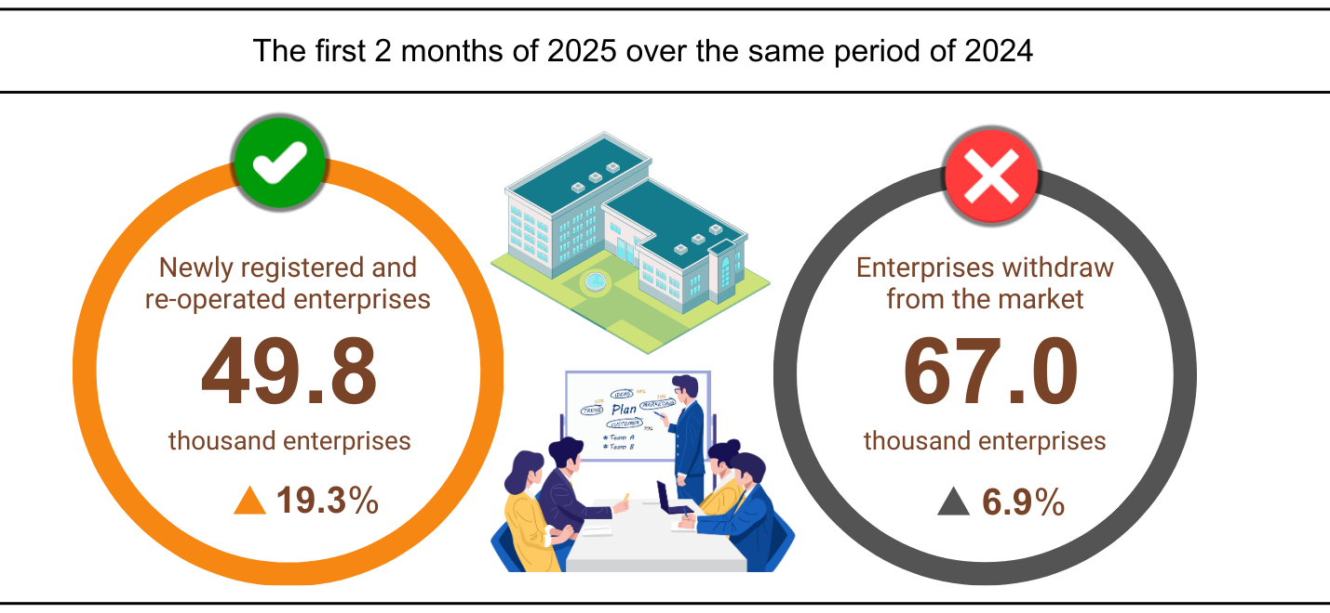

Also in February, there were 3,554 teamporarily inactive enterprises, down 93.3% compared to the previous month and down 30.9% over the same period in 2024; 2,971 enterprises ceased and awaited dissolution procedures, down 14.9% and up 38.0%; 1,737 enterprises completed dissolution procedures, down 14.1% and up 44.4%.

In the first two months of 2025, there were nearly 56.9 teamporarily inactive enterprises, a year-on-year increase of 15.5%; nearly 6.4 thousand enterprises ceased and awaited dissolution procedures, a decrease of 36.3%; nearly 3.8 thousand enterprises completed dissolution procedures, up 10.3%. On average, there were more than 33.5 thousand enterprises withdrawing from the market per month.

**Table 3: Number of newly registered enterprises and completed dissolution procedures in the first two months of 2025 by kinds of activity**

|  |  |  |  |  |
| --- | --- | --- | --- | --- |
|  | Number of enterprises (Enterprise) | | Growth rate over  the same period last year (%) | |
| Newly registered | Dissolution | Newly registered | Dissolution |
| Wholesale and retail trade; repair of motor vehicles and motorcycles | 7,153 | 1,392 | -22.9 | 9.1 |
| Manufacturing | 2,641 | 430 | -2.6 | 13.8 |
| Construction | 1,923 | 261 | -21.1 | 4.8 |
| Real estate business | 492 | 230 | -9.7 | 2.7 |
| Transportation and storage | 1,050 | 146 | -9.6 | 7.4 |
| Accommodation and catering service | 600 | 188 | -33.4 | 23.7 |
| Production and distribution of electricity, water, gas | 146 | 42 | -11.0 | -8.7 |

**4. Investment**

*Right after the Lunar New Year holiday, Ministries, branches and localities have focused on implementing work, accelerating the progress of investment projects from the State budget , especially transitional projects. In the first two months of 2025, the investment capital implemented from the State budget is estimated at 8.5% of the annual plan, up 21.7% over the same period last year. Foreign direct investment (FDI) implemented in Vietnam in the first two months of 2025 is estimated at 2.95 billion USD, up 5.4% over the same period last year .*

Realized investment capital from the State budget in February is estimated at VND 37.9 trillion, up 36.5% over the same period last year, including: Centrally managed capital reached 5.5 trillion VND, up 20.1%; locally managed capital reached 32.4 trillion VND, up 39.8%. In the first two months of 2025, the total realized investment capital from the State budget is estimated at 73.2 trillion VND, equal to 8.5% of the annual plan and up 21.7% over the same period last year (the same period in 2024 was equal to 7.7% and up 2.6%). Specifically:

- The investment capital implemented under the central management is estimated at 10.2 trillion VND, equal to 7.8% of the annual plan and up 8.6% over the same period last year. Of which, the Ministry of Transport reached 5.9 trillion VND, down 4.2%; the Ministry of Agriculture and Rural Development reached 1.5 trillion VND, up 99.3%; the Ministry of Health reached 329.3 billion VND, 3.8 times higher; the Ministry of Education and Training reached 161.6 billion VND, up 89.1%; the Ministry of Culture, Sports and Tourism reached 104.9 billion VND, up 56.5%; the Ministry of Natural Resources and Environment reached 69.2 billion VND, up 18.6%; the Ministry of Information and Communications reached 40.4 billion VND, up 54.9%.

- Realized investment capital managed by localities is estimated at nearly 63.0 trillion VND, equal to 8.6% of the annual plan and up 24.2% over the same period last year, of which:

Provincial State budget capital reached 41.1 trillion VND, equal to 7.8% and increased by 23.7% over the same period in 2024;

District-level state budget capital reached 18.9 trillion VND, equal to 10.5% and increased by 25.2%;

State budget capital at commune level reached nearly 3.0 trillion VND, equal to 11.8% and increased by 24.4%.

Investment capital implemented from the State budget in the first two months of 2025 of a number of provinces and centrally run cities is as follows:

**Figure 6. Investment capital implemented from the State budget**

**of the first 2 months of the year in some localities**

*Total foreign investment capital registered in Vietnam[12]* The first two months of 2025 included: Newly registered capital, adjusted registered capital and capital contribution and share purchase value of foreign investors reached nearly 6.90 billion USD, up 35.5% over the same period last year.

**­­­**- Newly registered capital has 516 licensed projects with registered capital reaching 2.19 billion USD, an increase of 10.0% over the same period last year in terms of number of projects and a decrease of 48.4% in terms of registered capital. Of which, the processing and manufacturing industry is the one with the largest newly licensed foreign direct investment with registered capital reaching 1.45 billion USD, accounting for 66.1% of the total newly registered capital; real estate business activities reached 371.5 million USD, accounting for 16.9%; the remaining industries reached 371.8 million USD, accounting for 17.0%.

Among the 44 countries and territories with newly licensed investment projects in Vietnam in the first two months of 2025, China is the largest investor with 679.8 million USD, accounting for 31.0% of the total newly registered capital; followed by Singapore with 450.7 million USD, accounting for 20.6%; Hong Kong Special Administrative Region (China); Japan with 253.3 million USD, accounting for 11.5%; British Virgin Islands with 163.7 million USD, accounting for 7.5% ; the United States with 107.9 million USD, accounting for 4.9%; and Japan with 104.1 million USD, accounting for 4.8%.

- Adjusted registered capital: 256 licensed projects from previous years registered to adjust investment capital by an additional 4.18 billion USD, 6 times higher than the same period last year.

If including newly registered capital and adjusted registered capital of licensed projects from previous years, foreign direct investment capital registered in the processing and manufacturing industry reached 4.51 billion USD, accounting for 70.8% of the total newly registered and increased capital; real estate business activities reached 1.45 billion USD, accounting for 22.7%; the remaining industries reached 409.4 million USD, accounting for 6.5%.

- There were 553 registered capital contributions and share purchases by foreign investors with a total capital contribution value of 529.8 million USD, an increase of 88.8% over the same period last year. Of which, 240 capital contributions and share purchases increased the charter capital of the enterprise with a capital contribution value of 318.8 million USD and 313 foreign investors bought back domestic shares without increasing charter capital with a value of 211 million USD. For the form of capital contribution and share purchase by foreign investors, investment capital in the processing and manufacturing industry reached 198.4 million USD , accounting for 37.5% of the capital contribution value; professional activities, science and technology reached 157.0 million USD, accounting for 29.6%; the remaining industries reached 174.4 million USD, accounting for 32.9 %.

*Foreign direct investment realized in Vietnam in the first* two months of 2025 is estimated at 2.95 billion USD, up 5.4% over the same period last year. This is the highest realized foreign direct investment in two months in the past 5 years. Of which: Processing and manufacturing industry reached 2.42 billion USD, accounting for 82.1 % of total realized foreign direct investment; real estate business activities reached 203 million USD, accounting for 6.9%; production and distribution of electricity, gas, hot water, steam and air conditioning reached 122 million USD, accounting for 4.1%.

**Figure 7. Realized foreign direct investment**

**first 2 months of 2021-2025 (Billion USD)**

*Vietnam's overseas investment* in the first two months of 2025 had 30 projects newly granted investment certificates with a total capital of Vietnam's side of 233.6 million USD, 9.4 times higher than the same period last year; there were 05 projects with capital adjustment with the adjusted capital increasing by 5.4 million USD, 24.3 times higher.

In total, Vietnam's total investment capital abroad (newly granted and adjusted capital) was nearly 239 million USD, 9.5 times higher than the same period last year. Of which: Production and distribution of electricity, gas, hot water, steam and air conditioning reached 111.2 million USD, accounting for 46.5% of total investment capital; processing and manufacturing industry reached 65.6 million USD, accounting for 27.4%; mining reached 41 million USD; accounting for 17.1%.

In the first two months of 2025, 22 countries and territories received investment from Vietnam, of which: Laos was the leading country with 139.7 million USD, accounting for 58.4% of total investment capital; Philippines 34.2 million USD, accounting for 14.3%; Indonesia 31.1 million USD, accounting for 13%; British Virgin Islands reached 21.0 million USD, accounting for 8.8%; Cuba 4.0 million USD, accounting for 1.7%.

**5. State budget revenue and expenditure[13]**

*State budget revenue in the first two months of 2025 was estimated to increase by 25.7% over the same period last year[14]. State budget expenditure was estimated to increase by 13.2% over the same period in 2024, ensuring the needs of socio-economic development, national defense, security, state management, payment of due debts as well as timely payment to subjects according to regulations.*

**Figure 9. State budget revenue and expenditure in the first two months of 2025**

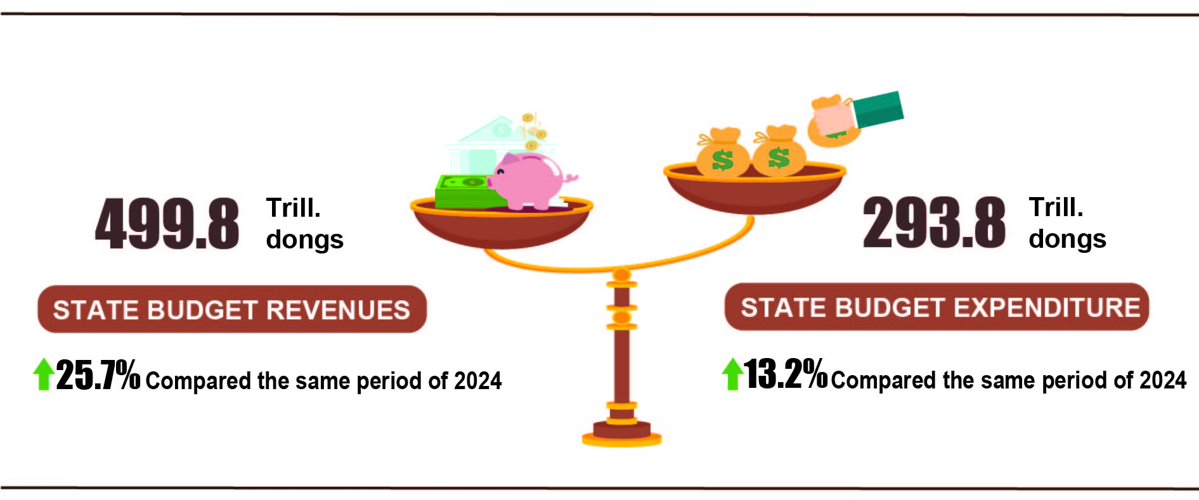

***State budget revenue***

Total state budget revenue in February 2025 was estimated at 191.9 trillion VND. Total state budget revenue in the first two months of 2025 reached 499.8 trillion VND, equal to 25.4% of the annual estimate and up 25.7% over the same period last year. In particular, some main revenue items are as follows:

*- Domestic revenue* in February 2025 was estimated at 164.3 trillion VND. The accumulated revenue in the first two months of 2025 reached 454.9 trillion VND, equal to 27.3% of the annual estimate and an increase of 28.9% over the same period last year.

*- Revenue from crude oil* in February 2025 was estimated at 4.0 trillion VND. Accumulated revenue in the first two months of 2025 reached 8.1 trillion VND, equal to 15.3% of the annual estimate and down 17.1% over the same period last year.

*- Budget revenue from import and export activities* in February 2025 was estimated at 23.4 trillion VND. The accumulated revenue in the first two months of 2025 reached 36.5 trillion VND, equal to 15.5% of the annual estimate and an increase of 4.4% over the same period last year.

***State budget expenditure***

Total state budget expenditure in February 2025 is estimated at 140.6 trillion VND; the accumulated expenditure in the first two months of 2025 is estimated at 293.8 trillion VND, equal to 11.5% of the annual estimate and an increase of 13.2% over the same period last year . Of which , regular expenditure in the first two months of 2025 reached 210.0 trillion VND, equal to 13.4% of the annual estimate and an increase of 15.9% over the same period last year; development investment expenditure is estimated at 60.4 trillion VND, equal to 7.6% and an increase of 13.7%; debt interest payment is 23.3 trillion VND, equal to 21.1% and a decrease of 7.1%.

**6. Trade, prices, transport and tourism**

***a) Retail sales of consumer goods and services***

*Increased domestic consumption demand during the Lunar New Year holiday along with the strong recovery of tourism has contributed positively to the growth of the trade and service industry. The total retail sales of consumer goods and services in 02/2025 increased by 9.4% over the same period last year. Overall, in two months of 2025, the total retail sales of consumer goods and services was estimated to increase by 9.4% over the same period last year, of which revenue from accommodation and food services increased by 12.5%, revenue from tourism up to 16.4%.*

The total retail sales of consumer goods and services at current prices in was estimated to reach 561.7 trillion VND, down 2.5% over the previous month and up 9.4% over the same period last year[15], of which, revenue from cultural and educational items increased by 15.2%; household appliances, tools and equipment increased by 11.0%; garments increased by 10.6%; food and foodstuffs increased by 7.3%; accommodation and catering services increased by 12.7%; tourism and travel increased by 17.3% due to the high increase in the number of international visitors to Vietnam and Vietnamese tourists traveling abroad compared to the same period last year.

**Table 3. The total retail sales of consumer goods and services at current prices**

***Trillion VND***

|  |  |  |  |  |
| --- | --- | --- | --- | --- |
|  | Estimate  February  2025 | Estimate  02 months  of 2025 | Growth rate compared to the same period last year (%) | |
|  |
|  | February  in 2025 | 02 months of 2025 |
|  |
| **Total** | **561.7** | **1,137.5** | **9.4** | **9.4** |
| Retail sale of goods | 432.5 | 878.4 | 8.3 | 8.7 |
| Accommodation and catering service | 65.2 | 131.1 | 12.7 | 12.5 |
| Tourism revenue | 7.1 | 14.1 | 17.3 | 16.4 |
| Other services | 56.9 | 113.9 | 13.6 | 10.2 |

Generally for two months of 2025, the total retail sales of consumer goods and services at current prices was estimated at 1,137.5 trillion VND, up 9.4% over the same period last year (up 8.4% in the same period in 2024), if excluding the price factor, up 6.2% (the same period in 2024 increased by 5.3%).

**Figure 11. Total retail sales of consumer goods and service at current prices  
in the first 2 months of 2021-2025**

*Retail sales of goods* in two months of 2025 were estimated at 878.4 trillion VND, accounting for 77.2% of the total retail sales of consumer goods and services and up 8.7% over the same period last year. Of which, the group of cultural and educational goods increased by 15.9%; food and foodstuffs increased by 9.9%; garments increased by 9.0%; household appliances, tools and equipment increased by 6.8%. Retail sales of goods in the first two months of 2025 compared to the same period last year in some localities are as follows: Hai Phong increased by 9.4%; Can Tho increased by 8.9%; Da Nang increased by 8.7%; Ha Noi increased by 7.3%; Ho Chi Minh City increased by 7.1%.

*Revenue from accommodation and catering services* in two months of 2025 was estimated at 131.1 trillion VND, accounting for 11.5% and up 12.5% over the same period last year. Revenue in two months of 2025 compared to the same period last year of some localities was as follows: Quang Ninh increased by 20.1%; Da Nang increased by 16.4%; Hai Phong increased by 13.8%; Can Tho increased by 10.4%; Hanoi increased by 10.0%; Ho Chi Minh City increased by 9.2%.

*Tourism revenue* in two months of 2025 was estimated at 14.1 trillion VND, accounting for 1.3% and up 16.4% over the same period last year. The revenue of some localities in two monthsof 2025 compared to the same period last year was as follows: Hue increased by 31.5%; Quang Ninh increased by 21.3%; Binh Duong increased by 17.1%; Da Nang increased by 16.6%; Ho Chi Minh City increased by 13.2%; Ha Noi increased by 12.2%.

*Other service revenue* in two months of 2025 was estimated at 113.9 trillion VND, accounting for 10.0% and up 10.2% over the same period last year. Revenue in two months of 2025 of some localities was as follows: Ninh Binh increased by 26.0%; Can Tho increased by 18.6%; Lam Dong increased by 15.8%; An Giang increased by 13.7%; Ho Chi Minh City increased by 11.8%; Binh Dinh increased by 9.8%; Hai Phong increased by 9.1%; Binh Duong increased by 7.6%; Bac Lieu decreased by 1.8%; Quang Ninh decreased by 2.7%; Hoa Binh decreased by 12.4%.

***b) Export and import of goods[16]***

*Total export and import turnover of goods[17] in 02/2025 reached 63.77 billion USD, up 0.7% over the previous month and up 32.6% over the same period last year[18]. Generally, in two months of 2025, the total export and import turnover of goods reached 127.07 billion USD, up 12.0% over the same period last year, of which exports increased by 8.4%; imports increased by 15.9%[19]. The trade balance of goods had a surplus of 1.47 billion USD.*

**Figure 11. Import and export of goods in 2 months of 2025**

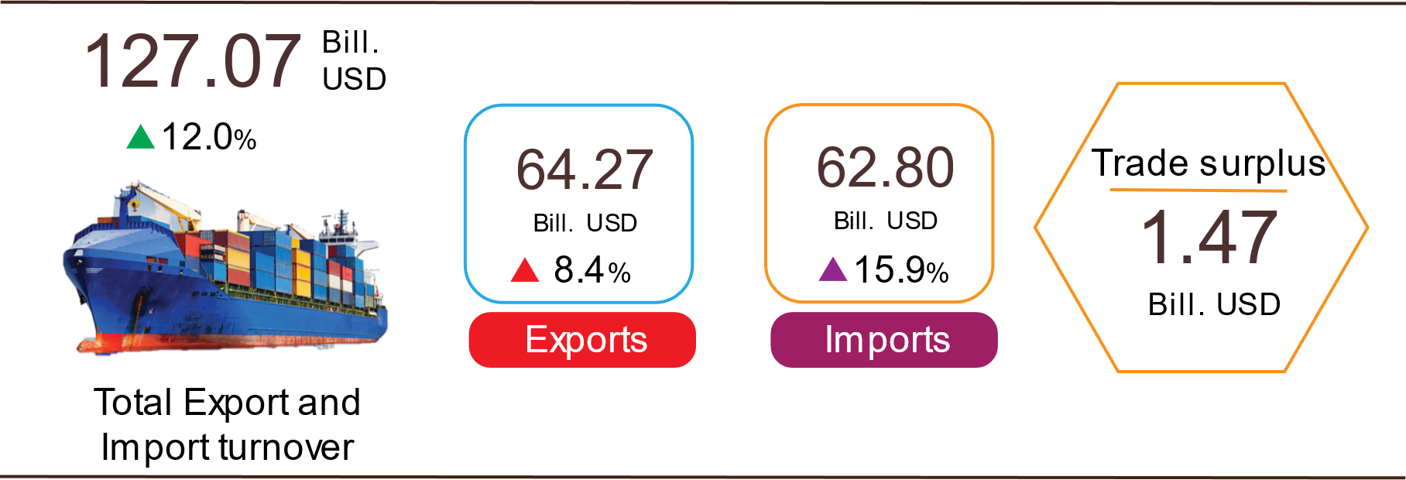

***Export of goods***

Export turnover of goods in 01/2025 reached USD 33.16 billion[20].

*Export turnover of goods in 02/2025* reached 31.11 billion USD, down 6.2% over the previous month. Of which, the domestic economic sector gained 8.39 billion USD, decreased by 12.0%; the FDI sector (including crude oil) reached 22.72 billion USD, decreased by 3.8%. Compared to the same period last year, export turnover of goods in February increased by 25.7%, of which the domestic economic sector increased by 32.8%, the FDI sector (including crude oil) increased by 23.2%.

*Generally in two months of 2025*, export turnover reached 64.27 billion USD, increased by 8.4% over the same period last year. Of which, the domestic economic sector was 17.92 billion USD, went up 12.8%, accounting for 27.9% of total export turnover; the FDI sector (including crude oil) attained 46.35 billion USD, increased by 6.7%, sharing 72.1%.

*In two months of 2025*, there were 12 products with export turnover of over 1 billion USD, contributing 77.7% to the total export turnover (4 products with export turnover of over 5 billion USD, accounting for 54.6%).

**Table 4. Value of some export products in 2 months of 2025**

|  |  |  |
| --- | --- | --- |
|  | Value  *(Mill. USD)* | Growth rate compare to  the same period last year *(%)* |
| **Items with a value of over 5 billion USD** |  |  |
| Electronic goods, computers and their parts | 12,535 | 25.3 |
| Phones all of kinds and their parts | 9,215 | -3.1 |
| Machinery, instrument, accessory | 7,692 | 10.3 |
| Textiles and garments | 5,634 | 9.3 |

*Regarding the structure of exported groups in two months of 2025,* the group of fuels and minerals was estimated at 0.48 billion USD, accounting for 0.8%; the group of processing industry was estimated at 57.01 billion USD, accounting for 88.7%; agricultural and forestry products was estimated at 5.35 billion USD, accounting for 8.3%; the group of fishery products was estimated at 1.43 billion USD, accounting for 2.2%.

**Figure 12. Structure of exported groups**

**in 2 months of 2025**



***Import of goods***

Import turnover of goods in 01/2025 reached 30.14 billion USD[21].

*Import turnover of goods in* *02/2025* reached 32.66 billion USD, increased by 8.4% over the previous month. Of which the domestic economic sector gained 11.87 billion USD, increased by 8.7%; the FDI sector reached 20.79 billion USD, increased by 8.1%. Compared to the same period last year, the import turnover of goods in February increased by 40.0%, of which the domestic economic sector increased by 49.6%; the FDI sector increased by 35.1%.

*Generally in two months of 2025*, import turnover of goods reached 62.8 billion USD, increased by 15.9% over the same period last year. Of which the domestic economic sector reached 22.8 billion USD, went up 18.7%; the FDI sector gained 40.0 billion USD, up 14.4%.

*In two months of 2025*, there are 16 imported products with a turnover of over 1 billion USD, accounting for 76.2% of total import turnover (2 products with import turnover of over 5 billion USD, accounting for 44.5%).

**Table 5. Value of some imported goods in 2 months of 2025**

|  |  |  |  |
| --- | --- | --- | --- |
|  |  | Value | Growth rate compare to |
|  |  | *(Mill. USD)* | the same period last year *(%)* |
| **Items with a value of over 5 billion USD** | |  |  |
|  | Electronic devices, computers and their parts | 20,147 | 28.9 |
|  | Machinery, instrument, accessory | 7,787 | 18.5 |

*Regarding the structure of imported groups in two months of 2025,* the group of production materials was estimated at 58.83 billion USD, accounted for 93.7%, in which the group of machinery, equipment, tools spare parts accounted for 50.8%; raw materials, fuel and materials accounted for 42.9%. The group of consumer products was estimated at 3.97 billion USD, accounted for 6.3%.

**Figure 13. Structure of imported groups**

**in 2 months of 2025**



*Regarding the export and import market of goods in two months of 2025,* the United States was the Viet Nam's largest export market with a turnover of 19.6 billion USD. China remained the largest import market of Viet Nam with a turnover of 23.3 billion USD. In two months of 2025, the trade surplus to the United States reached 17.0 billion USD, up 16.3% over the same period last year; the trade surplus to the EU 6.4 billion USD, up 19.2%; the trade surplus to Japan was 0.5 billion USD, nearly 10 times higher than the first 2 months of 2024; the trade deficit from China was 15.4 billion USD, went up 36.9%; the trade deficit from Korea was 4.6 billion USD, went up 20.6%; the trade deficit from ASEAN was 2.1 billion USD, increased by 116.8%.

**Figure 14. Major commodity import and export markets in 2 months of 2025**

|  |  |  |  |  |  |
| --- | --- | --- | --- | --- | --- |
|  | | |  | | |
|  |  | **Export of goods** | **Import of goods** |  |

*According to preliminary data,* the trade surplus in January was 3.02 billion USD[22]; the trade deficit in February was 1.55 billion USD. Generally in two months of 2025, the trade balance of goods had a trade surplus of 1.47 billion USD (in the same period last year, the trade surplus of 5.13 billion USD). Of which, the domestic economic sector has a trade deficit of 4.87 billion USD; the FDI sector (including crude oil) had a trade surplus of 6.34 billion USD.

***c) Consumer price index, gold price index and US dollar price index***

*Increased pork prices due to supply shortages, increased prices of eating out,**rental housing prices and transport service prices due to consumer demand are the main reasons for the consumer price index (CPI) in February 2025 to increase by 0.34% compared to the previous month; increase by 1.32% compared to December 2024 and increase by 2.91% compared to the same period in 2024.*

*On average, in the first two months of 2025, CPI increased by 3.27% compared to the same period last year; core inflation increased by 2.97****%.***

**Figure 15. . CPI growth rate in February 2025 compared to the previous month**

In the 0.34% increase in CPI in February 2025 compared to the previous month, there were 09 groups of goods and services with increased price indexes and 02 groups of goods with decreased price indexes.

(1) The nine groups of goods and services with increased price indexes include:

*- The transport group* increased the highest with 0.63% (making the general CPI increase by 0.06 percentage points), in which: People's travel demand increased at the beginning of the new year, causing the price of passenger transport by rail to increase by 61.99%; the price of passenger transport by air increased by 25%; passenger transport by taxi increased by 0.74%; passenger transport by road increased by 0.26% and passenger transport by waterway increased by 0.08%. The gasoline price index increased by 0.61% due to the impact of domestic gasoline price adjustments. The price of auto spare parts increased by 0.23%; motorcycle tires and tubes increased by 0.24%; other motorcycle spare parts increased by 0.17% due to increased demand for vehicle purchase and repair. Car and motorbike rental services increased by 0.49%; driving tuition increased by 0.41%; vehicle maintenance services increased by 0.32%; car wash and tire inflation services increased by 0.07%. On the other hand, used car prices decreased by 0.08%; car parking services decreased by 0.2%; diesel price index decreased by 1.7%.

*- Housing, electricity, water, fuel and construction materials* increased by 0.55% (increasing the overall CPI by 0.1 percentage points), mainly due to price increases in the following items: House rental prices increased by 0.8% due to a large number of workers from the provinces returning to the city to find work after Tet and students returning to school, leading to high demand for rental housing. In addition, high real estate prices caused many homeowners to increase rental prices to match the value of their assets. House maintenance material prices increased by 0.09% due to increased cement and steel prices following increases in input material costs such as coal, steel billets, electricity and labor costs. Household electricity prices increased by 0.38%; household water prices increased by 0.26%[23] due to increased consumer demand. Gas price increased by 0.56% because from February 1, 2025, domestic gas price was adjusted up by VND 3,000/12 kg cylinder after world gas price increased by USD 10/ton, fixed at USD 630/ton.

*- The food and foodstuff* *group* increased by 0.43% (causing the general CPI to increase by 0.14 percentage points), of which: Foodstuff increased by 0.41%[24] (causing the general CPI to increase by 0.09 percentage points); eating out increased by 0.75%[25] (causing the general CPI to increase by 0.06 percentage points); the food group alone decreased by 0.24%[26].

*- The group of medicines and health care services* increased by 0.31%, of which the price index of the medical services group increased by 0.36% due to some localities applying new medical service prices according to Circular No. 21/2024/TT-BYT dated October 17, 2024 of the Ministry of Health stipulating the method of pricing medical examination and treatment services. In addition, the weather in the North turned humid, so flu and respiratory diseases increased, and people's demand for pain relievers, fever reducers, respiratory drugs, vitamins and minerals increased. Specifically, the price of vitamin and mineral drugs increased by 0.21%; drugs affecting the respiratory tract increased by 0.17%; pain relievers and fever reducers increased by 0.1%; gastrointestinal drugs increased by 0.04%.

*- The group of other goods and services* increased by 0.18%, mainly increasing prices in some items: Jewelry group increased by 4.32%; wedding services increased by 0.31%; electrical appliances for personal care increased by 0.25%; personal care services increased by 0.2%; wristwatches increased by 0.18%. On the contrary, hair cutting and shampooing services decreased by 0.28%; administrative and legal services decreased by 0.19%.

*- The culture, entertainment and tourism group* increased by 0.17%, mainly focusing on the following items: Prices of flowers and ornamental plants increased by 3.27%; package tours increased by 0.25% due to people's travel demand and increased service costs; hotels and guesthouses increased by 0.21%; books, newspapers and magazines of all kinds increased by 0.03%.

*- Beverages and cigarette group* increased by 0.12% due to consumer demand during New Year festivals, causing alcohol prices to increase by 0.06%; cigarettes increased by 0.22%; non-alcoholic beverages increased by 0.07%.

*- The group of household appliances and equipment* increased by 0.05% due to increased costs of raw materials and transportation. Of which, prices of plastic and rubber products increased by 0.51%; metal products increased by 0.38%; electric lighting increased by 0.2%; household services increased by 0.15%; non-electric stoves, gas and electric appliances increased by 0.14%; beds, wardrobes, tables and chairs increased by 0.07%; glass, ceramic and porcelain products increased by 0.04%.

*- The education group* increased slightly by 0.02% due to the increase in stationery prices such as pens of all kinds increased by 0.3%; stationery and other school supplies increased by 0.37%; paper products increased by 0.1%.

(2) Two groups of goods and services with price indexes decreasing include:

*- The post and telecommunications group* decreased by 0.03%, of which, accessories for smart mobile phones and tablets decreased by 0.75%; regular mobile phones decreased by 0.12%; fixed-line phones decreased by 0.04%. On the contrary, the price of phone repair increased by 0.5%; the price of smart mobile phones and tablets increased by 0.29%.

*- The garment, hat and footwear group* decreased by 0.11% due to the decrease in demand for clothes and footwear after the Lunar New Year. Of which, footwear decreased by 0.24%; ready-made clothes decreased by 0.11%. On the other hand, the fabric price index increased by 0.07%; other garments increased by 0.06%; hats increased by 0.12%; garment, hat and footwear services increased by 0.14%.

Core inflation[27] in February 2025 increased by 0.3% compared to the previous month and by 2.87% compared to the same period last year. On average, core inflation in the first two months of 2025 increased by 2.97% compared to the same period last year, lower than the average CPI (up 3.27%) mainly due to the prices of food, foodstuffs, electricity, and medical services, which are factors affecting the increase in CPI but are excluded from the list of core inflation calculations.

Domestic gold prices fluctuate in the same direction as world gold prices. As of February 28, 2025, the average world gold price was at 2,898.22 USD/ounce, up 6.92% compared to January 2025. In February 2025, US tax policy announcements led to concerns about escalating trade wars. This has boosted demand for investment in gold as a safe asset. At the same time, central banks continue to buy gold to diversify reserves and protect assets from currency fluctuations. Domestically, the demand for gold shopping for luck on the God of Wealth Day after the Lunar New Year increased, causing the gold price index in February 2025 to increase by 4.72% compared to the previous month; increase by 32.57% compared to the same period last year; increase by 5.8% compared to December 2024; On average, in the first two months of 2025, the gold price index increased by 30.84%.

As of February 28, 2025, the US dollar price index in the international market reached 107.31 points, down 1.16% compared to the previous month due to the decrease in US government bond yields and the impact of tariffs and trade tensions from the US. Domestically, the average US dollar price in the free market is around 25,548 VND/USD. The US dollar price index in February 2025 decreased by 0.06% compared to the previous month; increased by 3.52% compared to the same period last year; increased by 0.15% compared to December 2024; on average in the first two months of 2025, the US dollar price index increased by 3.75%.

***d) Transport***

*Transport activities in February are vibrant to serve the travel, tourism and consumption needs of people during the Lunar New Year. Compared to the same period last year, passenger carried in 02/2024 increased by 14.3% in transport and passenger traffic increased by 22.7%; freight carried increased by 13.5% and freight traffic up 4.7%. Overall, in the first 2 months of 2024, passenger carried increased by 9.2% and passenger traffic up 11.8% over the same period last year;Freight carried increased by 13.9% and freight transport up 14%.*

*Passenger transport* in 02/2024 was estimated at 421.5 million passengers, increased by 8.7% over the previous month and passenger traffic was 23.7 billion passengers-kilometers, up 10.2% due to traveling demand of domestic people as well as international visitors rose during the Lunar New Year holiday. In the first 2 months of 2024, passenger carried was estimated at 809.1 million passengers, up 9.2% over the same period last year and passenger traffic was 45.2 billion passengers.km, increased by 11.8%. Of which, domestic transport reached 806.1 million passengers, up 9.1% over the same period last year and 34.9 billion passengers-kilometers, up 3.8%; overseas transport reached 3 million passengers, increased by 37.5% and 10.3 billion passengers-kilometers, up 51.2% compared to the same period last year.

In terms of transportation, all types of transport in the first 2 months of 2024 increased compared to the same period last year.

**Table 6 : Passengers transport in the first 2 months of 2024   
by types of transport**

|  |  |  |  |  |
| --- | --- | --- | --- | --- |
|  | Number of passengers | | Growth rate compared to the same period last year (%) | |
|  | Carried (Mill. passengers) | Traffic (Bill. passengers-km) | Carried | Traffic |
| **Total** | **809,1** | **45,2** | **9,2** | **11,8** |
| Rail way | 1,3 | 0,5 | 19,0 | 18,9 |
| Sea way | 4,0 | 0,2 | 10,2 | 16,4 |
| Inland water way | 61,4 | 1,1 | 6,4 | 11,4 |
| Road | 733,1 | 28,2 | 9,5 | 8,6 |
| Airway | 9,3 | 15,2 | 0,5 | 17,9 |

*Freight transport* in 02/2024 was estimated at 205.5 million tons of freight carried, decreased by 2.2% from the previous month and 41.1 billion tons.km of freight traffic, down 12% due to freight transportation activities for Tet Giap Thin mainly took place from January and the number of working days in this month for shipping companies was also less than last month when all the days off for Lunar New Year were in February. Generally for 2 months of 2024, freight transport was estimated at 415.8 million tons of freight carried, up 13.9% over the same period last year and 87.9 billion tons.km of freight traffic, an increase of 14%. Of which, domestic transport reached 408.1 million tons of freight carried, up 14.1% and 54.9 billion tons.km of freight traffic, up 13.8%; overseas transport reached 7.7 million tons of freight carried, up 6.6% and 33 billion tons.km of freight traffic, up 14.2%.

In terms of transportation, most of transport in 2 months of 2024 had a positive growth rate compared to the same period last year due to increased transportation of goods to serve domestic production and consumption demands. Particularly, railway faces many difficulties when competing with other transport industries.

**Table 7. Carriage of freight in the first 2 months of 2024  
by types of transport**

|  |  |  |  |  |  |
| --- | --- | --- | --- | --- | --- |
|  | Quantity of goods | |  | Growth rate compared to the same period last year (%) | |
|  | Carried | Traffic |  | Carried | Traffic |
| (Mill. tons) | (Bill. tons-km) |  |
|  |  |  |  |  |  |
| **Total** | **415,8** | **87,9** |  | **13,9** | **14,0** |
| Rail way | 0,6 | 0,5 |  | -2,8 | -10,2 |
| Sea way | 21,8 | 41,1 |  | 18,1 | 11,9 |
| Inland water way | 94,8 | 22,1 |  | 21,0 | 14,7 |
| Road | 298,5 | 22,4 |  | 11,6 | 16,2 |
| Airway | 0,08 | 1,8 |  | 72,6 | 37,0 |

***đ) International visitors to Viet Nam[28]***

*Thanks to the effectiveness of favorable visa policies, tourism stimulus programs as well as the efforts of the government and people, the number of international visitors to Vietnam in 02/2024[29] reached more than 1.5 million,* *up 1.3% compared to the previous month and* *increased by 64.1% compared to the same period last year. In the first 2 months of 2024, international visitors to our country reached* *more than 3 million arrivals, up 68.7% compared to the same period last year and equal to 98.5% to the same period of 2019 - the year before the Covid-19 pandemic.*

Out of a total of 3 million international arrivals to Viet Nam in the first 2 months of this year, arrivals by air reached nearly 2.6 million arrivals, accounting for 84.2% of international arrivals to Viet Nam and 1.6 times higher than the same period last year; by road reached 388.6 million arrivals, accounting for 12.8% and 2.5 times higher; by sea reached 90.7 thousand arrivals, accounting for 3% and 7 times higher.

**Figure 17. International visitors to Viet Nam in the first 2 months   
of 2024 by territories**

***d) Passengers and freight transport***

*Transportation activities in February 2025 continued to be vibrant, meeting the travel and spring travel needs of domestic people as well as international visitors to Vietnam, serving production and import and export of goods. Compared to the same period last year, passenger transport in 02/2025 increased by 12.2% of passenger carried and increased by 12.7% of passenger traffic; freight transport increased by 16.0% of freight carried and up 19.1% of freight traffic.*

*Overall, in two months of 2025, passenger carried increased by 13.8% and passenger traffic up 16.2% over the same period last year; freight carried increased by 14.5% and freight traffic up 11.8%.*

*Passenger transport* in 02/2025 was estimated at 464.3 million passengers, increased by 3.6% and passenger traffic was 26.3 billion passengers-kilometers, increased by 1.9% over the previous month. In two months of 2025, passenger carried was estimated at 912.4 million passengers, up 13.8% over the same period last year and passenger traffic was 52.1 billion passengers.km, increased by 16.2%. Of which, domestic transport reached 909.0 million passengers, up 13.8% over the same period last year and 40.9 billion passengers-kilometers, up 16.3%; overseas transport reached 3.4 million passengers, increased by 15.3% and 11.2 billion passengers-kilometers, up 15.8% compared to the same period last year.

**Table 6 : Passengers transport in 02 months of 2025  
by types of transport**

|  |  |  |  |  |
| --- | --- | --- | --- | --- |
|  | Number of passengers | | Growth rate compared to the same period last year (%) | |
|  | Carried (Mill. passengers) | Traffic (Bill. passengers-km) | Carried | Traffic |
| **Total** | **912.4** | **52.1** | **13.8** | **16.2** |
| Rail way | 1.2 | 0.5 | 4.9 | 7.3 |
| Sea way | 3.4 | 0.2 | -6.4 | -12.7 |
| Inland water way | 85.5 | 1.4 | 28.7 | 22.1 |
| Road | 812.8 | 33.4 | 12.6 | 18.3 |
| Airway | 9.5 | 16.6 | 9.5 | 12.4 |

*Freight transport* in 02/2025 was estimated at 234.2 million tons of freight carried, decreased by 1.4% and 48.9 billion tons.km of freight traffic, decreased by 0.6% over the previous month. Generally for two months of 2025, freight transport was estimated at 471.8 million tons of freight carried, up 14.5% over the same period last year and 98.1 billion tons.km of freight traffic, an increase of 11.8%. Of which, domestic transport reached 463.4 million tons of freight carried, up 14.7% and 59.5 billion tons.km of freight traffic, up 8.6%; overseas transport reached 8.1 million tons of freight carried, up 5.8% and 38.6 billion tons.km of freight traffic, up 17.0%.

**Table 7. Carriage of freight in 02 months of 2025  
by types of transport**

|  |  |  |  |  |
| --- | --- | --- | --- | --- |
|  | Quantity of goods | | Growth rate compared to the  same period last year (%) | |
|  | Carried | Traffic | Carried | Traffic |
| (Mill. tons) | (Bill. tons-km) |
| **Total** | **471.8** | **98.1** | **14.5** | **11.8** |
| Rail way | 0.7 | 0.5 | -0.9 | -4.8 |
| Sea way | 27.2 | 56.5 | 25.9 | 24.9 |
| Inland water way | 97.5 | 18.3 | 8.7 | -7.6 |
| Road | 346.3 | 21.1 | 15.5 | 3.0 |
| Airway | 0.1 | 1.7 | 10.2 | -2.3 |

***đ) International visitors to Viet Nam[30]***

*Favorable visa policies, enhanced tourism promotion programs, and prestigious tourism awards presented by international organizations have attracted an increasing number of international visitors to Vietnam.*

In 02/2025[31], the number of international visitors to Viet Nam reached 1.9 million, increased by 23.7% compared to the same period last year. In the first two months of 2025, international visitors to our country reached nearly 3.96 million arrivals, up 30.2% compared to the same period last year.Of which, arrivals by air reached nearly 3.4 million arrivals, accounting for 85.7% of international arrivals to Viet Nam and up 32.5% over the same period last year; by road reached 467.2 thousand arrivals, accounting for 11.8% and up 20.2%; by sea reached 99.4 thousand arrivals, accounting for 2.5% and up 9.6% .

**Figure 17. International visitors to Viet Nam in 02 months   
of 2025 by territories**

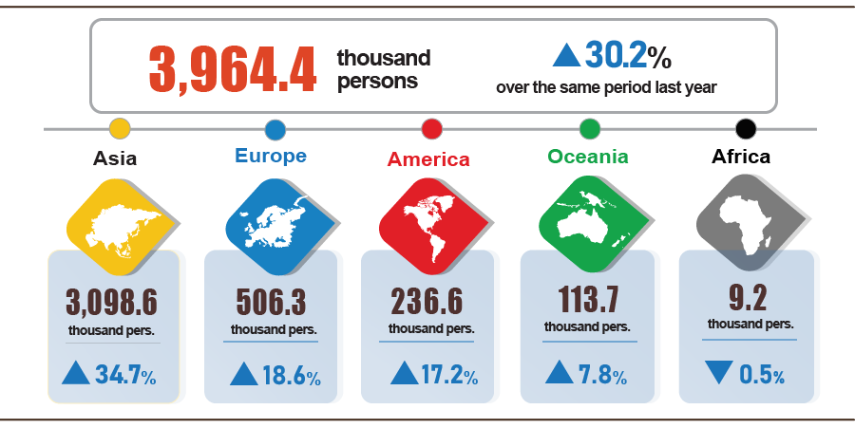

**7. Some social situations**

***a) People's life***

According to the preliminary results of the Labor and Employment Survey, the rate of households with income in the month remained unchanged and increased compared to the same period last year at 97.0% (an increase of 1 percentage point compared to the January 2025 reporting period and an increase of 2.8 percentage points compared to the same period last year); the rate of households with income decreased was 3.0%.

Households whose income in February decreased compared to the same period last year identified the main reasons as[32]: Some household members lost their jobs or temporarily quit their jobs (48.1%); due to a decrease in the scale of household production and business activities (17.6%); due to an increase in input costs for household production and business activities (16.0%); due to a decrease in the selling price of products from household production and business activities (15.1%).

In the first two months of 2025, 30.4% of households reported experiencing at least one event that negatively affected their family life, similar to the January 2025 reporting period and down 2.6 percentage points compared to the February 2024 reporting period. Among households negatively affected by events: 29.4% of households are suffering from the effects of rising prices of goods and services; 2.1% of households are negatively affected by natural disasters; 2.5% of households are negatively affected by human diseases and 1.7% of households are negatively affected by diseases in livestock and crops.

In February, 14.3% of interviewed households received assistance from various sources. Of these, 10.0% received assistance from relatives and friends; 5.1% from local programs and policies; 4.8% from national programs and policies; 1.9% from charitable activities of other organizations and individuals; and 0.01% from other sources.

Social security work has always been promptly implemented by all levels and sectors. From the beginning of the year to February 27, 2025, the Government has supported people with nearly 6.9 thousand tons of rice, including: Supporting more than 6.0 thousand tons of rice to relieve hunger on the occasion of Lunar New Year for 402.6 thousand people; supporting 836 tons of rice to relieve hunger during the 2025 crop gap for 55.8 thousand people.

***b) Disease situation and food poisoning***

According to a report from the Ministry of Health, in the month (from January 19 to February 18, 2025), the whole country had 6,540 cases of dengue fever; 1,989 cases of hand, foot and mouth disease; 18.5 thousand cases of typhus suspected of measles (01 death); 08 deaths due to rabies; 26 cases of viral encephalitis; 03 cases of meningococcal meningitis. In the two months of 2025, the whole country had 16,607 cases of dengue fever (01 death); 5,595 cases of hand, foot and mouth disease; 38.7 thousand cases of typhus suspected of measles (04 deaths); 10 deaths due to rabies; 50 cases of viral encephalitis; 06 cases of meningococcal meningitis.

The total number of people living with HIV in the country as of February 18, 2025 was 246.9 thousand people; the number of deaths due to HIV/AIDS was 116.1 thousand people.

Regarding food poisoning, in February 2025 there was no food poisoning. In the two months of 2025 (from January 19 to February 18, 2025), the whole country had 05 cases with 37 people being poisoned (05 people died).

***c) Sports activities***

In February, many solemn activities took place across the country to celebrate the 95th anniversary of the founding of the Communist Party of Vietnam (February 3, 1930-February 3, 2025). This was also the beginning of the new year, so many festivals were organized by localities across the country to preserve the nation's traditional cultural identity and promote history, culture, and tourism to domestic and international tourists. Outstanding festivals include: Perfume Pagoda Festival - Hanoi, Dong Da Festival - Hanoi, Yen Tu Festival - Quang Ninh, Lim Festival - Bac Ninh, Tran Temple Festival - Nam Dinh, Tam Chuc Pagoda Festival - Ha Nam...

Regarding the mass sports movement, some outstanding activities took place during the month such as: National U19 Women's Football Championship - Acecook Cup 2025; final round of the 2024-2025 national U19 football championship; V-League national football championship 2024-2025; the 3rd traditional men's boat race in Krong Ana district - Dak Lak in 2025; The 27th Ta Cu - Binh Thuan Open mountain climbing tournament in 2025...

Regarding high-performance sports, in February there were a number of outstanding events such as: Singapore International Badminton Tournament 2025 starting from February 18-23, 2025 in Singapore; Vietnam women's futsal team won tickets to the 2025 Asian women's futsal tournament; Indonesia Masters 2025 international badminton toursnament kicks off from January 21-26, 2025 in Indonesia; Asian Road Cycling Championship 2025 from February 5-17, 2025 in Thailand; The 9th Asian Winter Games 2025 takes place from February 7-14, 2025 in China.

***d) Traffic accidents*[33]**

In February (from January 26 to February 25, 2025), there were 1,431 traffic accidents nationwide, killing 784 people and injuring 1,053 people. Compared to January 2025, the number of traffic accidents decreased by 19.2%; the number of deaths decreased by 18.7%; the number of injuries decreased by 7.5%. Compared to the same period in 2024, the number of traffic accidents decreased by 36.8%; the number of deaths decreased by 21.5%; the number of injuries decreased by 40.4%.

In the first two months of 2025, there were 3,203 traffic accidents nationwide, killing 1,748 people and injuring 2,191 people. Compared to the same period last year, the number of traffic accidents decreased by 31.2%; the number of deaths decreased by 10.5%; the number of injuries decreased by 41.0%. On average, there were 52 traffic accidents per day in the first two months of 2025 nationwide, killing 28 people and injuring 35 people.

***d) Damage caused by natural disasters[34]***

Damage caused by natural disasters in February was mainly due to the impact of storms and lightning, injuring 5 people; 545.3 hectares of rice and crops were flooded and damaged; the total value of property damage caused by natural disasters in the month was nearly 6 billion VND, down 64.7% compared to the same period last year. In the first two months of this year, natural disasters injured 5 people; 2.7 thousand hectares of rice and crops were damaged; the total value of property damage was estimated at 20.8 billion VND, down 73.7% compared to the same period in 2024.

***e) Environmental protection and fire and explosion prevention***

In February (from January 18 to February 17, 2025) [35], authorities detected 1,535 environmental violations in 54/63 localities[36], of which 1,522 cases were handled with a total fine of VND 24.9 billion, down 17.0% compared to the previous month and down 13.4% compared to the same period last year. In the first two months of this year, authorities detected 5,329 environmental violations, of which 4,659 cases were handled with a total fine of VND 54.9 billion, down 1.1% compared to the same period last year.

During the month (from January 15 to February 14, 2025) [37], there were 338 fire and explosion incidents nationwide, killing 6 people and injuring 4 people, causing an estimated loss of VND 24.6 billion, 2.1 times higher than the previous month and down 11.2% over the same period last year. In the first two months of this year, there were 715 fire and explosion incidents nationwide, killing 14 people and injuring 12 people, causing an estimated loss of VND 36.3 billion, down 23.0% over the same period last year./.

1. Raising buffaloes and cows for meat has decreased mainly due to difficult farming conditions, high farming costs, and low profits, leading to a decrease in the number of animals. However, the dairy herd was still growing steadily.
2. According to data from the Ministry of Agriculture and Rural Development, calculated from December 16, 2024 to January 15, 2025.
3. In February 2024, the damaged forest area was 54.2 hectares, of which the burned forest area was 0.4 hectares and the cut and destroyed forest area was 53.8 hectares.
4. Source: Compiled from reports of Mekong Delta provinces: The price of raw pangasius has increased since the last two weeks of December 2024 until now. Currently, the price of raw pangasius in the Mekong Delta is fluctuating at 31,500-31,800 VND/kg, an increase of about 3,000-3,500 VND/kg compared to the selling price in the same period last year.
5. <https://vasep.com.vn/gia-thuy-san/gia-trong-nuoc/gia-thuy-san-tai-khanh-hoa-tu-14-20-02-2025-24800>: The price of white leg shrimp 100 pieces/kg is 85,000-95,000 VND/kg, 60-80 pieces/kg fluctuates at 150,000-160,000 VND/kg, the price of raw black tiger shrimp 40 pieces/kg is 150,000-155,000 VND/kg, 30 pieces/kg is 175,000-180,000 VND/kg, 20 pieces/kg is 230,000-235,000 VND/kg.
6. Favorable sea weather, falling oil prices (DO 0.05S-II oil price in February 2024 is 20,910 VND/liter, DO 0.05S-II oil price in February 2025 is 19,050 VND/liter), and increased consumer demand have encouraged fishermen to go out to sea to fish.
7. The Industrial Production Index (IIP) in February 2025, compared to the previous month, experienced a sharp decline in several major industrial provinces: Quảng Ngãi decreased by 14.9%; Quảng Nam by 10.4%; Bắc Ninh by 7.2%; Quảng Ninh by 6.9%; Cần Thơ by 6.7%; Bà Rịa - Vũng Tàu by 5.7%; Hải Phòng by 4.2%; and Thái Nguyên by 1.9%.
8. In the same period last year, the Lunar New Year holiday (Giáp Thìn) fell entirely within February 2024, from February 8 to the end of February 14, 2024."
9. Localities have a high production index of the processing and manufacturing industry in the first two months of 2025 compared to the same period last year: Phu Tho increased by 48.5%; Bac Kan increased by 41.4%; Bac Giang increased by 26.8%; Thanh Hoa increased by 19.9%; Quang Nam increased by 19.5%; Nam Dinh increased by 18.0%; Kien Giang increased by 17.8%. Localities with a high production index of the electricity production and distribution industry: Tra Vinh increased by 51.3%; Hoa Binh increased by 43.6%; Quang Nam increased by 13.8%; Kien Giang increased by 12.7%; Ben Tre increased by 9.1%.
10. Localities with the production index of the processing and manufacturing industry in the first two months of 2025 decreased compared to the same period last year: Ha Tinh decreased by 11.1%; Ca Mau decreased by 4.6%; Cao Bang decreased by 3.2%; Quang Ngai decreased by 0.5%. Localities with the index of the electricity production and distribution industry in the first two months of 2025 decreased compared to the same period last year: Bac Lieu decreased by 29.7%; Ca Mau decreased by 16.5%; Lao Cai decreased by 9.0%; Ha Tinh decreased by 5.7%. Localities have a decrease in the production index of the mining industry in the first two months of 2025 compared to the same period last year: Gia Lai decreased by 60.7%; Ba Ria - Vung Tau decreased by 13.7%; Hanoi decreased by 3.7%.
11. Source: National Business Registration Information System, Department of Private Enterprise and Collective Economy Development, Ministry of Finance, received March 03rd, 2025. Implementing Decree No. 62/2024/ND-CP dated June 07th, 2024 of the Government (effective from August 01st, 2024), the data period on business registration in the month is calculated from the 1st to the last day of the reporting month. Particularly for time indicators (enterprises returning to operations, enterprises temporarily suspending business for a limited period of time, enterprises temporarily suspending operations awaiting dissolution procedures), the data period is the months before the time. August 01st, 2024 is calculated from the 21st of the month preceding the reporting month to the 20th of the reporting month.
12. According to the report of the Foreign Investment Agency, Ministry of Finance , received on March 1 , 2025.
13. According to Report No. 56/BC-BTC dated February 26, 2025 of the Ministry of Finance.
14. The growth rate of state budget revenue in the first two months of 2025 increased quite a bit due to the economic growth from the fourth quarter of the previous year at a fairly high rate, causing a high increase in domestic revenue such as income tax, value added tax of enterprises, the difference between state budget revenue and expenditure arising in the fourth quarter of 2024 and payment to the state budget at the beginning of 2025 .
15. Lunar New Year At Ty fell in January 2025, while Lunar New Year Giap Thin fell in February 2024.
16. The value of export turnover is calculated at F.O.B price and import turnover is calculated at C.I.F price (including transportation and insurance costs of imported goods).
17. Preliminary export and import data for February 2025 provided by the Viet Nam Customs on March 3, 2025.
18. Because February last year had Lunar New Year holiday, the number of working days in February this year is 5 days more than February last year.
19. Total import and export turnover of goods in two months of 2024 reached 113.5 billion USD, up 18.2% over the same period last year, of which exports reached 59.3 billion USD, up 19.2%; imports reached 54.2 billion USD, up 17.1%.
20. 74 million USD higher than the figure sent by the Viet Nam Customs to the Statistics Office on February 3, 2025.
21. 79 million USD higher than the figure sent by the Viet Nam Customs to the Statistics Office on February 3, 2025.
22. January report shows trade surplus of 3.03 billion USD
23. The electricity and water price index for February 2025 reflects fluctuations one month later than other items because it is calculated based on revenue and consumption output of January 2025.
24. Pork price index increased by 1.74%; fresh and processed fruit price index increased by 2.01%; fresh seafood price index increased by 1.18%; processed seafood increased by 0.29%; fish sauce and dipping sauce price index increased by 0.35%; beans and nuts increased by 0.2%; spices increased by 0.19%; tea, coffee, cocoa increased by 0.17%; cakes, jams, and candies increased by 0.11%; milk, butter, and cheese increased by 0.09%. On the contrary, the fresh, dried, and processed vegetable price index decreased by 2.69%, of which tomato prices decreased by 11.94%; kohlrabi decreased by 8.26%; cabbage decreased by 7.06%; fresh and dried spices of all kinds decreased by 2.77% due to favorable weather conditions that made the supply abundant and plentiful.
25. Due to the increased consumer demand during the New Year festivals, spring travel, and gatherings. Along with that, the high prices of raw materials and labor costs after the Lunar New Year holiday have pushed up the price of eating out. Of which, the price of eating out increased by 0.74%; drinking out increased by 0.99%; and fast food takeaway increased by 0.62%.
26. Domestic rice prices decreased due to lower consumer demand after the Lunar New Year, while export rice prices decreased due to increased world rice supply as India returned to the rice export market after two years of restrictions. Accordingly, the rice price index decreased by 0.54% (regular rice decreased by 0.7%; premium rice decreased by 0.1%).
27. CPI after excluding food, fresh food, energy and state-managed goods including medical services and education.
28. According to the report of the Border Gate Department, the Border Guard Command, the Ministry of National Defense and the Immigration Department.
29. The reporting period was from January 21, 2024 to Februari 20, 2024.
30. According to the report of the Border Gate Department, the Border Guard Command, the Ministry of National Defense and the Immigration Department on February 27, 2025.
31. The reporting period was from January 26, 2025 to February 25, 2025.
32. A household can choose many causes for reduced income.
33. According to a quick report from the Office of the Ministry of Public Security and the Vietnam Maritime Administration (Ministry of Transport) on February 28, 2025.
34. Summary of Reports from 63 Departments of Agriculture and Environment, reporting period from January 19 to February 18, 2025.
35. According to reports from the Department of Agriculture and Environment, the Provincial and Municipal Police Departments under the Central Government were compiled by the Statistics Offices.
36. There are 09 localities that did not detect any environmental violations in February 2025: Lao Cai, Khanh Hoa, Kon Tum, Dak Nong, Lam Dong, Ba Ria - Vung Tau, Long An, An Giang and Can Tho.
37. According to a quick report from the Ministry of Public Security on February 23, 2025.